Quality Assurance and Enhancement

Internal Quality Review Process

Background and Guidelines

2023

Contents

1. The Statutory Basis for Quality Reviews 4
2. Structure of the DCU Quality Review Process 5
3. Establishing a Quality Review Committee 6
4. Briefing Sessions and Quality Review Training 7
5. Self-Assessment 8
6. The Peer Review Group (PRG) 10
7. The Quality Review Visit 13
8. The Peer Review Group Report 14
9. Reimbursement of Expenses during Quality Reviews 15
10. Enhancement Planning 15
11. Follow Up Meeting and Publication of Review Outputs 17
12. Governing Authority Approval and Publication 17
13. Follow-up Reports 17
Appendices 18

The Statutory Basis for Quality Reviews
The broad approach to quality assurance and enhancement DCU aims to promote and develop a culture of quality throughout all aspects of the University. The framework derives from the spirit of Quality Assurance and Quality Improvement enshrined in the Universities Act (1997), which is the legislative basis for quality throughout the Irish University sector, and the Qualifications and Quality Assurance (Education and Training) Act 2012.

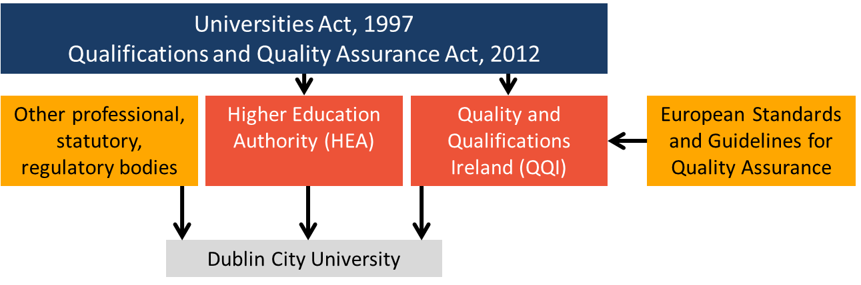
Figure 1 Overview of the Statutory and Legislative Basis of Quality Assurance within Irish Higher Education

The DCU processes for quality reviews at DCU are further aligned to the standards and guidelines for quality assurance in the European Higher Education Area (ESG) and the published guidelines of Qualifications and Quality Ireland (QQI), and are continually reviewed and further developed based on national and international good practice.

  - Purpose of DCU Quality Reviews
While the completion of cyclical internal quality reviews is a statutory requirement for higher education providers in Ireland, the purpose of DCU quality reviews extends well beyond meeting mandated external quality assurance requirements. The DCU Quality review processes have been developed to provide Areas with an opportunity to reflect on their practice, and engage with national and international peer reviews to develop a range of initiatives that aim to ultimately enhance quality at DCU.

Participating in a quality review therefore,
- Provides an opportunity for an entire area to reflect on the quality and impact of their work, and reaffirm the purpose and responsibilities of the area
- help an Area to identify and analyse its strengths, weaknesses, opportunities and threats, and allows it to suggest appropriate remedies where necessary
- Reflect on your practice, based on feedback from a range of perspectives- including the experiences of students, colleagues, collaborators
- Be used as an opportunity to evaluate the current operational and strategic trajectory of an Area, and the priorities for achieving those goals
- Highlight good practice in an areas, and identify issues which may require support to maintain or develop quality
- Be used as an opportunity to receive advice from sectoral or disciplinary leaders, which may challenge current practice or suggest new opportunities for development
- Provides a framework within which the Area can continue to work in the future towards quality improvement.

Structure of the DCU Quality Review Process
The DCU quality review process includes four key stages,

- A period of self-assessment, involving all staff within an Area under review, which aims to critically assess the activities of the Area. The outputs of this self-reflection are summarised in the development of a Self-Assessment Report (SAR), which forms the basis of the evaluation of the Peer Review Group.
- A visit by an externally led Peer Review Group (PRG), to verify and evaluate the SAR, and meet with staff, students, and other stakeholders to discuss key issues identified. The visit is followed by the completion a PRG Report, which summaries the Group’s findings and makes commendations and recommendations for future quality enhancement within the Area under review.
- The development of Area led Quality Enhancement Plan (QuEP) in light of the PRG recommendations. This involves both an Area, and University level response to the PRG recommendations. The QuEP is discussed and agreed at a follow-up meeting, attended by at least one external member of the PRG
- The consideration of the PRG Report and QuEP by University Executive and Governing Authority ahead of publication on the DCU website.

Figure 4 Key stages of the Quality Review Process at DCU
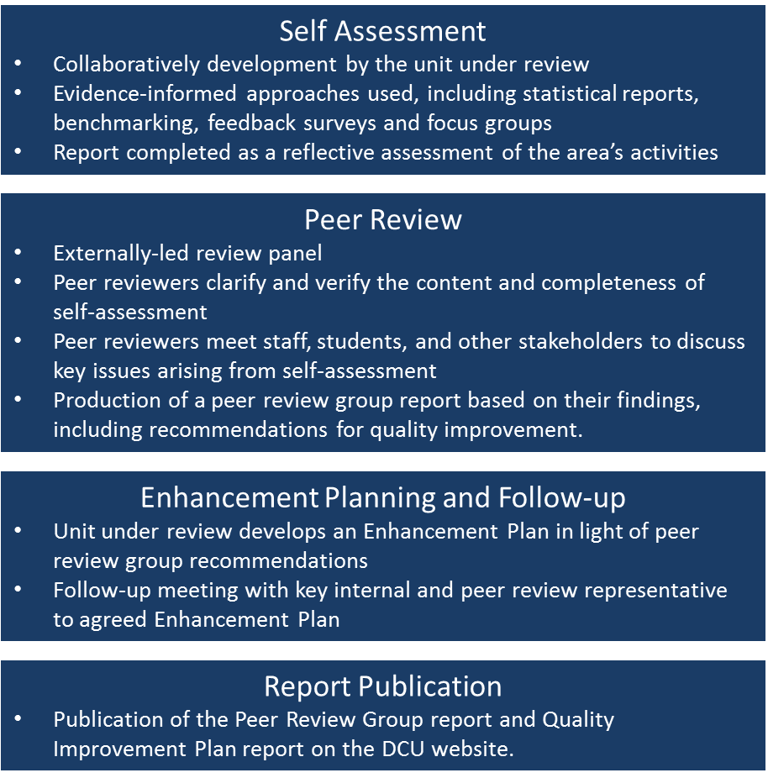

Establishing a Quality Review Committee

The area should, at the outset of the process, designate a group to form a committee that will be responsible for coordinating and preparing the self-assessment report. The committee should include the Head of the area and at least one other senior member of staff (one of whom should chair the Committee). The committee is an active working group, and as such not be too large (an upper limit of 10 is suggested).

Additional administrative burden involved with being a member of the Quality coordinating committee should be reflected in any staff workload allocation model for the Area under review. Although the preparation for the self-assessment is conducted primarily by the committee, it is very important that all staff in the area are appraised, on a regular basis, of progress with the review. It is suggested therefore, that for the duration of the preparation of the self-assessment report, the Quality Review should feature as an agenda item on, for example, staff meetings.

It is important that the Committee be representative of all grades and all categories of staff, wherever possible.

Examples of Quality Committee Membership

Academic Areas | Professional Support Areas
- Dean of Faculty (who will normally chair the committee)  - A representative of Teaching and Learning within the Faculty (e.g. ADTL)  - A representative of Research within the Faculty (ADR)  - A representative of Engagement/ External Outreach within the Faculty  - A Head of School  - Technical Representative (normally the Senior Technician)  - Faculty Manager  - Member of the Post-Doctoral Research Staff  - A student representative (a postgraduate student?) | - Head of Area  - Senior Members of staff with leadership responsibility for core activities  Other suggestions:  - A member is relatively new to either DCU, or the Area, who may provide new or different insights  - A mix of junior and senior grades from various teams  - A member of staff would may also be involved in supporting the administrative support for the review visit and the collation of appendices

Each member of the committee should have specific designated tasks allocated to him or her. The committee should ideally meet every month at the beginning of the self-assessment process and weekly as the deadline for the self-assessment report nears.

Briefing Sessions and Quality Review Training
The QIIO have a number of options available to Areas for both staff who will be involved in the Quality Review Committee, and all staff within the Area under review. These sessions are delivered by the QIIO, and can be arranged by contacting Fiona Dwyer (Fiona.Dwyer@dcu.ie)

Quality Review Committee Training is a 1.5-hour session led by the QIIO. The purpose of the training is to provide,
- An opportunity to learn more about how Quality Reviews fit alongside other assurance and enhancement activities at the University
- Information on the purpose of undertaking quality reviews, and the value of these for the Area
- An opportunity to ask questions and seek clarification on the process
- Advice on coordinating the self-assessment process
- Information on what to expect during the review visit, and the follow-up stages after receiving the Peer Review Group Report

Quality Review Staff Briefing sessions are usually a 20 minute presentation that can be built into a team or departmental meeting. Information in the briefing session includes,
- Information on the statutory basis of Quality Reviews, and why they are undertaken at DCU
- The purpose of a quality review- what it is, and crucially, what it is not
- How staff might be involved in the self-assessment process
- Who are the Peer Review Group and what to expect during a quality review visit
- What happens after an Area receives its Peer Review Group Report

Separately, the QIIO deliver both internal and external peer reviewers training and/or a briefing sessions prior to Peer Review Group members ahead of their participation in a DCU Quality Review visit.

Self-Assessment

Self-assessment culminates in the development of a Self-Assessment Report (SAR), which forms the basis for engagement with the external peer review team during the Quality Review Visit. The purpose of the report is to provide a succinct, but comprehensive and reflective statement of the area’s activities. Some of the data for the self-assessment report will be collected via questionnaires completed by staff, students and, where applicable, graduates and employers. The final self-assessment report should be circulated to all staff in the area and to the Director of Quality Promotion, who is responsible for distributing it to the Peer Review Group responsible for reviewing the Area.

In common with good international practice and in agreement with sectoral policy, the University does not intend to make the self-assessment report further available. It is our belief, adhering to the spirit of the legislation, that the candour and self-criticism expressed in such private reports will be less likely if the report is made public.

  - Stakeholder Consultation

Consultation- both internal and external to the Area under review- is a critical element of self-assessment. It is expected that that area will elicit feedback from a wide range of stakeholders to inform their analysis and self-reflection. These may include,

- Staff in the Area- feedback and consultation from a wide variety of staff in the area. This is often completed through staff surveys, staff away-days, meetings within smaller teams to discuss and reflect on quality in the area
- Other DCU staff- feedback from others who interact regularly with the Area, including, collaborators on projects/ teaching/ research,
- Students- feedback from students from surveys, focus groups, ongoing engagement with elected student representatives, feedback from recent alumni
- External Stakeholders- this might include feedback from external partnerships or advisory boards, graduate employers.
- For professional support areas in particular, you may wish to contact similar departments in other universities as part of external benchmarking, e.g. comparable remit and responsibilities, resource profile and staff levels, budgets, reporting lines and team structures etc

The Quality And Institutional Insights Office can provide advice on the development of surveys and/or the design of focus groups, including access to questionnaires that have previously been developed to gather feedback at part of the Quality Review process.

  - Other Sources of Information to Support Self-Assessment

There are a range of other information sources that you might find useful to consider as part of self-evaluation.
- Statistical information available from the Institutional Research and Analysis Officer. This may including information across the student life-cycle including student applications, student enrolment profiles, student academic performance metrics, graduating award profile, student survey results, graduate outcomes survey results
- Case-studies or vignettes highlighting good practice or innovation within the Area
- Research and innovation metrics- data may be available from RIS on research funding and publication profiles.
- Other information sources may also be useful:
  - www.scival.com (bibliometrics information from Web of Science)
  - https://www.knowledgetransferireland.com/Reports-Publications/ (Knowledge Transfer Ireland- national research and innovation metrics
  - https://hea.ie/statistics/data-for-download-and-visualisations/ (HEA- various institutional profiles and sectoral level statistics)
  - https://www.cso.ie/en/statistics/education/highereducationoutcomes/ (CSO- national information on Graduate Outcomes)

  - Writing the Self-Assessment Report (SAR)

The QIIO made available templates to help you complete your self-assessment report. These are slightly different for academic and professional support areas. The headings used in the templates have been developed to ensure an alignment between areas of focus required at national (QQI) and European (ESG) levels for quality assurance in higher education.

While it is recommended that Areas use the template provided, they are free to adjust the format of the SAR to their own circumstances and needs. Any major changes to the templates provided should be discussed with the Director of Quality Promotion before they are made and before the SAR is written.

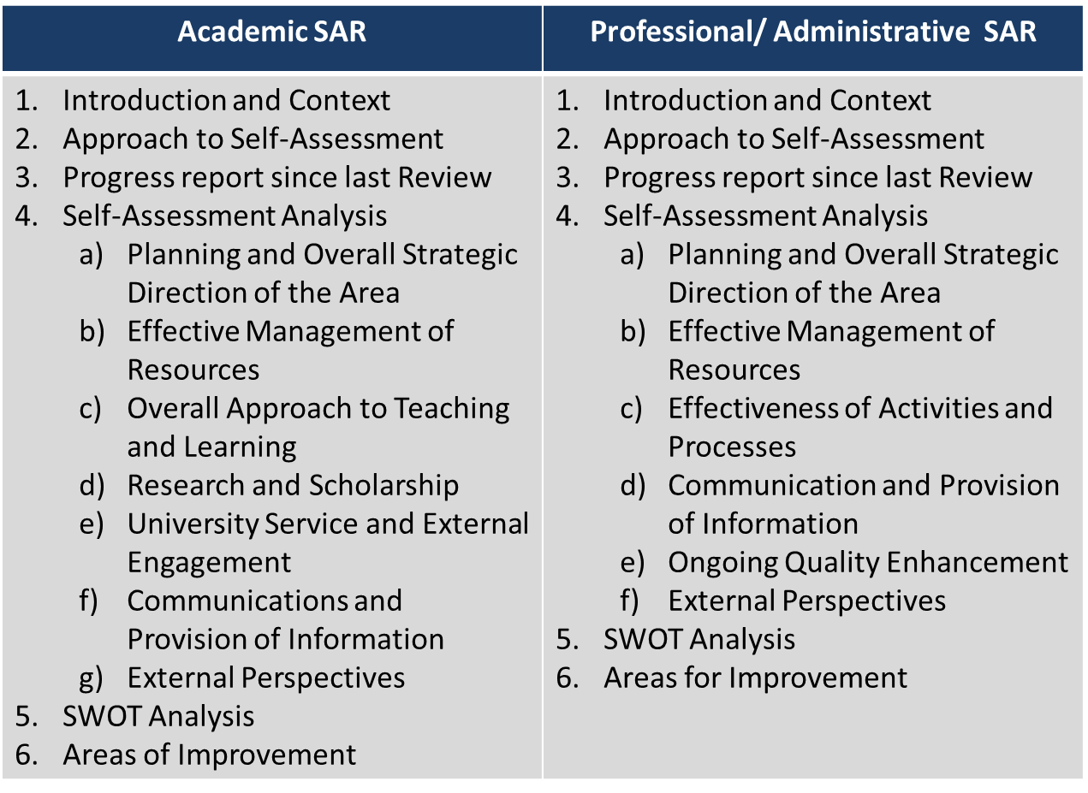

The main body of the SAR should be analytical and self-reflective, rather than focusing solely on describing the activities and responsibilities of the area. Since the overall goal is Quality enhancement, the formulation of strategies and recommendations for improving the work of the Areas should be highlighted. The subsequent external validation provided by the peer review will become an important element of the follow-up discussion within the university.

It is anticipated that the main self-assessment report should be no longer than 40 pages for a professional support area, and no longer than 60 pages for the review of Faculty review. This suggested length does not include appendices or other supplementary documentation.

The Peer Review Group (PRG)

  - Role of the PRG
The involvement of an externally-led peer review as part of quality reviews is specifically called out in the statutory requirements for quality reviews in higher education (University Act 1997). Engagement with a PRG provides Ares with an opportunity to discuss quality with experienced and respected experts and leaders in their field, and receive advice and guidance on potential areas for enhancement at DCU. Engagement with the PRG should not be considered as an ‘inspection’ or an ‘audit’ within the area. The term ‘critical friend’ is often used to describe the relationship between the PRG members and an Area under review. Their role is to discuss practice within the Area, and discuss with staff, students and other stakeholders about opportunities for practice enhancement within an Area.

The PRG reviews all the self-assessment material provided by the Area, and receives additional information and insight during the Peer Review Visit to draw conclusions about the quality of practice within and area. Following the peer review visit, they will both commend identified good practice in an Area, and make recommendations on areas for enhancement.

The objectives of the Peer Review Group will be to:

- Clarify and verify the information contained within in the self-assessment report
- Make judgements on how well the aims and objectives of the Area are fulfilled, having regard to the available resources
- Confirm the Area’s strength, weaknesses, opportunities and challenges as outlined in the self-assessment report
- Discuss any perceived strengths, weaknesses not identified in the self-assessment report
- Check the suitability of the teaching, learning and research environment (where applicable)
- Draw conclusions on the quality and standards achieved within the area and make commendations and recommendations for future quality improvements.

  - Profile of the PRG
The PRG is made up of 6 (Professional support Areas) or 7 (Executive Faculties) PRG members. The profile of a PRG includes both national and international experts, including representation from within and outside of higher education. Since 2021, all PRG panels now include a student reviewer.

Profile | Academic Review | Professional Support Review | Notes
External (Irish Higher Education) | Senior person from a HEI (normally a Dean or senior academic from a discipline similar to that under review) | Senior person from a HEI (Head/ Director of an Office similar to that under review) | Chairperson of the PRG shall be selected from among the external members.  **Note: For Faculty Reviews three external reviewers shall be selected from within higher education, with at least one being from an Irish HEI)
External (International) | Senior person from a HEI (normally a Dean or senior academic from a discipline similar to that under review) | Senior person from a HEI (Head/ Director of an Office similar to that under review)
External (Outside Higher Education) | Senior person from outside the Higher Education Sector (industry, business, professions or the public service). | Senior person from outside the Higher Education Sector (industry, business, professions or the public service).
Internal Senior Reviewer | Senior Academic/ Professional Support | Senior Academic/ Professional Support | QIIO Appoint
Coordinating Reviewer | Senior Academic/ Professional Support | Senior Academic/ Professional Support | QIIO Appoint
Student Reviewer | DCU student or recent graduate | DCU student or recent graduate | QIIO Appoint

  - Selecting the PRG
Nominations for external PRG members are initially nominated by the Area under review, with support, where requested from the QIIO. Areas are encouraged to “aim high” when suggesting potential peers for reviews, suggesting individuals recognised for their national or international leadership, extensive experience or specific disciplinary knowledge. Peers may also be selected from other HEIs that represent can be consider to be peer institutions. Following Area nominations, the selection of external peers is led by a sub-group of Quality Promotion Committee (QPC) who shall review the profile of the nominations, and rank them. Invitations to PRG members are made by the Quality Promotion Office.

  - Roles in the PRG
All PRG members are considered full reviewers during a quality review, and all members will participate fully in PRG visit meetings, and contribute to the completion of the PRG report. There are a number of defined roles within the Peer Review Group that are worth noting.

Review Group Chair
The PRG will elect, from among its own membership, a chairperson at the start of the quality review visit. The Chair will always be a member of the PRG that is external to DCU. The chairperson will normally preside over the PRG meetings, and will be responsible for ensuring that all PRG members are allocated a responsibility during the visit. The PRG Chair will also normally present the summary findings of the PRG at the exit presentation on the Friday afternoon of the review visit.

Coordinating Reviewer
The co-ordinating reviewer is a member of the DCU Quality Promotion Committee, and has a number of specific responsibilities in relation to the review. During the visit, the co-ordinating reviewer is the key point of contact between the PRG group and the Quality Promotion Office. This may include making requests for additional material or documentation, or requesting to meet additional staff or other stakeholders during the visit. They are responsible for co-ordinating the writing of the report. This means that they collate the contributions of all PRG members, before the group sign off on the final draft of the document. The co-ordinating reviewer also has the responsibility of sending the PRG report to the Quality And Institutional Insights Office following the completion of the report.

Student Reviewer
Since 2021, all PRG groups include a student reviewer. These students are selected by the QIIO and will meet the following criteria,
- are in Year 3 of an undergraduate programme, or a postgraduate student, or a recent graduate (no more than 2 years since completion of award)
- Student reviewers will have participated, or will participate in either class-rep training, or national N-StEP student reviewer training
- Are willing to participate in DCU student reviewer training prior to the quality review visit

The Quality Review Visit
The Peer Review Group will base their report on a combination of the information that they gather from both the Self-assessment Report and from interviews and discussions during the site visit.

Quality Review visits take place over 3 days, usually a Wednesday- Friday.

  - Purpose of the Quality Review Visit

The main aims of the site visit are to clarify and verify details of the Self-Assessment Report, and to allow members of the School/Faculty/Office/Centre as well as students and other stakeholders to meet with the Peer Review Group.

The Objectives of the PRG Visit are to:

- Verify how well the aims and objectives of the Area are fulfilled given the resources available
- Confirm the Area’s SWOC report
- Consider any noticeable strengths and weaknesses not identified in the SAR
- Check the sustainability of the teaching, learning, research and administrative support environment
- Provide opportunities to meet staff of the Area, students, DCU staff and other internal and external stakeholders.
- Provide an Exit Presentation
- Provide commendations and recommendations within a PRG report using a defined template.

  - Planning for the Quality Review Visit

The Peer Review Group will visit the Area over a minimum of a two and a-half-day period. This visit is central to the peer review process and must be carefully planned. Close liaison will be required between the area Co-ordinating Committee and the Quality Promotion Office.

It is envisaged that the visit will normally take place during the weeks of the first or second semester so that students can participate. This has important implications for the timing of all other activities. In order to facilitate personal schedules, the membership of the Peer Review Group will normally be decided at least six months in advance and the days for the visit fixed. All contact with the Peer Review Group Members (including arrangements for the stay in Dublin of the External members) will be carried out by the Quality Promotion Office.

A check-list for planning the Peer Review Visit and responsibilities for the Area and the QIIO are outlined in Appendix 4.

  - Structure of the Review Visit

The detailed structure and timetabling of the visit should be organised by the Chair of the Area’s Quality Committee in consultation with the Director of Quality Promotion. Templates are available from the QIIO which outline a suggested structure for the visit. The final timetable should be agreed four weeks prior to the visit identifying the staff, students, external stakeholders and others who it may be relevant for the PRG to meet. Sample timetables for Faculties and Professional Support Areas are included in Appendix 5 and Appendix 6.

A suitable room must be provided (by the Area under review) for the use of the Peer Review Group during the course of the visit.

The Peer Review Group will meet (at a minimum):
- The Quality Committee who co-ordinated the self-assessment process
- The Head of an Area and their leadership team
- A range of staff from across the Area, covering all aspects of activity within the Area
- Students, including elected student representatives
- Staff from other areas of the University that work with or support the Area under review
- The University Senior Management Group

The visit will also include a short campus tour, focusing on the Area under review. In every quality review schedule, a 30 minute session is left available for any member of staff from the Area to request to meet the PRG. All staff within the Area should be made aware of the timing and location of this session.

All Peer Review Visits conclude with an Exit Presentation, made by the Chairperson of the PRG. All the staff in the Area should be invited to attend this meeting. The Area under review is responsible for identifying and booking a suitable room for this session. At the Exit Presentation, the PRG will provide a high level summary of their findings, including information on their key commendations and recommendations. It is important to note that this session is for information purposes only, and no questions or discussion between the PRG and staff present can be facilitated.

The Peer Review Group Report
The area will receive a draft Peer Review Group report no later than 4 weeks following the completion of the Peer Review Group visit.

Factual Checking of Peer Review Group Report
The draft PRG report will be provided to the Head of the Area, who is responsible for circulating a copy to all members of the quality review co-coordinating committee. This is to afford the committee with an opportunity to indicate any errors of fact or poorly based assumptions in the report. This feedback should be almost entirely to do with verifiable facts and should take no longer than five working days. Taking any points raised into consideration, the Rapporteur, in consultation with the chair, and the other member of the PRG then produces a final PRG report.

Publication of the Peer Review Group Report
Following finalisation of the Peer Review Group report, a copy of the final report will be provided to the Area, who should share this with all staff within the Area. The PRG report shall also be shared with the university Senior Management Group (SMG) and the Quality Promotion Committee (QPC). The Peer Review Group is also published on the QIIO website (https://www.dcu.ie/QIIO/published-quality-review-reports) alongside the Areas Quality Enhancement Plan.

Reimbursement of Expenses during Quality Reviews

The Quality And Institutional Insights Office will reimburse all reasonable expenses, in relation to activities undertaken that are directly related to the development of the Self-Assessment Report, and the Peer Review Visit. Up to €6,000 is available for such expenses depending on the size of the Area under review.

Typical expenses/costs that can be claimed for, include, but are not limited to, the following:
- Staff replacement
- Staff training
- Consultants / facilitators
- Survey/focus group/other research and associated analysis
- Away Day
- Catering (day 2 & 3 of Review visit)
- Printing
- Travel
- Software Licences

In order to claim for these expenses, and have the associated total amount transferred to the relevant account, the following should be submitted to Fiona Dwyer in the Quality And Institutional Insights Office not later than one month after the peer review visit:

A list of all relevant expenses.
Proof of payment (paid invoice or receipt) for each expense listed.
The Income/Expense code and Sub-Cost Centre code where the monies should be transferred.
An appropriate description for the transfer e.g.:
Faculty of Humanities & Social Sciences Quality Review Expenses 2010

Further information, and assistance if required, can be obtained from Fiona Dwyer in the Quality And Institutional Insights Office – Ph: 7008411 or Email: Fiona.dwyer@dcu.ie.

Enhancement Planning

Quality Enhancement Planning, which follows the finalisation of the Peer Review Group Report, is a crucial aspect of the overall quality process. Both the Universities Act (1997) and the Qualifications and Quality Assurance Act (2012) note the responsibilities of the university to implement each of the recommendations of the PRG Report, unless it would be impractical or unreasonable to do so. The decisions on improvement made in the follow-up process provide a framework within which each Area can continue to work towards the goal of developing and fostering a quality culture in the University.

While this process inevitably focuses on addressing the recommendations of the Peer Review Group, it is equally important to both acknowledge and celebrate any commendations received by the PRG Group.

Typically, the process of Quality Enhancement Planning will be led by the Head of the Area under review, and will include broad consultation across the Area. The QEP will address all the recommendations in the Peer Review Group report, and develop and action plan for quality improvement, including a timeframe for implementation.

The Quality Enhancement Plan (QEP) should be developed over a period of 4-5 months following receipt of the PRG report. The QEP has a number of elements,

Quality Enhancement Plan
The area will be required to produce a QEP, which is an action plan of activities, milestones and predicted impact of activities being planned in response to the PRG report. Typically, this plan will be implemented over a 3 year period.

A QEP document will be produced (template available from the QIIO) to document the response of the area to the PRG report, and outline the key areas identified for quality enhancement.

The QEP report includes the following:
- The Area must respond to each of the recommendations of the Peer Review Group, summarising the activities that will be undertaken to address the recommendation, and the predicted impact on quality this will have
- Senior Management Group will also contribute to this report by commenting on the recommendation of the PRG, and the response made by the Area in their QEP
- Develop a 1-year and a 3-year implementation plan
- Propose projects (and budget information) on prioritised spending requirements to support the implementation of the QEP.

Proposals for prioritised spending generally cover non-recurrent expenditure that will support the implementation of a QEP. It may include, but is not limited to,
- External advice, consultation, facilitation to address or progress particular quality issues identified within QEP
- The purchase of software licences to support new processes
- Meeting specific training requirements that cannot be delivered by internal learning and professional development capacity

The Director of QIIO can provide advice on making prioritised spending proposals, and an estimate of the budget that is available. All proposals made will be reviewed by a sub-group of QPC prior to being distributed to Areas. These funds are usually placed in a multi-annual research account, and spent over the 3 years of the implementation plan.

Follow Up Meeting and Publication of Review Outputs
A draft QEP will be submitted to the QIIO, who will then liaise with SMG to complete the University response to each of the recommendations in the report. Following completion of this element, the QIIO shall organise for a follow-up meeting to finalise the QEP.

The follow-up meeting is usually attended by the following individuals,
- The Head of the Area, and one other co-ordinating reviewer from the Area
- The Deputy President
- The Director of the Quality Promotion Office
- The Chairperson of the PRG (or their nominee)
- The Co-ordinating reviewer from the PRG

This meeting is can be hosted online to facilitate ease of engagement with the external PRG attendee.

The follow-up meeting fulfils a number of functions. It provides an opportunity for the Area to discuss their response to the PRG Report with members of the PRG team. It provides an opportunity to ensure that the plans developed align to the intent and spirit of the PRG recommendations, and to discuss the predicted impact of the plans with the PRG. It also provides an opportunity for the PRG Chairperson to provide feedback on the proposed QEP. Following the meeting, and possible edits to the QEP following the discussions at the follow-up meeting, the QEP is considered final.

Governing Authority Approval and Publication
The two key outputs of a quality review- the Peer Review Group Report and the Quality Improvement Plan are reviewed by Governing Authority, ahead of final approval and publication on the DCU website.

The process of review and noting of the PRG Report and QEP are coordinated by the Quality Promotion Committee. Both reports are reviewed by a member of Governing Authority with responsibility for oversight of the Quality Review process; the full Governing Authority receive a summary of both the PRG Report and the QEP. Review outputs are presented and discussed by Governing Authority, and once noted as published by DCU on the Quality And Institutional Insights Office website (https://www.dcu.ie/QIIO/published-quality-review-reports).

Follow-up Reports
Follow up reports required after Year 1 and Year 3 of the QEP implementation. Templates for these are provided to areas by the Quality Promotion Office.

Appendices

Appendix 1 DCU Quality Policy

DCU acknowledges that it is ultimately responsible for the academic standards of awards made in its name and for its students’ quality of learning experiences. DCU’s quality policy has the following main aims and goals:
- To develop a quality culture that permeates all parts of the university for the benefit of the students, staff and the local, regional and national community.
- To ensure that the University’s strategic planning and development and quality assurance and improvement mutually inform and support each other.
- To ensure that appropriate and transparent governance and management structures are in place to guarantee continuous progress in implementing and supporting quality assurance and improvement measures.
- To implement and maintain procedures relating to the approval, monitoring and review of programmes.
- To take the advice of independent external peers and organisations, in particular external examiners, professional, statutory and regulatory bodies and external assessors in internal and external reviews of academic, administrative and support units, and in topic-based quality reviews.
- To gather quantitative and qualitative data and to conduct periodic surveys to get feedback from key stakeholder groups including students and employers, for quality improvement and policy making.
- To maintain the University in good standing in relation to its legislative obligations and to make the university a model public body.

Appendix 2 Timelines for Review Stages

Stage 1: Self-Assessment
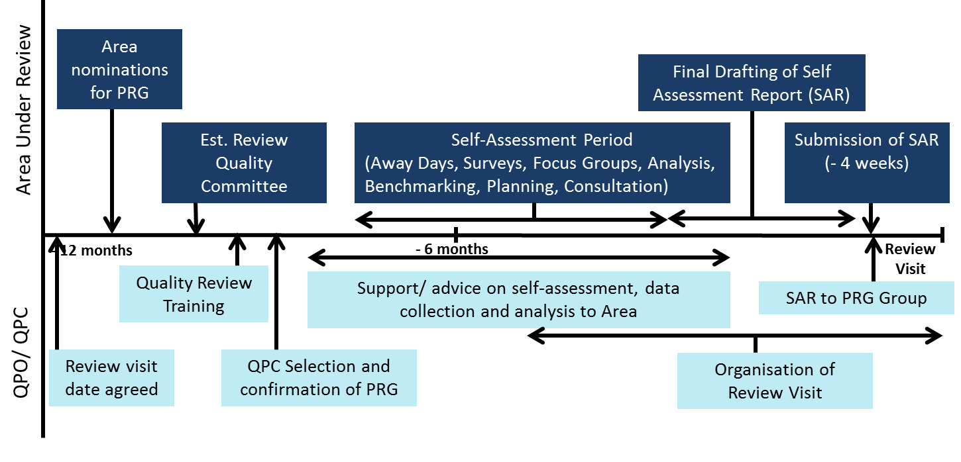

Stage 2: Peer Review Group Visit
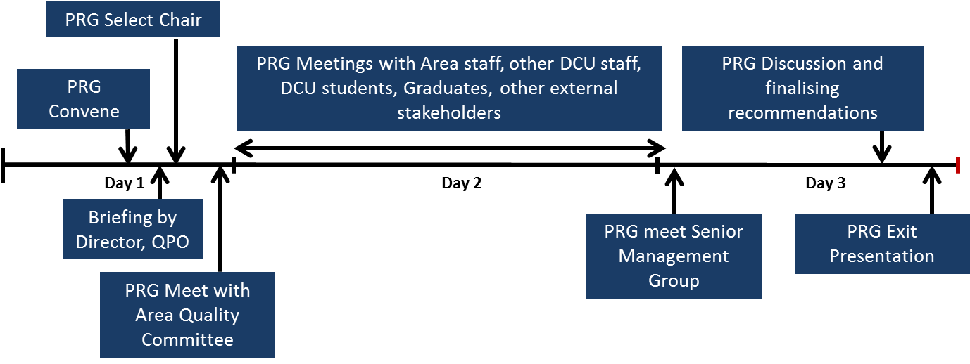

Stage 3: Quality Enhancement

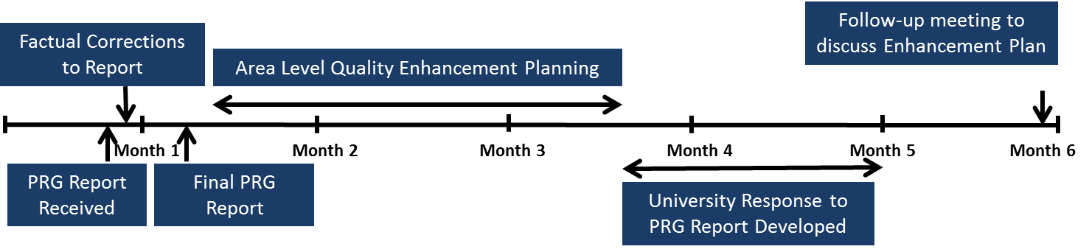

Appendix 3: Facilitators Contact Details
Brian McDonald
Mobile: 086-8526192.
Email: brian2coach@gmail.com

Sarah Lewis
Phone +44 8450559874 / +44 7973782715
Email sarahlewis@appreciatingchange.co.uk

Lorraine McGrath
McGrath Associates,
Business Analyst, Tutor & Mentor
Mobile: 086-8157120
Email: mcgrathlorraine@eircom.net

Tony Shone
Director
Invisio Limited
Tel: +353 45 900 810
Mob: +353 87 811 6780
Web: www.invisio.ie
Email: tony@invisio.ie

Appendix 4: Check List of Logistical Responsibilities during Quality Review

Documentation and other information to Quality And Institutional Insights Office (QIIO) from Area under review:

- Four weeks in advance of the review visit, the Area will provide an electronic copy of the Self-Assessment Report (SAR) and 8 bound hard copies of the SAR and Appendices. Appendices should be shared with QIIO to be made available to the PRG using Google Drive Folders.

- At least three days in advance of the review visit, the Area will provide the final, confirmed timetable including names and roles of those meeting with the Peer Review Group (PRG). Full title Prof. Dr. etc and position in DCU.

Before the Review Group Visit the Head/Director of Office will:

- Ensure that the Self-Assessment Report (SAR) is shared with all staff in the Area. Staff should be reminded that the document is confidential, and not for distribution outside of the department.

- Notify all staff of the time and location of the Open Staff Session, where, if they wish they can meet with the Peer Review Group. Notification of an intention to meet the review team should be provided to Fiona Dwyer, Quality Promotion Office, prior to the allocated time slot.

- Arrange and book a suitable room for the exit presentation and invite all staff members to this event on the evening of the last day of the visit. It is understandable that due to work commitments not all staff members will be able to attend, but it is important that all staff are invited, and that at least a few representatives from all areas/offices are there to hear the Chair of the PRG provide feedback on the findings.

- Arrange name plates printed on A4 card (folded) for all internal and external people meeting with the PRG, including the 1.30pm meeting on Wednesday (example available from QIIO – fiona.dwyer@dcu.ie). These should be put on the table in front of each person meeting the PRG.

Fiona will provide the name plates for the 5 Peer Review Panel members and Senior Management Group.

During the Review Group Visit the Area will provide the PRG with:

- A suitable room that will act as ‘headquarters’ for the PRG. This room should facilitate meetings with staff, students and others. A waiting area should be set up nearby the base room, and staff member/ external attendees should be informed of this before their meeting with PRG.

- A key to the base room to be made available to the PRG for the duration of the visit.

- Access to PC or Laptop and printer together with access to Internet and email.
- Enough electrical outlets in the base room for laptops/other PRG equipment.

- Wireless broadband available in the base room, and relevant passwords if required.

- Secretarial assistance and photocopying facilities (if needed), during PRG visit.

- Flip Chart available if required

Presentation Guidelines for 1.30pm Wednesday meeting with PRG

A verbal presentation works best in this forum, given by the Head of the Area, but powerpoint slides can be provided. This presentation is just to set the scene for the PRG and to give an opportunity to the Area to set out what it has gained from the experience to date and hopes to gain from the rest of it.

The presentation should last only about 5-10 minutes and could include:

- An overview of the background to this particularly quality review (previous individual reviews, input into larger reviews)
- Any developments that have occurred in the Area or university that affected the Area over the last few years (eg anonymous marking, structural and organisational changes etc.)
- An overview of how the SAR was developed, co-ordinated, and communicated and the research undertaken (away days, focus groups, surveys)
- A summary of the key finding of the SAR, particularly issues identified for improvement, and what it would like to gain from the rest of the quality review process

Before and during the review visit, the QIIO Provides PRG with:

- Copies of the Self-Assessment Report and Appendices received from the Area.
- DCU parking tickets, flights, accommodation, transport to and from DCU if required for all three days of review visit.
- All PRG catering arrangements during the visit
- Stationary for use during the PRG visit
- Name plates for Peer Review Panel for use during three days of visit and also for SMG Meeting.
- Small gift for each of the PRG members, presented by Director of QIIO after the exit presentation is completed.

After the Review Visit the Head of Office will liaise with the QIIO as follows;

- Circulate a copy of the draft PRG report received from the QIIO to all members of the Area Co-ordinating Committee.
- Provide the QIIO with any factual corrections to the draft PRG report within five working days.
- When provided by the QIIO, circulate a copy of the Final Peer Group Report to all members of staff in all offices reporting to the Area.
- Set up an implementation committee to draft a Quality Improvement Plan (QuIP) on receipt of the final review group report. This will be sent to the QIIO who will provide this to the SMG/University Executive and the Quality Promotion Committee.
- QIIO will convene and chair a follow-up meeting with an internal and external member of the PRG, and one or more members of Senior Management. The purpose of this meeting is to finalise the QuIP.
- One year after the completion of the QuIP, prepare a progress report and provide to QIIO. This will be discussed with the Director of Quality promotion and reviewed by the Quality Promotion Committee (QPC) as well as Executive.
Appendix 5 Draft Timetable for Professional Support Areas

Time | Peer Review Group (PRG) Activity/Meeting | Venue | Attendees
Day 1- Wednesday
1000-1030 | Arrival of PRG Members, coffee on arrival-
1030-1130 | Briefing by Director of Quality Promotion; guidelines provided to assist the PRG during the visit and in developing its report
1130-1230 | PRG Private Meeting Time.  PRG Selects a Chair  PRG discusses key themes, areas for exploration based on the SAR  PRG assigns tasks and responsibilities amongst members
1230-1330 | Lunch with Director of QIIO (Light lunch) |  |  | Arranged by QIIO
1330-1445 | Consideration of the SAR with the Area Head and members of the Quality Review committee. Shall commence with a short presentation by Area head, followed by discussion (Director, QIIO to attend)
1445-1500 | PRG private discussion time
1500-1555 | Meeting with Students (mix of qualification type, programme of study, gender, nationality etc where appropriate)
1600-1700 | Meeting with external stakeholders (e.g. alumni, employers, collaborators, suppliers, linked colleges, members of governing authority) if appropriate (or Area Management Team meeting- leaving scope for additional area staff meeting on day 2)
1700-1730 | PRG private discussion time
1800-1930 | PRG Private Dinner and discussion |  |  | Arranged by QIIO
Day 2- Thursday
0830-0900 | PRG Assemble/ Private Meeting Time
0900-0940 | Area Staff- Meeting 1
0945-1025 | Area Staff- Meeting 2
1030-1100 | PRG Coffee/ Private Meeting Time
1100-1140 | Area Staff- Meeting 3
1145-1230 | Key staff from other university departments where the area under review has significant co-operation (academic staff)
1230-1300 | Tour of Facilities (where relevant)
1300-1400 | Lunch/ PRG Private Meeting Time |  |  | Arranged by QIIO
1400-1445 | Relevant Central Support Units- senior representatives
1445-1515 | Staff Open Forum for any member of Area staff
1515-1630 | PRG Private Meeting Time
1630-1715 | Meeting with Area Management Team
1715-1800 | Meeting with Area Head
1830-2000 | PRG Private Dinner and Meeting |  |  | Arranged by QIIO
Day 3- Friday
0900-0955 | PRG Meeting with SMG |  |  | Arranged by QIIO
1000-1025 | Meeting with Area reporting head (relevant member of SMG) |  |  | Arranged by QIIO
1030-1300 | PRG Private Meeting Time- final discussion on recommendations
1300-1345 | PRG working lunch and finalization of exit presentation |  |  | Arranged by QIIO
1345-1400 | Briefing with Area Head and Director of QIIO on key recommendations
1400-1430 | PRG Exit Presentation

Appendix 6: Draft Timetable for Academic Areas

Tuesday
Time | Peer Review Group (PRG) Activity/Meeting | Room No.
1630-1715 | Briefing by Director of Quality Promotion  guidelines provided to assist the PRG during the visit and in developing its report (Tea and Coffee)
1715-1845 | PRG Private Meeting Time  Select of Chairperson  Review of initial impressions document  Identification of key areas of interest  Assignment of tasks and responsibilities
1845-1900 | Transfer to restaurant
1900-2100 | Peer Review Group Dinner with Quality Director

Wednesday
Time | Peer Review Group (PRG) Activity/Meeting |  | Room No.
0915-1015 | Consideration of the SAR with the Dean and Faculty Quality Committee Representatives  Will begin with a short presentation by the Dean, followed by discussion (Director, QIIO to attend)
1015-1030 | PRG Private Meeting Time
1030-1130 | Internal Faculty Staff Meeting- Teaching and Learning  Meeting with ADTL, Faculty Teaching and Learning Committee, Teaching Convenors  Focus on Faculty level view of T&L
1130-1230 | Parallel Session 1  Programme Chairs – Undergraduate (UG) | Parallel Session 2  Programme Chairs – Postgraduate (PGT)
1230-1300 | PRG Private Meeting Time
1300-1330 | Peer Review Group Lunch
1400-1445 | Parallel Session 1  Meeting with Students (UG) | Parallel Session 2  Meeting with Students (PGT)
1445-1515 | PRG Private Meeting Time / Coffee
1515-1600 | Internal Faculty Staff Meeting- External Engagement  Meeting with Staff who are involved in external engagement and collaborative activities  (e.g. AD Engagement, Internationalisation, Community Engagement, Professional Bodies, Internships & Placements)
1600-1700 | Meeting with External Engagement Stakeholders
1700-1730 | PRG Private Meeting Time
1900 | PRG Private Dinner and Discussion

THURSDAY
Time | Peer Review Group (PRG) Activity/Meeting |  | Room No.
0915-1000 | Internal Faculty Staff Meeting- Teaching and Learning  ADR, Faculty Research Committee,
1000-1045 | Parallel Session 1  Academic Staff- Research Centres | Parallel Session 2  Academic Staff: School based researchers
10.45-11.00 | PRG Private Meeting Time
1100 -1145 | Parallel Session 1  Focus on PhD Supervision/ Doctoral Education | Parallel Session 2  PhD Students
1200-1230 | Campus Tour
1300-1400 | Lunch/ PRG Private Meeting Time
1400-1445 | Parallel 1: Administrative Support- Faculty Office Staff | Parallel 2: Administrative Support- School based administrative staff
1505-1515 | Relevant Central Support Units (ISS, Library, SS&D, Estates, Finance, HR, OCOO etc.)
1515-1545 | Staff Open Forum
1545-1615 | PRG Private Meeting Time/ Coffee
1615-1700 | Faculty Management Team
1700-1745 | Meeting with Faculty Executive Dean
19.00 | PRG Private Dinner and Meeting

