How to create sales order/Credit note

- Go to:
https://agresso.dcu.ie/agresso/Default.aspx
Insert your username & passwords
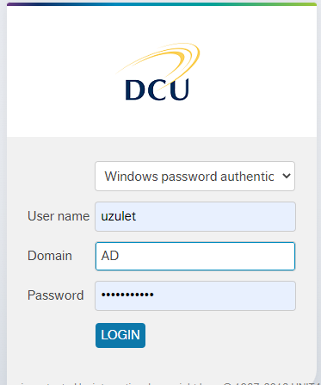

- Please click on the Customer & Sales orders folder (left side menu)
&
click on the Credit note folder (highlighted in red below on the right side menu):

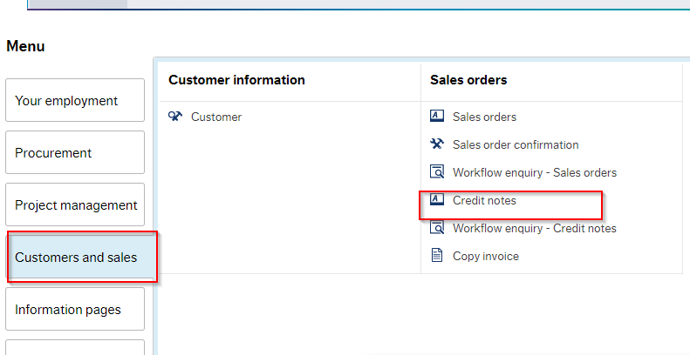

- On the next screen please insert invoice number or sales order number & click load
A full description of the invoice will appear (highlighted below in blue)
Please add a reason for the credit note (description field) & then Click SAVE.

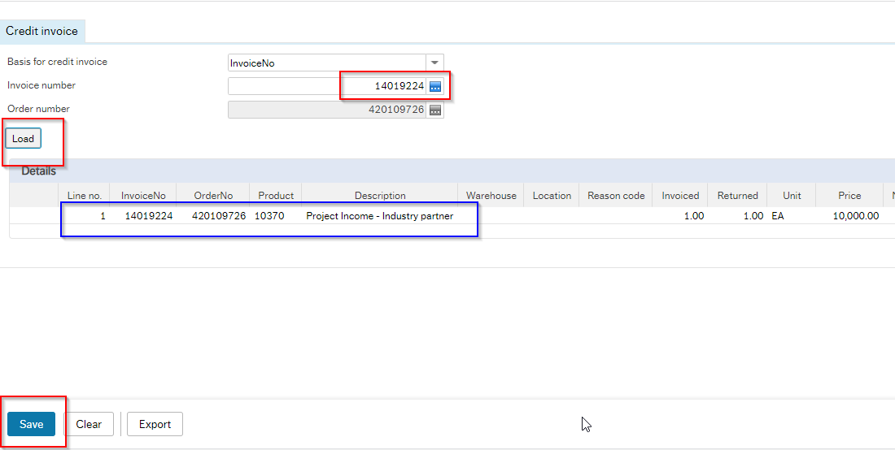

- When Credit note completed you must receive credit note base number (see below number 6).
