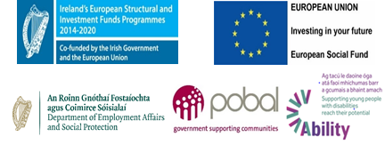 | 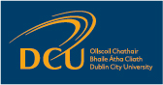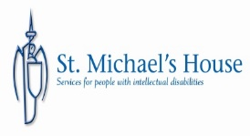
DCU Ability
Employment and, of course, unemployment is a major issue for everyone in Irish society but particularly, so for people with disabilities.
The DCU Ability Programme will build on the Irish Government strategy in this area, namely to build skills; capacity and independence; provide bridges and supports into work and to also engage with employers to provide co-ordinated support going forward.
The Programme
DCU Ability will promote the employability of young people with disabilities to gain the skills, competencies and experiences needed to be career-ready.
Our objective is to create meaningful and tailored pathways into education, training and employability for young people with disabilities, using a person-centred approach.
Dublin City University are working in partnership with St Michael’s House and campus businesses to harness their joint expertise, resources and facilities.
DCU Ability will support each participant to build the skills and confidence needed to become career-ready while supporting partnerships within and external to DCU to address barriers to employment.
The Team
Dr. Deirdre Corby (Principal Investigator), Dr. Carmel Andersen (Project Manager), Eilish King (Occupational Therapist), Schira Reddy (Career Adviser)
Anne O’Connor and Susan Madigan (Disability and Learning Support Service)
Prof. Ronnie Munck and Joanna Ozarowska (DCU in the Community)
Our community partner in this project is St Michael’s House (CEO Anna Shakespeare)
What we do
We support young people with disabilities to discover: how they want to live their life; what their ambitions are; and what is needed to make that possible.
We offer:
- Individual vocational assessments with an occupational therapist
- Quality of life assessments
- Individualised support plan tailored to each participant
- Accessibility needs for each participant
- Accessible communication interventions
- Modules in areas such as literacy and personal and professional development, and potentially QQI accredited learning opportunities
- Individual tuition
- Career planning and preparation for work
- Skills building such as in interviewing techniques, career planning, CVpreparation, completing application forms, job searching
- Work experience and voluntary work opportunities
Who is eligible?
To be eligible, participants must:
- Be between the ages of 18 and 29 years; and
- Be in receipt of disability or invalidity pension or in receipt of illness benefit for more than three months; or
- an existing service user or client of the lead applicant or project partner (if they are a disability service); or
- referred to us by relevant organisations or services supporting young people with disabilities
Please note that this is a national initiative so referrals from other organisations and services outside DCU and St. Michaels House are also welcome.
Get involved
Can you offer a work placement or could you be a mentor? Please get involved with this project by contacting the team below for further information.
Contact Points:
For further information please try www.dcu.ie/ability
Or contact the ability team at Ability@dcu.ie
Phone: 01 700 7545

