MEDICAL SPICE

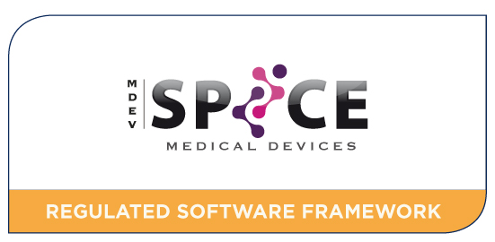

Background:
A significantly increased proportion of software applications are classified as medical devices and must be developed in a regulatory compliant manner.
The number of software suppliers requiring compliance with the medical device regulations is growing.
Aim:
To develop and commercialize an end-to-end solution for medical device software regulatory compliance that integrates the regulatory requirements of the medical device industry with generic software engineering best practices.

Deliverables:
- Medical SPICE process models;
- a measurement framework for regulatory compliance/ process assessment;
- interfaces between Medical SPICE and a medical device QMS ;
- training to companies on medical device software processes;
- a suite of assessment methods;
- a Conformity Assessment scheme;
- an Assessor Training and Certification scheme;
- International roll-out of Medical SPICE.

Contact:
Technology Transfer: Neil McLoughlin, DkIT; neil.mcloughlin@dkit.ie

Principal Investigator: Dr Fergal McCaffery; fergal.mccaffery@dkit.ie

