RESPSENSE @RSRC at DkIT

Dundalk Institute of Technology’s Regulated Software Research Centre, RSRC, has developed a prototype technology platform and product for applications in respiratory rate detection and analysis in patients.
Background:
- RR is considered to be the first and most significant vital sign that can detect the deteriorating patient.
- New patient monitoring solutions and Early Warning Score Calculations require accurate and automatic RR detection.
- Trends in RR can provide very important diagnostic and prognostic information which is currently unavailable.

The outcome of this research programme was:
- The development a Prototype Respiratory Rate Device (photo 1) using an acoustic sensor, including the hardware and embedded software platforms for the sampling of respiratory sounds with a low power wireless interface
- The development of a Software application (Photo 2) to provide analysis

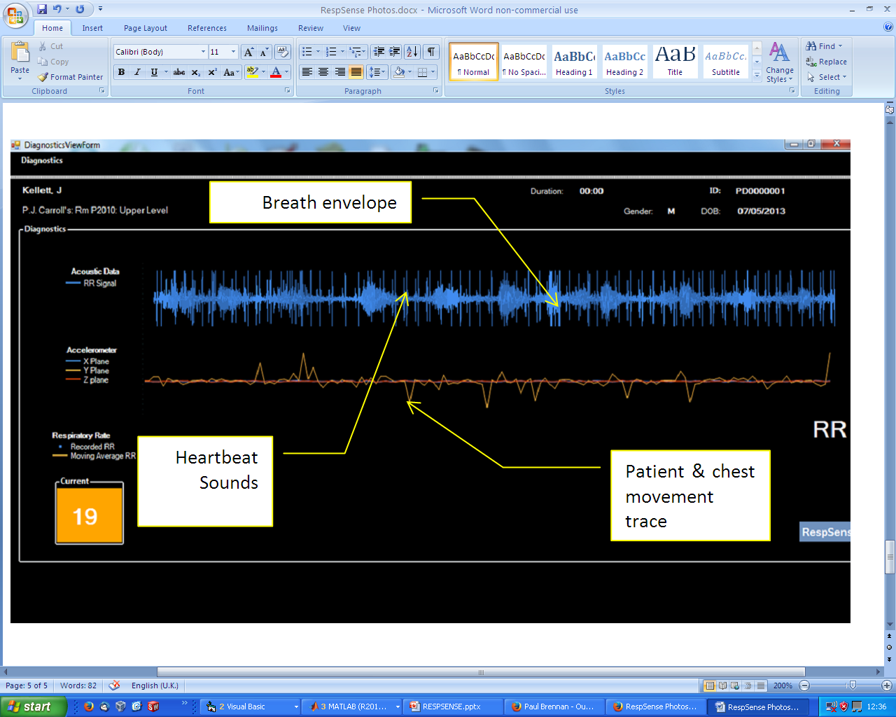
Photo 1. Prototype Acoustic Sensor Photo 2. Prototype Signal Display/Analysis
positioned in sternal notch.

The opportunity :

Key further development work is required in the following areas;
- Further mechanical design of the Patient Unit & Sensor Unit enclosures Design of disposable membrane for Sensor Unit to enhance acoustic transmission and provide an infection control solution.
- Improve robustness and accuracy of RR detection algorithm.

DkIT would licence the prototype technology platform and device to a company who could then apply for Applied Research support for these further developments.

Contact:
Technology Transfer: Neil McLoughlin, DkIT; neil.mcloughlin@dkit.ie
Principal Investigator: Dr Peter Donnolly; peter.donnolly@dkit.ie

