How to Write an Essay
Student Learning

Essays allow students to demonstrate an in-depth knowledge of a topic based on research and reading. The skill of good essay writing is to be able to critically discuss and evaluate ideas within a set word limit. 7 key steps should be taken to structure and write an essay that effectively develops an argument, or analyses and evaluates ideas rather than simply describing them.

7 STEPS TO WRITE AN ESSAY
- Analyse the Question
- Brainstorm
- Targeted Research
- Plan
- First Draft
- Revise & Edit
- References

STEP 1: CHOOSE AND ANALYSE THE QUESTION
The exact requirements of the essay/question brief need to be understood.
If you must select a topic from a range of choices, light scanning of material will be necessary to indicate which topic would be of most interest to you. If you do not need to select a topic you should analyse the question. Break the question down into clearly identifiable parts so that you can accurately see what the question requires. Check the meaning of the key verbs used in the question (e.g. ‘discuss’ or ‘critically analyse’). Write it out in your own words.

TIP: Use rewordify.com to simplify language.
TIP: Check the key essay verbs below.

Account for | Give reasons for; explain (note: give an account of; describe).
Analyse | Break the information into constituent parts; examine the relationship between the parts; question the information.
Argue | Put the case for or against a view or idea giving evidence for your claims/reasons for or against; attempt to influence the reader to accept your view.
Balance | Look at two or more viewpoints or pieces of information; give each equal attention; look at good and bad points; take into account many aspects and give an appropriate weighting to those aspects.
Be critical | Identify what is good and bad about the information and why; probe, question, identify inaccuracies or shortcomings in the information; estimate the value of the material.
Clarify | Identify the components of an issue/topic/problem/; make the meaning plain; remove misunderstandings.
Compare | Look for similarities and differences between; perhaps conclude which is preferable; implies evaluation.
Conclude/draw conclusions | The end point of your critical thinking; what the results of an investigation indicate; arrive at a judgement by reasoning.
Contrast | Bring out the differences.
Criticise | Give your judgement on theories or opinions or facts and back this by discussing evidence or reasoning involved.
Deduce | Conclude; infer.
Define | Give the precise meaning. Examine the different possible or often used definitions.
Demonstrate | Show clearly by giving proof or evidence.
Describe | Give a detailed, full account of the topic.
Determine | Find out something; calculate.
Develop an opinion/a view | Decide what you think (based on an argument or evidence).
Discuss | Investigate or examine by argument; debate; give reason for and against; examine the implications of the topic.
Elucidate | Explain and make clear.
Estimate | Calculate; judge; predict.
Evaluate/weigh up | Appraise the worth of something in the light of its truth or usefulness; assess and explain.
Examine | Look at carefully; consider.
Explain | Make plain and clear; give reasons for.
Give evidence | Provide evidence from your own work or that of others which could be checked by a third party to prove/ justify what you say.
Identify | Point out and describe.
Identify trends | Identify patterns/changes/ movements in certain directions (e.g. over time or across topics/ subjects).
Illustrate | Explain, clarify, make clear by the use of concrete examples.
Infer | Conclude something from facts or reasoning.
Interpret | Expound the meaning; make clear and explicit, giving your own judgement.
Justify | Show adequate grounds for decisions, a particular view or conclusions and answer main objections likely to be made to them.
Outline | Give a short description of the main points; give the main features or general principles; emphasise the structure, leaving out minor details.
Prove | Show that something is true or certain; provide strong evidence (and examples) for.
Review | Make a survey examining the subject carefully; similar to summarise and evaluate.
State | Present in a brief, clear form.
Summarise | Give a concise account of the chief points of a matter, removing unnecessary detail.
Synthesise | Bring elements together to make a complex whole, draw together or integrate issues (e.g. theories or models can be created by synthesising a number of elements).
Trace | Follow the development of topic from its origin.
Source: University of Kent (2017)
STEP 2: BRAINSTORM
Brainstorming is an important part of essay planning. Note down all ideas that come into your head about this topic freely. You may not necessarily use all of the ideas you come up with, but it’s helpful to have lots of ideas to choose from. Arrange these ideas into appropriately linked groups. However, you should also think about expanding and supporting the ideas you have brainstormed. In other words, you need to ask yourself further questions about each of your ideas and how they relate to the question posed. Ensure the ideas and topics are relevant!
TIP: Google search, online encyclopaedias and youtube.com may be helpful for obtaining a basic understanding of the essay at hand, and can be used to get going on a brainstorm if you are stuck. However, these are not recommended sources for academic writing.
Sign into Google Chrome using your DCU gmail to access Mindmup
TIP: Use free mind-mapping software to organise your thoughts

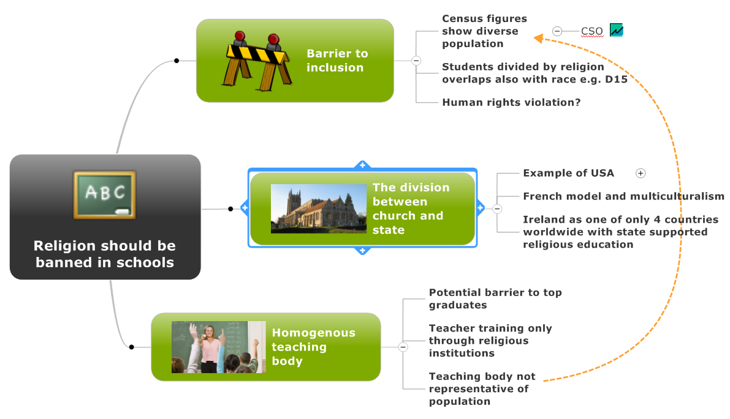
STEP 3: RESEARCH
Research the key ideas and topics emerging from your brainstorming. Use key readings/papers from lecturers reading lists and through these identify other important papers and articles which are cited. Use the library databases to research specific topics. Skim read during this process, concentrating on abstracts, introductions and results or findings to determine if the research is relevant to your essay. Make notes which can provide evidence for the arguments you wish to make in your essay.
TIP: Become familiar with how to complete online database searches and how to find books using library services. The Library staff will be happy to show you how!

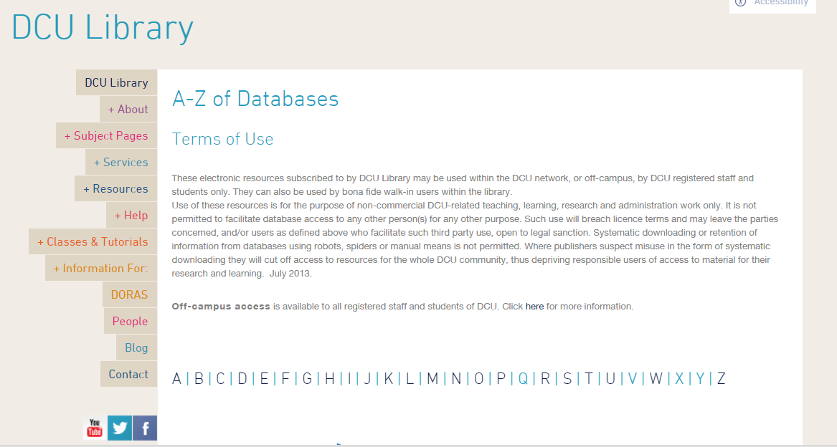

STEP 4: STRUCTURE
Planning your essay makes it much more likely that you will end up with a coherent argument. It allows you to work out a logical structure and an end point for your argument before you start writing. It also helps you to commit to sticking to the focus of your essay. A structured essay with a coherent argument greatly appeals to the reader. Typically an essay can be broken down into 3 components; introduction (~10% of word count), conclusion (~10% of word count) and the main body of the text (remaining 80%). The main body of the text is separated into sections based on the key topics identified during research, i.e. topic 1, topic 2 etc. The number of topics you have chosen to write about must then be assigned an equal word count to make up the main body of the essay. Each topic can then be divided into sub-points and the section word count divided equally for each sub-point.
INTRO  10% of word count | Go from the broad to the specific. Introduce the general topic, outline why it is an important area, then state what you will specifically do to investigate it further.
Section 1 | Sub-point 3  Sub-point 2  Sub-point 1
Section 2 | Sub-point 3  Sub-point 2  Sub-point 1
Section 3 | Sub-point 1  Sub-point 3  Sub-point 2
CONCLUSION  10% of word count | Go from the specific to the broad. State the conclusions you can draw from the points you’ve made in the essay, and connect this learning to the general topic. End by posing a question for future research in the field.
STEP 5: FIRST DRAFT
The most important thing is to start writing as this is your first draft and it can be edited later. Based on the essay structure you have planned, write about Section 1 – Sub-Point 1 and stick to the word count you have allocated. Avoid getting ‘bogged’ down in one Section by setting a time frame per Section and then moving on to the next Section when the allotted time is reached.
TIP: Use the online academic phrasebank to find useful sentences for an academic writing style. http://www.phrasebank.manchester.ac.uk/
Each Section will be written about in paragraphs to make up the main body of the essay. Each paragraph deals with a distinct sub-point. The opening sentence of the paragraph should indicate what this is. You should develop this sub-point through elaboration, analysis and illustration: that is, you should provide evidence of why this is important enough to warrant discussion in a paragraph.
TIP: Make a statement in the opening sentence of the paragraph, support with sentences that provide context and detail which relate to topic sentence. The concluding sentence should link to the next paragraph.

AFTER the main body of the essay is written, then write the introduction. The introduction first introduces generally why the issue or question is of importance. This might include relating the question the real-world ramifications or applications. The introduction then grows more specific by expressing the central argument. Finally, it becomes very specific by clearly stating what the essay will do to shed light on the issue/question.
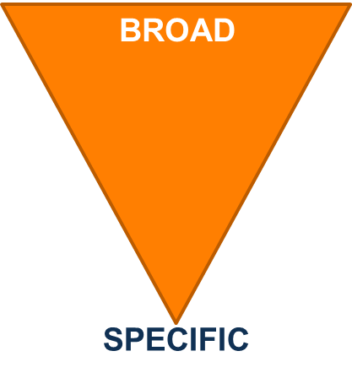
Finally, write the conclusion. The conclusion goes in reverse order to the introduction; from the specific to the broad. Start with the short answer to the question/issue that you’ve reached. Support this by summarising the key points you made in the main body of the essay. There is no need for any new references or material at this point. Finally, link your conclusions to the general research field. Perhaps look out for real-world implications, and, if relevant, highlight a follow-on area for future research.
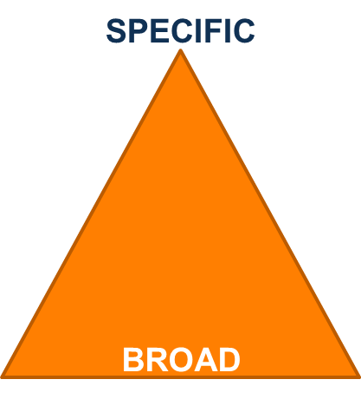

STEP 6: REVISE & EDIT
Revise your draft to work on the flow of the essay. Make sure you’ve answered the question. Change, rearrange or discard material to clarify points & achieve a well-crafted final product. Have you used appropriate sources in the right citation style to support your points?
TIP: When revising for cohesion, ask yourself whether the ideas in each sentence flow together logically. Are sentences too long or awkward? Do paragraphs show a connection? Doe the Sections of the essay relate to each other?
TIP: When revising for style, ask yourself what audience you’re targeting. Is the tone too formal/informal? Is the style appropriate to the audience and purpose?
TIP: When revising for sources and citation style, ask yourself whether paraphrased/quoted materials are cited correctly. Is it clear which ideas are yours and which come from sources? Do in-text citations & the bibliography list follow the specified format?
Editing of your first draft is required to rectify any errors and present a well-written and clearly finished piece. Correct any mechanical issues within the text: formatting, spelling, punctuation, and grammatical mistakes. If possible, do your editing in several short blocks of time with fresh eyes as concentration may wane if you try to proofread the entire text at one time.
TIP: When proofreading yourself, read out loud, reading in your head allows your brain to auto-correct some errors. This forces you to focus on each word.
TIP: Ask a friend/family member to proofread your essay for errors.

STEP 7: REFERENCING
In an essay you will typically use information from sources such as reference books, published articles and reviews etc. When you use information from sources, you must inform the reader where the information came from. Citations within the text credit the author/researcher of the information you have used. A reference list at the end of the essay gives the reader details about what kind of source you used and where to find the source themselves.
TIP: Attend library referencing workshops to learn how to avoid plagiarism.
TIP: Use referencing software available from the library website to easily generate reference lists. http://www.dcu.ie/library/index.shtml
TIP: Use reference guides supplied by the library/your academic department to ensure you’ve made no errors in your referencing.
FURTHER WRITING RESOURCES ARE AVAILABLE AT WWW.DCU.IE/STUDENTLEARNING

REFERENCES
Rewordify (2017). Understand what you read. Available at: https://rewordify.com/ (Accessed 11 October 2017).
University of Kent (2017). Instruction verbs in essay question. Available at: https://www.kent.ac.uk/ai/ask/documents/step_1_Instruction_verbs.pdf (Accessed 10 October 2017).
University of Manchester (2017). Academic phrasebank. Available at: http://www.phrasebank.manchester.ac.uk/ (Accessed 11 October 2017).

