TEMPLATE
PROJECT PLAN FOR
HOSTING AN INTERVARSITY

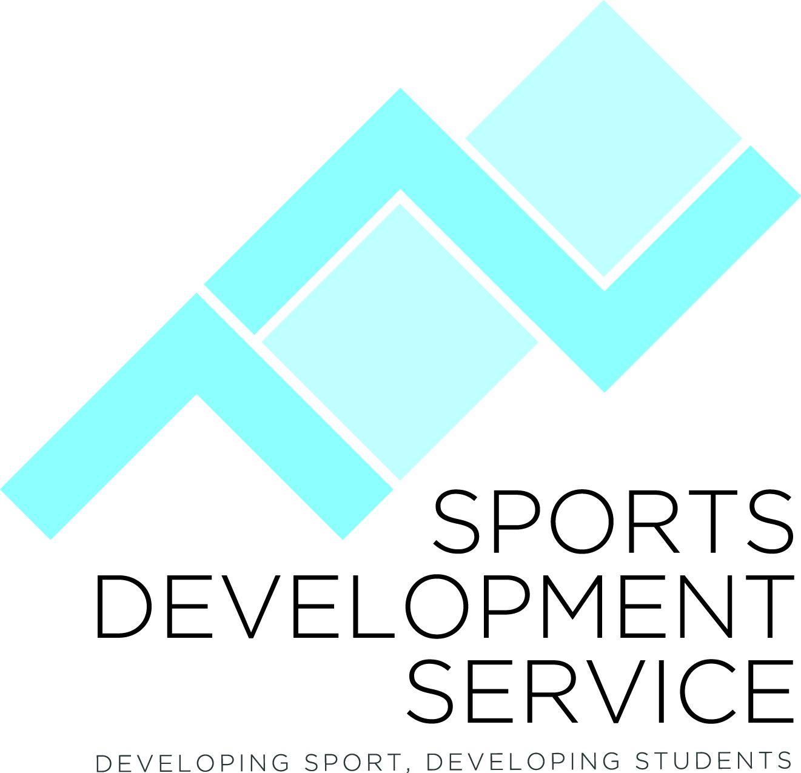
SPORT

Area | Action | Responsibility
Intervarsity  Name | Name of the Intervarsity Competition.
Date & Time | Date of the Intervarsity.
DCU Facilities | DCU Sports Facilities Required for the event. Please contact Yvonne Hennessy, DCU Sport, e: yvonne.hennessy@dcu.ie to book and complete a  Sports Facilities - Activity / Event Booking Form and receive a copy of the Sports Facilities - Bookings & Events Code of Conduct.
External Facilities | Name, address and phone number of External DCU Sports Facilities Required for the event.
Public Liability Insurance | If you are using an external venue you must provide a copy of DCU’s Public Liability Insurance for the external venue. See the Senior Sports Development Officer for details.
Equipment | Match balls, Flags, Mats etc
Organising Committee | To comprise Chair, Secretary and Treasurer, Sports Development Officer plus a number of other club members.  Tasks to be allocated to members of OC e.g. entertainment, presentation dinner, communication etc.  Reference www.studentsport.ie for entire organisational issues and useful information.
Number of Teams | Estimate of the number of sports team/individuals that will be competing. Use previous year’s numbers as an estimate.
Budget | Budget plan to be drawn up and submitted to CLC for approval. Suggested Budget income and expenditure:  Expenditure:  Officials  Refreshments/Meals  First aid/Medical  Posters & Printing  Medals & Trophy’s  Equipment – balls, flagpoles etc  Crew T-shirts  Income :  Participation Fees per team/individual  Sponsorship  NGB Funding  CLC Funding  Sports Development Service funding
Potential Sponsors | €: Confirmed:  Sponsorship In Kind: Confirmed:  Energy bars  Water or soft drinks - Red Bull, Coca Cola  Sports Equipment
Insurance | See the Senior Sports Development Officer for details of Public Liability Insurance, Personal accident Insurance & NGB Insurance.
First Aid  & ATT | First aid cover required on site for the duration of the event. Get a quote from Medicore, Contact details: www.medicore.ie, Tel: (0)1 6854466  Also contact DCU Athletic Therapy & Training students. See Noel McCaffrey, Head of Course,  E; noel.mccaffrey@dcu.ie, T; 01-700-7387.
Accommodation | Source ‘packages’ from local hotels based on approximate number of participants – Skylon, Regency, Crowne Plaza. Holiday Inn  Communicate accommodation options to colleges
Communication | Communication with participating colleges is of utmost importance.  Establish email database for all participating clubs/universities  Information updates to be sent to clubs and Club website/facebook to be used as key point of information  Set up a player welcome area/registration at the Sports Grounds and all clubs to be given a player welcome pack  Fixtures to be displayed on blackboard in the Sports Grounds
Eligibility | It is essential that participants’ eligibility is checked before the start of the tournament.  Entry forms to be ‘stamped’ by university and participants must bring their student cards.
Estates Office | Contact Michael Woods to inform him that the event is happening and the presence of any promotional activities.
Community Guard | If applicable contact Martin Lynch, Community Guard to inform him that the event is happening
Food & Refreshments | Details of food and refreshments to be provided for all participants. Include details of venue, costs and meal tickets or vouchers
Crew T-Shirts | Quantity of Crew T-shirts required for event crew. Where to purchase t-shirts, printing costs etc
Publicity | - Launch to be organised approximately 10 days before the event to include a photo on campus  - Arrange for a member of MPS to film footage of the event,  - Arrange College View sports Journalists and Photographer, e-mail sports@collegeview.com  - Article in Campus Magazine, e-mail campus@dcusu.ie  - Photosoc to take photos  - Create a pre & post event article for media and websites  - Use Facebook - your club page , DCU Student Sport  - Inform Public Affairs at monthly meeting  - Mail all DCU Students  - Send pdf of poster to Yvonne McGowan, Senior Sports Development Officer
Results | To be communicated to Yvonne McGowan, Senior Sports Development Officer, the CLC and Student Sport Ireland.
Next Years Event | To be agreed before the end of the tournament in DCU and communicated to Student Sport Ireland and the governing bodies.

For further assistance or queries regarding hosting an Intervarsity event contact:

Yvonne McGowan, Senior Sports Development Officer,
Sports Development Service, Henry Grattan Building
Dublin City University, Dublin 9
Tel: (01) 700 5811 Email: yvonne.mcgowan@dcu.ie Web: www.dcu.ie/sportsdevelopment

