Sports Representation Form
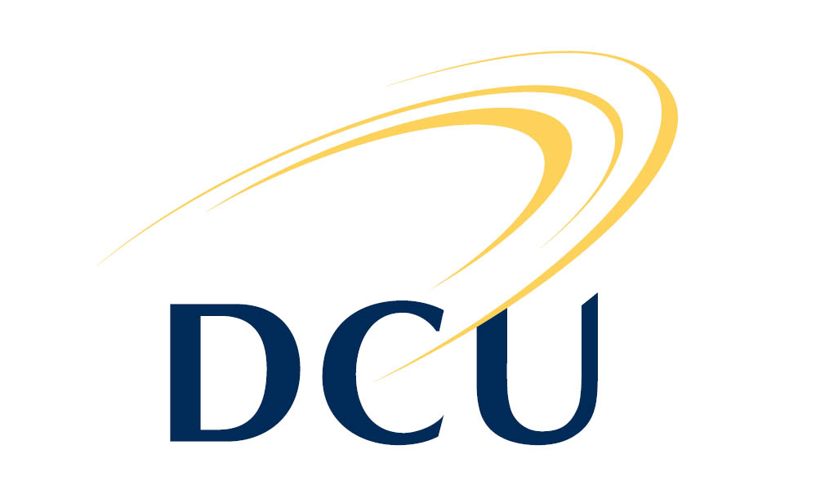
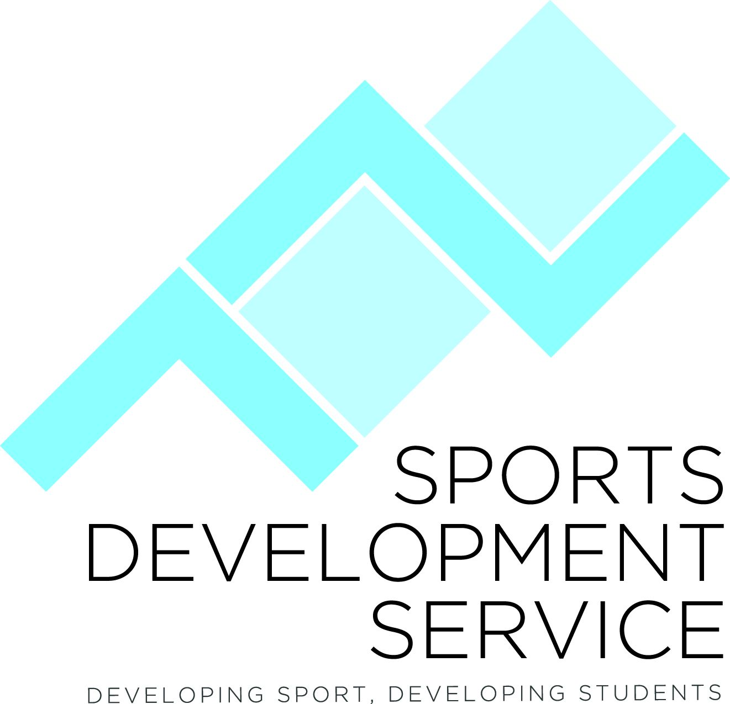

Personal Details

This letter is intended to verify that a student has/will represent DCU in a match or intervarsity event. This is for information purposes only and recognises that it is the students’ responsibility to ensure that they fulfil the requirements of their course.

Student’s Details
Student Name: | Student Id Number:
Course : | Year of Study:

Sports Event
Sport: | Event:
Dates & Time: | Venue:

Sports Representation (to be completed by the Student)
I (name) ___________________________ state that the above information is an accurate account of my DCU sporting representation:

Signed: ____________________________________________ Date: ________________________

To be completed by the Sports Development Service
Stamp | Signed:  Print Name:
Guidelines:
Stamp

————————————————
Signed:

Yvonne McGowan
Sport Development Officer
e-mail: yvonne.mcgowan@dcu.ie
tel: 01 700 5811
Stamp

————————————————
Signed:

Yvonne McGowan
Sport Development Officer
e-mail: yvonne.mcgowan@dcu.ie
tel: 01 700 5811
Stamp

————————————————
Signed:

Yvonne McGowan
Sport Development Officer
e-mail: yvonne.mcgowan@dcu.ie
tel: 01 700 5811
- This form should be completed by the student and signed by the DCU Sports Development Service as verification of a student’s sports representation at a match or intervarsity event.
- This form is not intended to defend students in the event of poor academic performance.
- This form may not be used in the event of missing a class exam.
- It is the student’s responsibility to submit the completed form to the appropriate academic staff.
- There is no obligation on a lecturer to accept this form.
- This form should be submitted to the Sports Development Service at least 48 hours before required.
Queries regarding the use of this form should be directed to the:
Sports Development Service, Henry Grattan Building,
Dublin City University, Dublin 9.
Tel: (01) 700 6041/5811 Email: sportsdevelopment@dcu.ie Web: www.dcu.ie/sportsdevelopment

