A Plain Language Statement (PLS) for children should use language and pictures that reflects the participant age group and corresponding comprehension level. It should contain the following information. The headings are there for guidance and do not need to be included in your form.

 | Pupils say they enjoy Paired Reading. It sometimes helps pupils become better readers and enjoy their reading more.
I am looking for pupils to take part in a Paired Reading programme.

Would you like to take part in a Paired Reading programme where you work with an adult while reading?
 | Here is some information about how the programme will work.
 | Your parent will read with you at home. Paired Reading will begin in January after our Christmas Holidays.
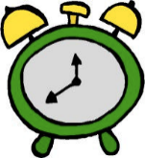 | The programme will take place for about fifteen minutes three times a week. It will last for about six weeks.
 | You and your parent will fill in some forms each time you do PR. In these forms you tell me how the reading session went and you write down any new words that you read.
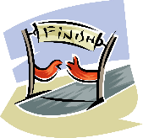 | I would need to collect some information before the Paired Reading programme starts and again after it finishes. This is to help me see if the programme has helped you to improve your reading.
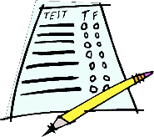 | I would ask you to complete three reading tests. During the first test you read words out from a list. During the second test you read out around twenty sentences while I time you. The third test will be very like the second test. You would do these tests before and after the Paired Reading programme.
 | I would also ask you to answer some questions on in a group about your reading and what you thought about the Paired Reading programme. You will be in a group with two other students who are also doing the programme. This is called a focus group and you will do one before, during and after the programme.
 | I will talk to your parent to see if he/she thought the programme helped you or didn’t help you.
 | If you do not feel comfortable taking part in the Paired Reading programme, we will stop immediately. You won’t have to take part in this programme after that.
 | I will write about the programme in my project but I will never use your name.
 | I will keep all of the information in a locked drawer, which no one else can open.
 | I will keep the information for two years in case I write other essays about the projects. After this I will safely delete the information.
If you and/or your parent(s)/guardian(s) have any questions about this project, please contact the researcher:
Name:
Work Address:
Tel:
Email:

Or

If you and/or your parent(s)/guardian(s) have concerns about this project and wish to contact an independent person, please contact:
The Secretary, Dublin City University Research Ethics Committee, c/o Research and Innovation Support, Dublin City University, Dublin 9. Tel 01-7008000, e-mail rec@dcu.ie

