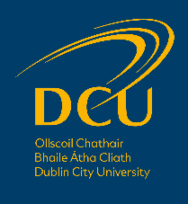
School of History and Geography
Doctoral Research Scholarship Application Form

In advance of submitting this application, applicants must discuss the research proposal with a member of academic staff in the School.
All sections of this form must be completed and emailed to carol.davis@dcu.ie
before 5pm on Wednesday 31 March 2021.

Section 1: Applicant Details
First (Given) name: | Surname (Family name):

Email address:

Section 2: Educational Record
Award | Year | Awarding Body | Classification/GPA

Other Education
Include any additional relevant information, e.g. details of courses attended, training, that are relevant to this application:

Section 3: Employment Record
Please provide details of any relevant work experience, academic, voluntary, paid:

Section 4: Research Proposal
Research Proposal Title:

Abstract (c.1-200 words):

Outline of Research Proposal
Please provide details of your proposed research. Your statement should address (a) aims, objectives and central research questions of the project; (b) how existing literature on the topic has been used to inform the proposal; (c) how the project will make a contribution to existing knowledge; (d) methodology, sources and other relevant information (c.2,000 words)

Proposed Supervisor

Section 5: Personal Statement
Why do you wish to pursue postgraduate research studies?

Section 6: Referees
Please provide the name and contact details of two referees at least one of which must be in relation to your academic studies:

Name & Position Held | Address | Email

Section 7: Scholarship Award Conditions
All scholarship awards are on the condition that you meet DCU entry requirements, that your qualifications are supported by relevant documentation and that you complete an application via the DCU application system.

Section 8: Data Protection Notice
Personal information that you submit in relation to this Scholarship Application will be treated in accordance with the DCU Data Protection policy.

