Accessing your personalised Timetable through Publish

This instruction applies to the following programmes only
BECE, PMEP, BED, SPDE and BEDCI4

Go to link https://mytimetable.dcu.ie/

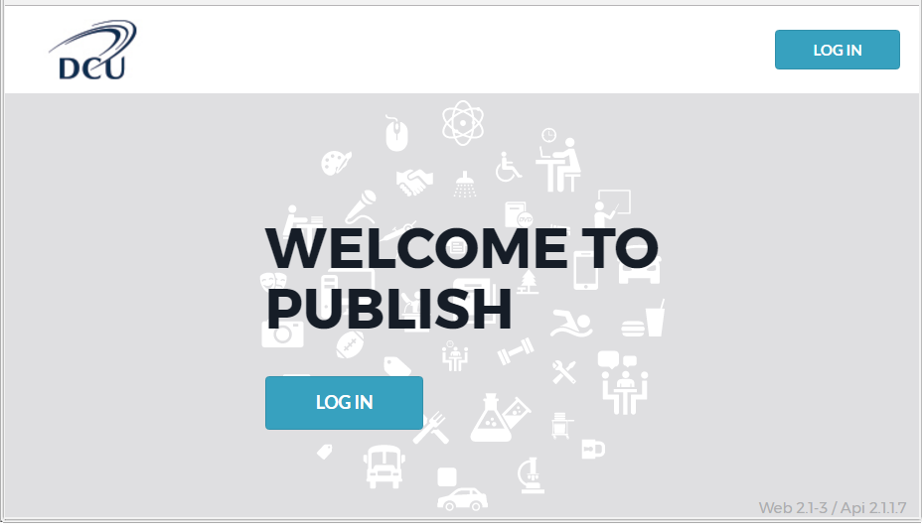

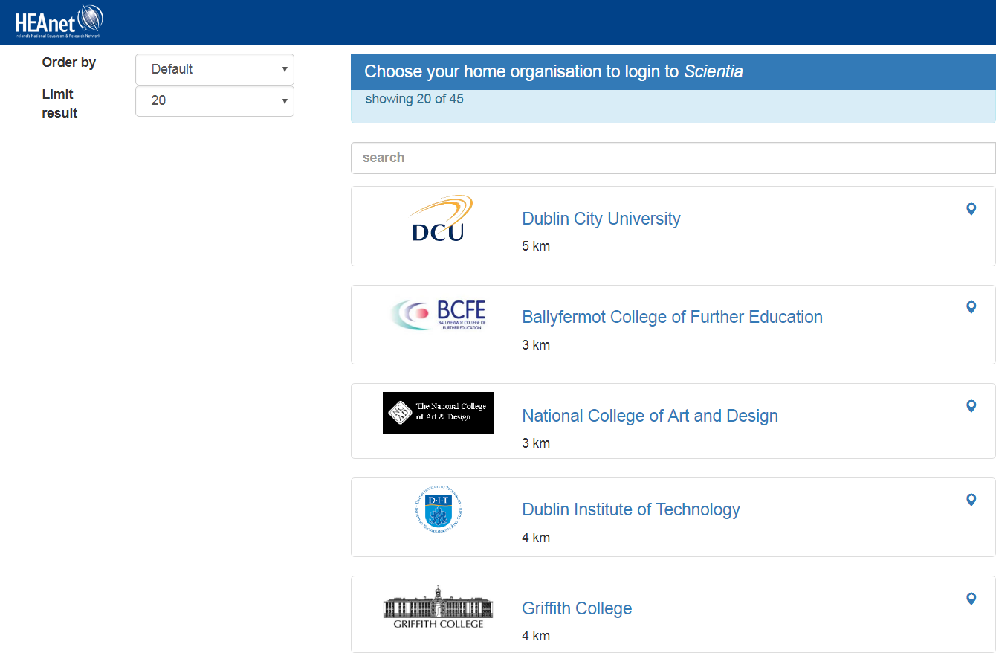

Select Dublin City University
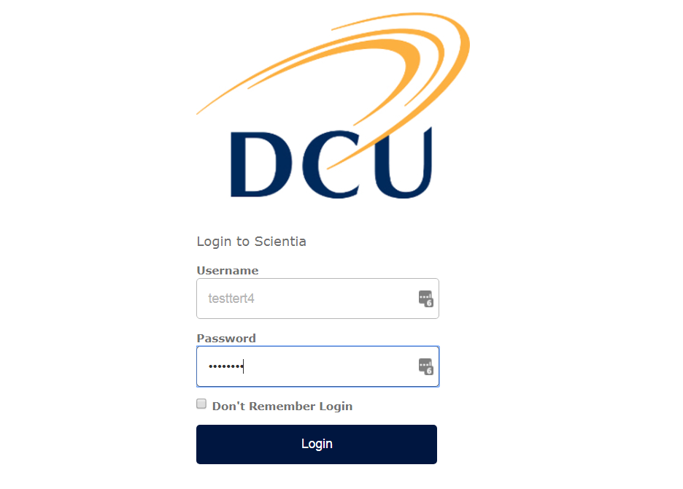

Log in with your DCU username and Password (AD credentials)
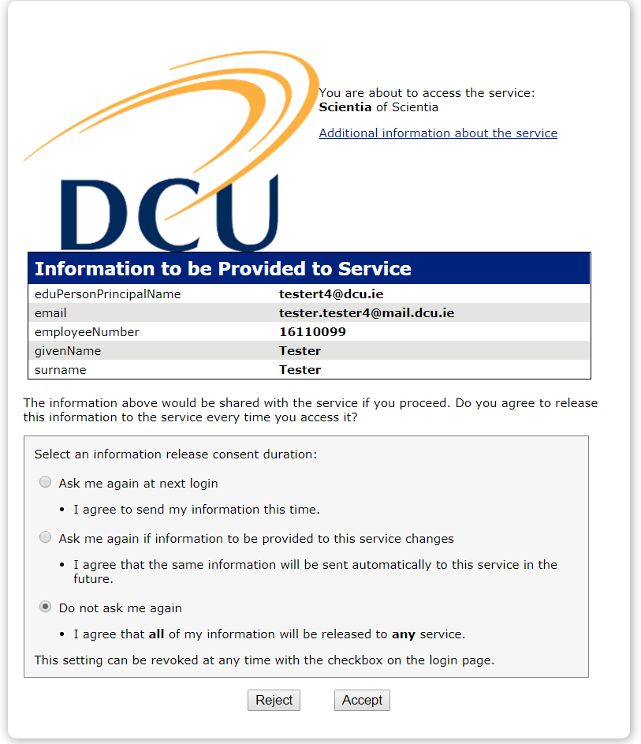

You can select any of the three options. Click Accept to proceed.

Your personalised timetable will be prepopulated into a calendar format.
You can select by Month, Week or Day

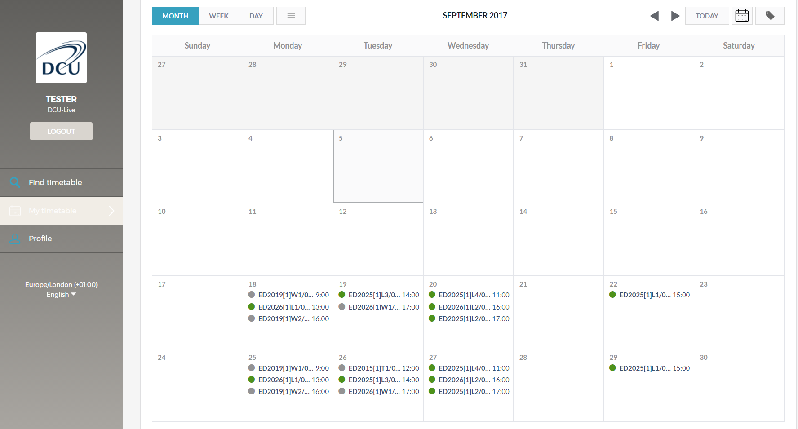
Click into any activity for more information

Activity name Locaton (Room number of activity)
Date and time of activity
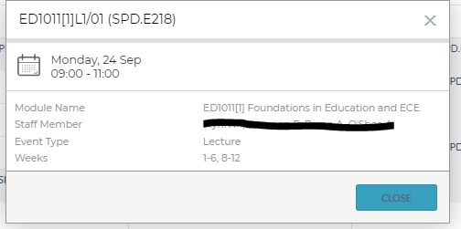

How to Receive Notification When Your Timetable Changes

Publish can be enabled to send you an email when an even has changed or cancelled. This functionality is disabled by default and must be enabled by you if you wish to receive notifications.

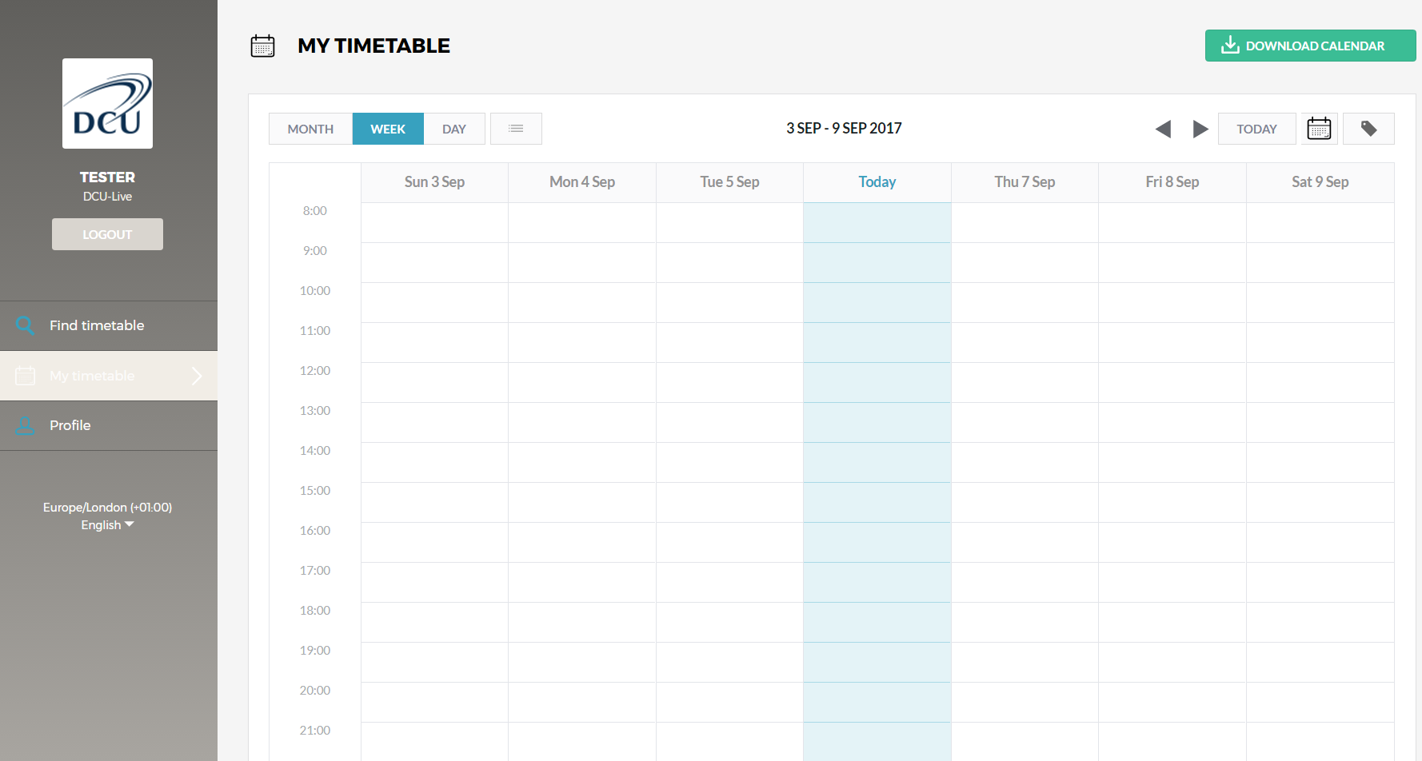
Click Profile
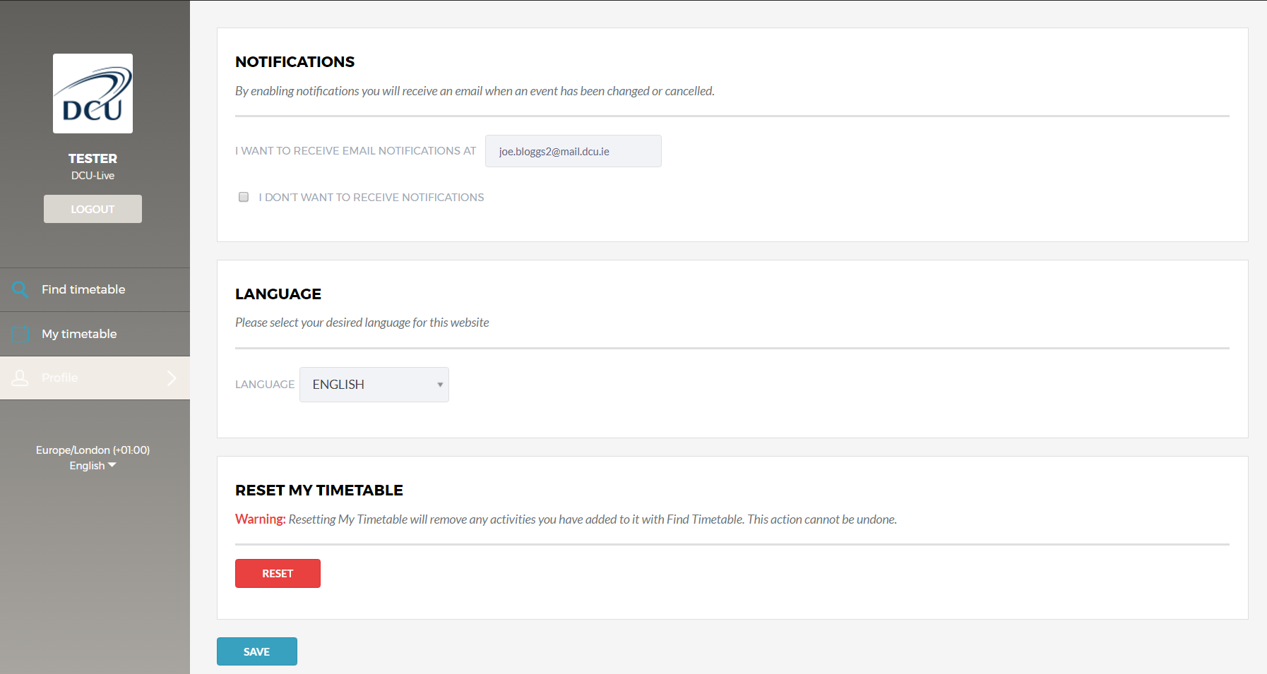

1.  Untick ‘I DON’T WANT  TO RECEIVE NOTIFICATIONS’. | 2.  Enter your preferred email address | 3.  Click Save

Each time an event is changed or cancelled and email notification will be sent to your nominated email address.

End

