Launch of Praying Together

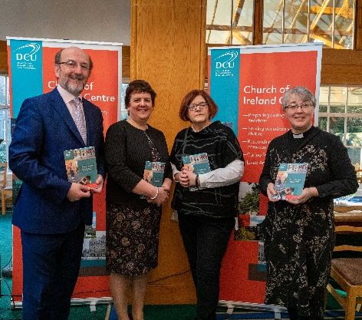
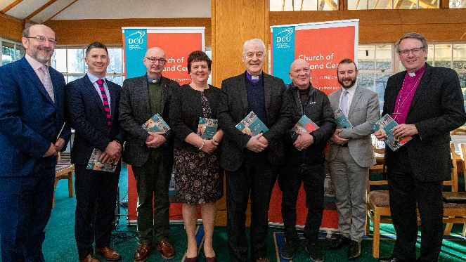
Pupils, teachers and people connected with Church of Ireland primary schools contributed to a new book of prayers which can be used in school assemblies. ‘Praying Together: Prayers for Primary School Assemblies’ was launched on Thursday February 6 by the President of Dublin City University, Prof Brian MacCraith.. The book contains a wide variety of prayers penned by children and adults connected with Church of Ireland primary schools all over Ireland. The book is the result of a project which began in Spring 2019 when the editor Jacqui Wilkinson had an idea for a new resource and project in which the network of Church of Ireland schools could get involved. She contacted all Church of Ireland primary schools last year inviting teachers and pupils to write new prayers for use in school assemblies and received a great response. Initially it was planned to produce an online collection of the prayers. Then, thanks to the generosity of DCU, it became possible to create a book containing many of the prayers received from schools.. The prayers cover many of the events in the school and church year The collection includes prayers which may only be used occasionally, for example when a teacher retires or there is a school inspection. Others may become regular features of assemblies marking the seasonal events of the school year such as sports day or 6th class graduations. There are also prayers when an urgent response is required, for example, in times of sickness or sadness, or if there is a national or local tragedy.”
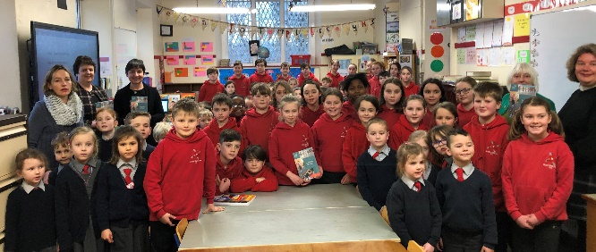
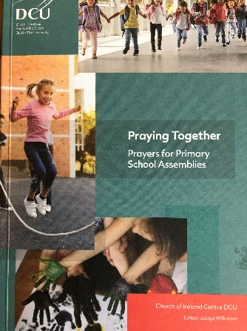
At the launch Prof Brian MacCraith and Prof Anne Looney, Executive Dean of the DCU Institute of Education, spoke of the importance of listening to the student voice. They acknowledged the work done by Jacqui Wilkinson to include the voices of children in the collection and commended the broad relevance and appeal the collection will have beyond its initial target audience of Church of Ireland primary schools. Archbishop Michael paid tribute to both the editor and DCU. “This book of prayers comes directly from the Church of Ireland context with the children’s voices from their schools. It is the first publication by Dublin City University of a volume from one of its denominational centres, in this case the Church of Ireland Centre,” he said. In her speech Jacqui Wilkinson thanked all the schools that participated in the project, and welcomed some teachers from schools to the launch.
The following day, the book was presented to Templebreedy National School in Crosshaven at their daily assembly. Pupils from the school read their school prayers which feature in the book.

