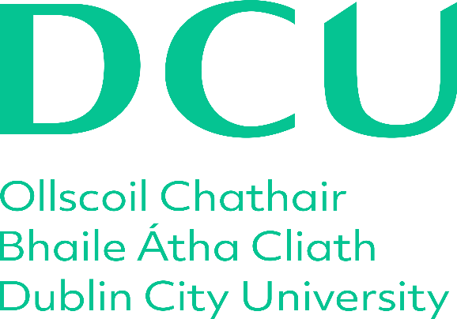

**School of Theology, Philosophy, and Music**

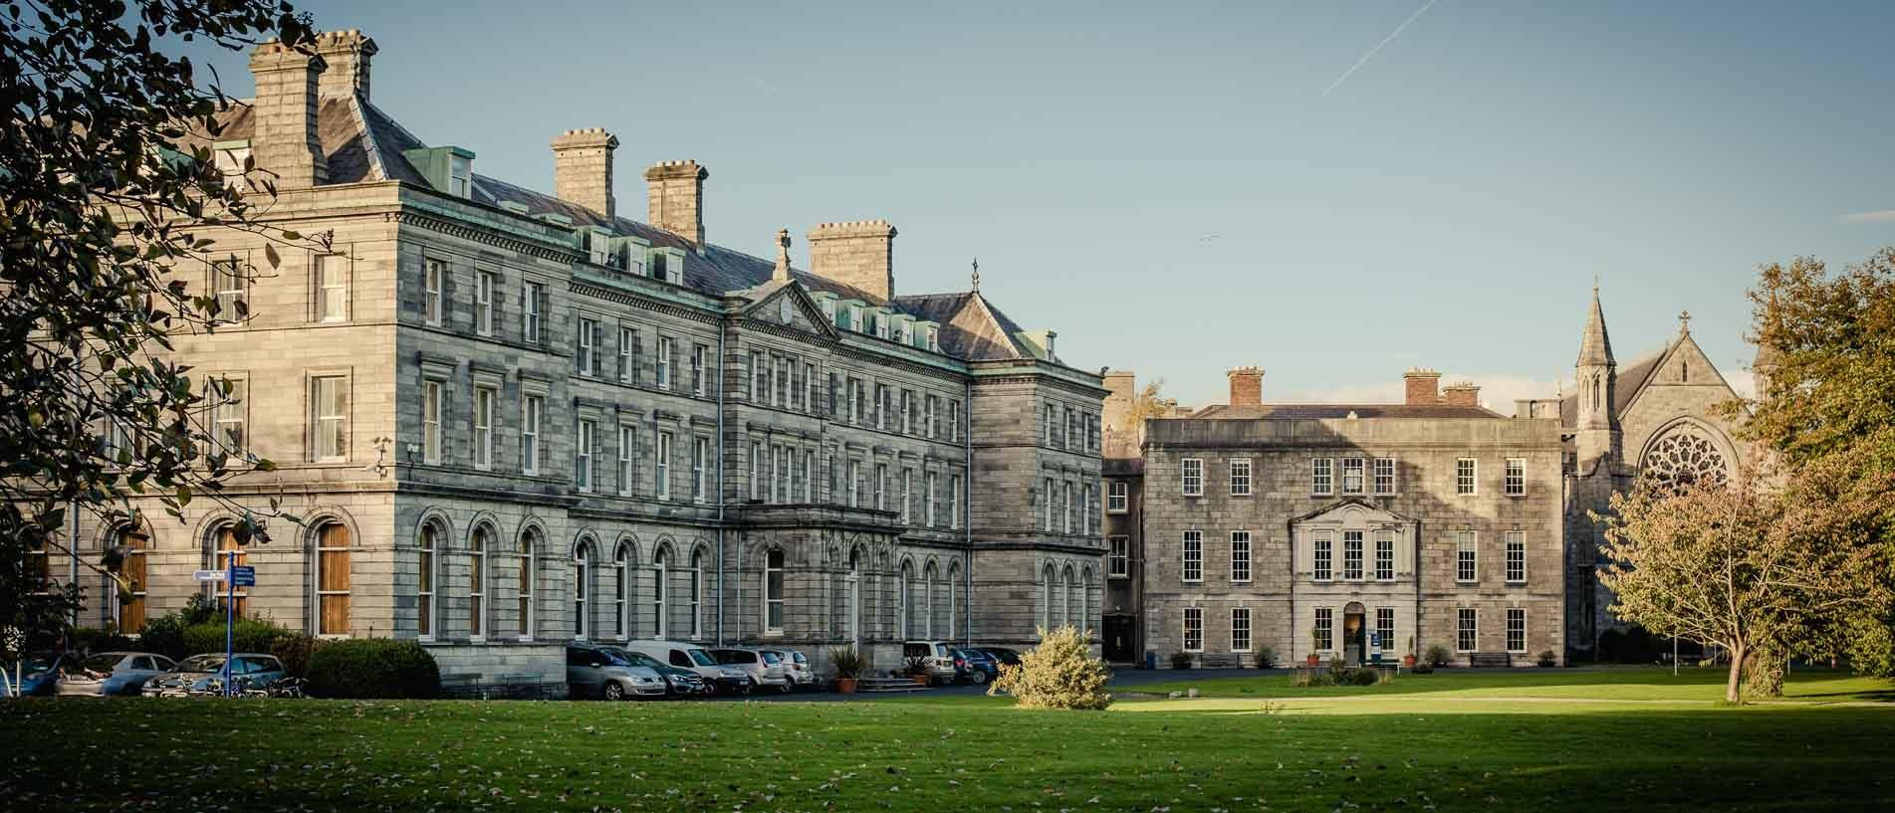

**PhD Handbook (2023-2024)**

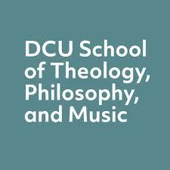

**Contents**

**Welcome**

**About the School**

**Contacting Staff and List of Staff**

**Maps**

**The Structure of the Programme**

**Your Supervisory Panel**

**Funding and Professional Development**

**Academic Progression**

**Key Contacts**

**Welcome**

Welcome to the PhD programme of the School of Theology, Philosophy, and Music at Dublin City University. We are a dynamic and creative school with a strong commitment to social and cultural engagement. You are joining a rich research environment across a diverse range of areas and projects that includes permanent staff, postdoctoral researchers, and PhD colleagues. During your time in DCU, you will have the opportunity to engage with and contribute to the scholarly activity of the School as you develop your own research skills and in-depth knowledge. We are delighted to welcome you to our PhD programme and we hope that you will find an inspiring and supportive environment here.

The programme offered to PhD students is designed to provide you with an academically rigorous yet practical grounding for your research career ahead. It aims to provide you with skills that will make the process of doctoral research smoother and more productive and equip you with the experiences and capacities that will serve you well in your future work.

This handbook provides an introduction and guide to the academic structures of the university and the processes you will go through during your doctoral studies. It is a first step in becoming familiar with the university and is designed to help you find out where to look for the information you need to settle in and progress through DCU. Most of this information is available on the [DCU website](https://www.dcu.ie/humanities-and-social-sciences/doctoral-studies-hub) and we have included links throughout.

We hope you enjoy the programme and find it both stimulating and rewarding. An important aspect of your PhD journey is engaging with your PhD colleagues, so don’t forget to enjoy life in Dublin together as you share both the peak moments and challenges over the coming years.

Dr Patricia Flynn

Head of School

Dr Peter Admirand

Deputy Head of School

Dr Joseph Rivera

School Research Convenor

**About the School**

The School of Theology, Philosophy, and Music is one of seven Schools in the Faculty of Humanities and Social Sciences. Based on the All Hallows Campus, the School promotes a diverse, interdisciplinary range of teaching, research, and scholarship. It also includes the [Institute of Ethics](https://www.dcu.ie/ethics/index.shtml), the [Centre for Interreligious Dialogue](https://www.dcu.ie/cird) (CIRD), the [Centre for Jazz Performance Studies](https://www.dcu.ie/jazz), and the [Centre for Religion, Human Values, and International Relations](https://www.dcu.ie/religionandhumanvalues). We also have a community of over 20 PhD students working on campus, many funded by European projects, the Irish Research Council, and our annual School scholarships.

Staff in the School are recognised internationally for their expertise and are both partners and leaders in many high level international research and creative projects. The School hosts a number of postdoctoral researchers including Marie Sklodowska Curie researchers and Government of Ireland postdoctoral researchers. Our MA programmes include the MA in Music, MA in Theology and World Religions, MA in Choral Studies, and MA in Ethics (with an additional pathway in Ethics and Corporate Responsibility). Our undergraduate programmes and subject areas draw in a diverse range of students of all ages and backgrounds. They include the BA in Theology and Religious Studies, BA in Jazz and Contemporary Music Performance, and the BA Joint Honours, where Theology, Philosophy, or Music can be studied with another subject area. The School also provides core and essential teaching for other degrees, especially the Bachelor of Religious Education (offered through the DCU Institute of Education).

Student engagement and the interchange of ideas are important to the School and you will find a vibrant series of events throughout the year to which you are invited to participate. **Weekly Lunch-time Concerts** feature student groups and invited performers. Our **Research Seminar** **Series**, both in Theology & Philosophy as well as in Music, feature staff research as well as visiting scholars. Our research centres programme events throughout the year and a Chamber Music Festival is held annually in November. Faculty members in the School are outstanding researchers with a range of expertise including creative and practice-based research. You’ll find their research profiles on the [School website](https://www.dcu.ie/theology_philosophy_music/index.shtml).

The postgraduate rooms on the All Hallows Campus provide a collegial and scholarly working environment. The newly built Jesuit Library is an inviting and welcome addition to the All Hallows Campus, while The Cregan Library, on the adjoining DCU St Patrick’s Campus, is a short walk away. All of the [libraries](https://www.dcu.ie/library/index.shtml), including the O’ Reilly Library on the Glasnevin Campus, have staff with a range of subject expertise who will be happy to help source the publications you need and provide training programmes in a range of bibliographic areas.

**Contacting Staff**

While much of your contact will be with your School, or the Faculty, you may also from time to time wish to be in contact with the University Graduate Studies Office or University Registry. All email contact with you will be through your DCU email so it is important to check this regularly.

**School and Faculty Contacts**

School [Staff contact details](https://www.dcu.ie/theology_philosophy_music/people/index.shtml) are available on the School’s web page.

The main office of the School of Theology, Philosophy and Music is located in Room AHC S216 on the second floor Senior House. Mary Hayes, the School Assistant, can be reached at 7006100 or by email [mary.hayes@dcu.ie](mailto:mary.hayes@dcu.ie).  She is happy to answer your question or direct you to the right place for many queries relating to practical matters such as desk allocation, telephone, postage, or internet access.

The first point of contact on most academic matters will usually be your supervisor; however, if the query is of an administrative nature and related directly to the programme processes, other useful contacts are the school research convenor, Dr [Joseph Rivera](mailto:%20joseph.rivera@dcu.ie), or at faculty level, [Carol Diamond](mailto:carol.diamond@dcu.ie), who is the senior administrator in the Faculty of Humanities and Social Science, depending on the nature of the query.

You may also find the Faculty of Humanities and Social Sciences Doctoral Research Hub useful.

**Offices of the University**

The [Graduate Studies Office](https://www.dcu.ie/graduatestudies/index.shtml) (GSO) is located on the Glasnevin Campus on the ground floor of the McNulty Building. It is led by the Dean of Graduate Studies, Prof Joseph Stokes, and supports the development and delivery of the University’s research and taught postgraduate degree programmes, providing a broad range of support services for its graduate student community, across all five faculties of the University. You will meet the GSO staff at orientation and they will be in contact by email to provide information about their programme of courses for research student development and events such as the annual *Tell It Straight* competition, which is a good way to engage with research students from other faculties of the university. You can contact the GSO team at [graduatestudiesoffice@dcu.ie](mailto:graduatestudiesoffice@dcu.ie). You may also be in contact with GSO If you have a research stipend from a scholarship or other award. They publish a very helpful [Research Student Guide](https://www.dcu.ie/sites/default/files/graduate_research/pdfs/dcu-gradres-2020-21.pdf) annually.

Progression through the various stages of your PhD are approved by the Graduate Studies Research Board (GRSB) and administered by the University Registry Office. All registry queries should be sent to [postgraduate.research@dcu.ie](mailto:postgraduate.research@dcu.ie) or phone 700 8489. In your first year, you will visit Registry to collect your student card, and in your final year, you will submit your completed thesis to the registry office. You’ll find it on the Glasnevin Campus in the Henry Grattan Building. This [link](https://www.dcu.ie/info/campus.shtml) will bring you to maps of all DCU campuses as well as cycling, walking and bus routes. On the following page you’ll find a map of the All Hallows Campus and location of the three DCU libraries.

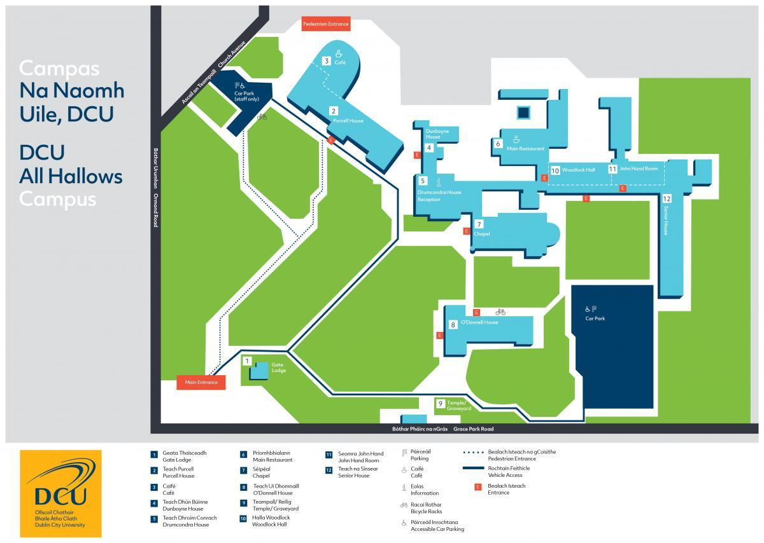

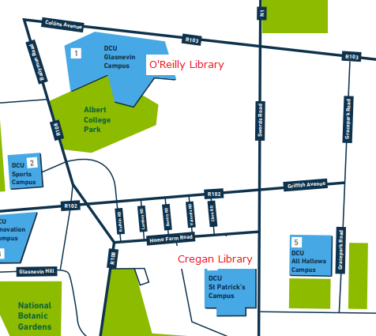

Woodlock Hall Library

Church Lane

**Structure and Aims of the Programme**

There are two aspects to our PhD programme:

1. A major piece of research that has the potential to make a significant and original contribution to knowledge conducted under the supervision of academic staff in the School of Theology, Philosophy and Music.
2. A structured training element that supports and advances the candidate’s research agenda. This might be through
   1. enhancing their core theoretical knowledge
   2. providing methodological skills relevant to their disciplinary area
   3. building capacities and a track record of research and academic experiences relevant for a range of future career pathways

This taught element to the PhD programme compliments and supports your research. They are designed to enable you to better carry out your research but they are not part of your final exam. It is important to note that the doctoral examination continues to be based solely on the examination of a written thesis and its defence at a viva-voce examination. Graduate Training Elements (GTEs) provide students with structured opportunities to develop the skills and understanding to support their original research and are credit-bearing but do not contribute to the final examination.

All research students in the Faculty **are required** to take the self-directed online module on integrity in research. While School GTE pathways are offered, not all students are required to take them. Because of the individual nature of research projects, students can create their own GTE pathway to meet their research training needs. Funded students on a structured 4- year programme are often required by their funders to complete graduate training elements of their choice. GTE modules are also an opportunity to engage with other research students and staff across schools and sometimes faculties. Candidates and supervisors will work together to decide which are the most appropriate modules to take. (see ‘Modules and Credits’ section below). By providing core skills modules, our programme seeks to combine the rigour and professionalism of the largely taught US approach with the independence and imagination of the traditional European supervisory model.

**Modules and Credits**

Students may take up to 30 credits in GTEs and are advised not to take on too many in one year. A typical load would be one GTE per semester of 5 credits in years 1-3. The modules below are available to students in our school during the academic year 23/23. Students should also consider taking non-credit bearing courses provided by the GSO or external summer schools.

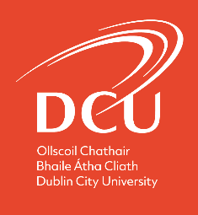 **Structured Doctoral Pathway 2023-24**

**School of Theology, Philosophy & Music**

**Overview**

This Graduate Training pathway is for students undertaking a structured 4-year PhD programme in the School of Theology, Philosophy, and Music. Structured doctoral programmes aim to develop the advanced knowledge, skills and competencies required for successful original research, and supports the acquisition of deep discipline knowledge and research skills as well as more generic transferable skills that are relevant to a range of career pathways.

**Selection and Registration**

The doctoral examination continues to be based solely on the examination of a written thesis and its defence at a viva voce examination. Graduate Training Elements (GTEs) provide students with structured opportunities to develop the skills and understanding to support their original research and are credit-bearing but do not contribute to the final examination. GTE modules available to students are credit-bearing but there are a number of non-accredited training opportunities. Students who complete credit-bearing modules will receive a separate transcript of their modules.

The pathway overleaf provides a mix of modules that includes discipline specific knowledge, generic skills and wider offerings that support students’ developing autonomy in research. Modules selected by students should be relevant to and support their research. Students should discuss their needs with their principal supervisor who must approve the selected modules prior to registration. The School recognises that individual students’ needs may vary as they are undertaking individual and original research. Students may follow the pathway overleaf or use this as a template to structure an individual pathway, to include:

• Up to 20 credits of core discipline-specific modules;

• 10 credits of core generic and transferable skills;

• Up to 20 additional credits for selected elective modules.

Students will normally take 10 credits each year for years 1-3, with year 4 most likely focused exclusively on research, but discretion about the number of annual credits is permitted to suit the work programme of each student and to include valuable non-credit modules. Students may include non-credit bearing courses in their pathway that, in discussion with their principal supervisor, are deemed appropriate to their needs. Along with level 9 modules, appropriate level 8 modules may be taken by students following discussion with their Supervisor and module coordinator. Students should register for their approved GTEs during the online registration process.

**Mandatory Modules**

It is the policy of the Humanities & Social Science Faculty that all students take the relevant stream of the self-directed ‘Online Research Integrity Training Module’ during their first year of registration. This is available online. All students who are assigned teaching-related responsibilities must complete module Postgraduate Tutoring Principles and Practice (GS602).

**Progression**

GTE modules taken should be noted in the student’s annual progress report (PGR2), which should also include confirmation that mandatory courses have been taken.

**Induction and Training**

Research students are also encouraged to take advantage of additional training opportunities offered by the Graduate Studies Office as appropriate throughout their period of study. In year one, at the time of initial registration, new students are expected to attend orientation sessions, the GSO- & library-run programmes and other relevant induction sessions.

**Structured Doctoral Pathway 2023-24**

**Core Discipline Specific Modules**

**Elective Modules**

**Core Transferable Skills Modules**

**Year 1 - 3**

* Engaged Research (**CM602)**

(10 ECTS)

* Qualitative Research Methods Summer School (**NS5055**)

(5 ECTS)

* Language Modules: Biblical Hebrew **(TP211) or** Kloine Greek **(TP222)** (5 ECTS)
* Uaneen Non-Contributing Module (**UM405**) (5 ECTS)

**Year 1 - 2**

* Postgraduate Tutoring Principles & Practice (**GS602**) (5 ECTS)
* Strategies for Academic Writing (**GS608BS**) (5 ECTS)

**Year 2 - 3**

* Advanced Academic Writing in the Humanities (**TP600**) (5 ECTS)
* Research Ethics (**TP602**) (5 ECTS)
* Navigating the Academic Publishing Landscape (LC604) (5 ECTS)

**Year 1 - 3**

**Theology and Philosophy**

* **TP517:** Readings in Ethics (10 ECTS)
* **TP518:** Ethics in World Religions (10 ECTS)
* **TP521**: History of Biblical Interpretation (10 ECTS)
* **TP522**:Islamic Thought in the 19/20th Centuries (10 ECTS)
* **TP523**: Themes in Modern Theology (10 ECTS)
* **TP524**: Philosophy and God: Readings (10 ECTS)
* **TP 525**: Rahner and 20th-Century Theology (10 ECTS)
* **TP528**: Natural Law Theory
* **TP532**: Religion, Human Values, and International Relations (10 ECTS)
* **TP 534**: Jewish and Christian Dialogue (10 ECTS)
* **TP 538**: Gender and Religion in Late Antiquity (10 ECTS)
* **TP 603**: Philosophical Texts: A Reading Group (10 ECTS)

**Music**

* **MC514**: Conducting, Interpretation and Style (10ECTS)
* **MC519**: Composition for Voices (10ECTS)
* **MC516**: Creative Approaches to Text (10ECTS)

**Non-accredited Training, Workshops and Masterclasses**

**Year 1 - 2**

* Graduate Studies Office Orientation Programme
* Online Research Integrity Training Module (non-accredited, compulsory )

**Year 1 - 3**

* External: Summer school as advised by Supervisor
* Cross-School or cross-Faculty GTE relevant to research topic and selected from Faculty Lists

**Year 2 - 3**

* Music Research Seminars (non-accredited)
* Theology, Religious Studies, and Philosophy Research Seminars ((non-accredited)

Students are encouraged to: engage with centrally-offered workshops and seminars through GSO and Library. Attend and participate in conferences in their discipline and participate in research communication events such as Tell It Straight organised by GSO and Postgraduate Association events.

**Your Supervisory Panel**

All PhD Students in DCU are supervised by a panel of at least two members: your principal supervisor and an independent panel member. You may also have additional panel members such as a joint principal supervisor or secondary supervisor, and in exceptional cases, some panels will include external specialist expertise. You will usually meet with individual members of your panel, but at least once a year there will be a full panel meeting to assess overall progress and provide advice prior to recommending progression into the following year of your programme. Following the annual review, your supervisory panel will all sign the PGR2 annual progression form.

**Role of the Supervisor(s)**

Supervisors have both a reactive and a proactive role. On the one hand, supervisors will be accessible to the candidate for academic support and advice across the entire duration of the research project. On the other hand, supervisors have an active duty to be informed about the progress of the research student’s work, to give constructive opinions about this work (whether or not these are asked for), to make sure that the student is aware of the quantity and quality of work required, and to negotiate and monitor a timetable for its submission. Furthermore, while the PhD is your own, candidates should not substantially change their research projects without discussion with, and approval from, their supervisor.

Candidates and supervisors should develop an agreed programme of work at the outset and agree on how regularly they will meet throughout the academic year. For most PhD candidates in this School, monthly meetings are the norm, but this may fluctuate depending on the circumstances of the student and supervisors at any given time.

Supervisors will do everything they can to provide careful analysis and constructive criticism of all work submitted to them within an agreed period of time, and to make themselves available, when feasible, for discussions with candidates. Supervisors also have an administrative duty to submit the necessary forms to allow their student to progress and submit the PhD.

**Role of the Independent Panel Member**

The Independent Panel Member (IPM) is not involved in direct supervision of the research candidate or their project. The IPM’s role primarily involves meeting with the student (and where necessary with the other supervisory panel members) to discuss progress; participating in the formal annual review process (PGR2); providing the candidate with advice, additional supports and pastoral care where needed, and directing the student to the relevant DCU supports where appropriate; aiding resolution, at a local level where possible, in cases of difficulties such as a lack of progression or a breakdown in the student-supervisory relationship. In this School, IPMs are drawn from across the school so that there is a wide awareness of the work of our postgraduate researchers. IPMs may thus be from a different disciplinary area than the student.

**The Student’s Responsibilities**

The research candidate must keep in contact with his or her supervisor(s) and inform them about the progress of the research. He or she should meet the supervisors for discussions, submit written work, and perform other academic exercises (for example, attending and contributing to the Research Seminars) according to a timetable negotiated with the supervisor(s).

Candidates are encouraged to engage with other staff members beyond their supervisor(s) to draw on additional support and expertise, but should be reminded that staff have many other commitments. Therefore, candidates should be patient and reasonable in their expectations from other staff.

Candidates should inform their supervisor(s) as early as possible regarding any issue that might affect their ability to complete an agreed programme of work on schedule. The essential point to remember is that the School is on the side of its postgraduate students in relation to almost any problem that might arise, and will do everything possible to help, given good notice and the information necessary to do so.

**Academic Integrity**

Students should familiarise themselves with the university’s rules on academic integrity and plagiarism (see <https://www.dcu.ie/info/regulations/plagiarism.shtml>). All research students in their first year of registration must also complete the relevant stream of the self-directed [‘Research Integrity Online Training Module’.](https://www.dcu.ie/graduatestudies/research-integrity) Plagiarism is academic theft and is one of the most serious offences in academia. Candidates found to have plagiarised may be required to withdraw from the PhD programme. Also consult the DCU handbook, [*Code of Good Research Practice*](https://www.dcu.ie/sites/default/files/research_support/Code%20of%20Good%20Research%20Practice_revised%20May%202015.pdf). and the [Code of Practice on Authorship](https://www.dcu.ie/policies/code-practice-authorship).

**Research Ethics**

Any candidate conducting research on human subjects is required to obtain approval from the Faculty of HSS Research Ethics Committee (F-REC). Ethical approval must be obtained before the start of the data collection/analysis. Information on the application process for ethical approval and the guidance on the application process to F-REC can be found [here](https://www.dcu.ie/researchsupport/research-ethics). All higher-risk research projects must be reviewed by the University-level REC.

**Writing Style and Conventions**

Writing a PhD is different from anything you are likely to have written before. It requires that almost everything you write is backed up by evidence or a citation, so it is important that you learn how to cite properly. It also requires that your language is clear and unambiguous. You also need to be completely consistent in any of the writing conventions you adopt. There are textbooks available that offer advice and suggestions for writing a doctoral thesis; for example, Desmond Thomas, *The PhD Writing Handbook* or Patrick Dunleavy, *Authoring a PhD.* You may also wanttoconsult previously successful PhD theses in your discipline and field.

**Advanced Academic Writing for the Humanities (TP600)**

For candidates in Humanities who wish to further develop their writing ability, or who wish to learn more about the conventions of academic writing, the Faculty of Humanities and Social Sciences offer a specific GTE module. The TP600 module engages postgraduate research students in approaches to advanced academic writing in the Humanities. It includes critical structural analysis of existing texts, interpretative writing, descriptive writing in the context of texts, music, visuals, film etc. Mirroring a peer-review system, it takes into consideration audience, argument, and voice in academic writing and examines the role and function of academic writing conventions.

**Funding and Professional Development Opportunities**

Doing a PhD is expensive. In recent years, the School has offered competitive-based scholarships to select PhD students. There are also external funding schemes, notably the Irish Research Council (IRC), which you should aim to secure. Students who are in receipt of a scholarship from the School are required to apply for an IRC doctoral scholarship in by year 2, and if necessary, year 3 (note: you can only apply twice).

Postgraduate members of scholarly associations can often apply for research grants, typically to attend conferences, and monthly newsletters often contain notices about other funding opportunities. All PhD students should join a scholarly association and engage with its programmes which may include postgraduate seminars, academic mentorship, networking, and other opportunities.

DCU provides one-time funding for each PhD student of €500 for travel and related costs to present their research at an international conference. The scheme is administered through the Graduate Studies Office and full details can be found at this [link](https://www.dcu.ie/graduatestudies/scholarships-opportunities.shtml#ScholarshipsGrants).

The Faculty also provides a postgraduate research publication fund. This scheme is to provide funding support to facilitate journal publication by research students (in their 3rd or later year) in the Faculty of Humanities and Social Sciences, DCU. Funding support is available for research leading to publication in a SCOPUS-ranked journal. The article can be sole-authored by the student or co-authored with a member of DCU staff, most typically, but not exclusively, a student’s supervisor. Items supported could include fieldwork, archive/research travel, conference dissemination, or data generation. It is likely the value of any single award will be in the region of €1,000. Students will receive email notification from the faculty office of how to apply.

At whatever stage of their career, academics should always aim to prioritise continuing professional development. This can include the acquisition of new research skills. It can also involve networking, contributing to conference organisation, tutoring on school programmes or modules, engaging with external organisations relevant to your research, and many other similar activities.

Presenting at conferences is also an essential part of your training and of doing a PhD. A good place to begin is at a postgraduate conference or session that offers you the opportunity to test your research among your peers and to receive feedback and critiques. Presenting your research at international scholarly conferences is a further helpful and necessary step in your doctoral path. Even if what you present is not ultimately used for your doctoral thesis, it may form the core of a future peer review article or a recorded and published performance piece. As a general rule, whatever you present at conferences should be worked towards eventual publication. Work with your supervisor during this process, as it is important that you present at conferences and then publish this work in a recognized peer-reviewed journal or book or through a professionally-recognised public performance.

The School organises two weekly research seminars, one in Theology and Philosophy and one in Music. Staff, postdoc researchers, and doctoral students come together to hear and discuss a research presentation by a visiting scholar, a member of staff, a postdoc, or doctoral student. Attendance at these seminars will form an important part of your training. Students will have an opportunity to present at these seminars during the later stages of their research and this is a wonderful opportunity to share your research in a supportive environment.

**Academic Progression**

A full list of the [academic regulations](https://www.dcu.ie/sites/default/files/registry/docs/dcu_postgraduate_academic_regulations_19_20_approved_by_academic_council_june_2019.pdf) is available from Registry. Be aware that these may change so always check the latest version on the Registry webpage.

The table below is taken from the Graduate Research Guidebook and shows the various pathways of academic progression in research degrees. Most students (both full and part-time) will register on the PhD Track in the first instance. After a period of research usually about 18-21 months, they undergo a transfer or confirmation viva. This process entails a written and oral part and includes an internal examiner who is not a member of the supervisory panel. Its purpose is to assess whether sufficient progress has been made, whether the research is weighty enough to make a significant and original contribution to knowledge, the strength of the research approach, and whether it is feasible, within the researchers’ skills and the time limits of the research programme.

The student and examiners complete a PGR3 form which is discussed and approved at the next Graduate Research Studies Board. Registry will notify the student of the outcome of this exam. This and other [PGR](https://www.dcu.ie/registry/application_forms.shtml#Examinations) forms can be found on Registry’s webpages.



**The Annual Review Process (PGR2)**

To progress from year to year of your PhD, you must gain a formal recommendation from your full supervisory panel. This annual review process (PGR2) happens in late spring/ early summer each year, and begins with a full panel meeting where the student summarises work completed in the current academic year and gains advice on their outline of the research work to be undertaken in the following period. The student then makes a report on the online PGR2 form. Subsequently, the supervisor(s) will write an evaluation of the progress made by the candidate, and issue a recommendation regarding continued registration which is approved by each member of the panel.

**Advice on your Transfer/Confirmation Viva**

While students on the PhD track must undergo a transfer viva, it is also recommended as a confirmation process for students admitted directly to the PhD register. This is carried out no earlier than 12 months and no later than 21 months after initial registration for full-time students and at an appropriate corresponding time for part-time students. In dialogue with your supervisor(s), you will have completed a substantial piece of research (often 1-2 full chapters) and a detailed summary and outline of your project, and as importantly, are deemed ready for the transfer exam. After an Internal Examiner is chosen and approved by the Head of School, the research materials and outlines will be sent to the Internal Examiner and a date advanced for the Transfer Exam.

During a typical PhD transfer exam, the student first presents an overview of his or her research, methodology, findings, and ultimate aims, and then the Internal Examiner asks a series of questions and critiques. **It is recommended that you see this exam** not only as a key milestone and gauge of your progress, but **as a rich opportunity for your research to be closely read and evaluated by another scholar in the School**, usually evaluating your work for the first time. Note that any staff member serving as an Internal Examiner for the Transfer Exam cannot serve as the Internal Examiner of your PhD *viva voce* exam.

In order to progress to the PhD registry, you must pass the viva transfer exam. If a student does not pass the viva transfer exam, the Examiner and Supervisor can recommend a second viva transfer exam (to occur within 6 months) or recommend the student transfer to the Master’s Register and complete such research as will allow him or her to graduate with a **Master’s** degree.

Upon completion of the oral exam, the student’s Supervisor(s), in dialogue with the Internal Examiner (and signed and approved by the Head of School), fills-out and submits the form, [*PGR3 Application for Transfer to/Confirmation on the PhD Register*](http://www.dcu.ie/registry/application_forms.shtml#research)*.* This form should then be sent to Registry at least two weeks in advance of the next Graduate Research Studies Board (GRSB) meeting.

**Intention to Submit Completed Thesis (PGR4)**

At least three months before you submit your completed thesis for examination, you must submit the PGR4 form, showing your intention to submit your completed thesis, with an abstract of your research. While it is normal to (informally) discuss potential examiners with your supervisor, it is ultimately your supervisor who will contact and propose your internal and external examiner. Both examiners must be approved by the Graduate Research Studies Board. Normally, the examiners have published substantial pieces of work in the last five years, have previously served as examiners, and have had successful PhD students of their own. The aim is to choose a recognised expert in your field(s) who can properly assess your research. It is in your best interests to have an examiner whose imprimatur (seal of approval) can signal your originality and expertise in the research area you want to inhabit and publish in. In this regard, it also makes sense to be familiar with your examiners’ scholarship and positions, especially as you prepare for the upcoming viva.

**Viva Voce (Doctoral Examination)**

With your thesis completed and your examiners approved by the Graduate Research Studies Board, you must submit two copies of your soft-bound thesis, together with one electronic PDF Copy (entitled with I.D. Number & date on memory key) and a [*PGR7 Thesis Access Consent*](http://www.dcu.ie/registry/application_forms.shtml#research) form.

Note: where there are two External Examiners appointed, three soft-bound thesis copies must be provided. Further details on the submission procedure should be reviewed in Section 9 of the [Academic Regulations for Postgraduate Degrees by Research & Thesis](http://www.dcu.ie/registry/regulations/postgraduate_regulations.shtml).

In preparation for the *viva voce*, your supervisor may arrange a mock viva with a member of staff or other expert not involved in the forthcoming exam. This can be a good opportunity to test your answers, rethink your presentation, or simply gain confidence for the real performance!

On the day of the chosen viva, you will likely be nervous but it is also the moment you have worked years to reach. It is again recommended that you also see this major milestone exam as an opportunity for your work to be closely evaluated by an internal and external examiner, a unique process in your academic career. Like your transfer exam, it will likely begin with your presenting an overview of your work and conclusions. Then expect a rigorous series of questions, dialogues, and critiques from your examiners.

Be clear, concise, and respectful in your answers and arguments. While you should defend your positions, you should also recognise and appreciate how insights and challenges from the

examiners can ultimately improve and strengthen your final piece of scholarship, such as a published monograph.

Upon completion of the viva, the examiners fill-out form PGR6, Examination Report for the Award of a Higher Degree, with an explanation of the recommended result, along with critiques and suggestions.

|  |  |  |
| --- | --- | --- |
| **Result Possibilities Include**: | | |
| **1** | Award recommended: no correction needed. |  |
| **2** | Award conditionally recommended: subject to inclusion of corrections and revisions |  |
| ***2.1*** *Please indicate if the corrections required are:* | |
| a. clearly specified textual emendations *and/or*  b. clearly specified revisions to content |  |
| ***2.2*** *Please indicate if corrections can be validated by:* | |
| a. the internal examiner only  b. the external examiner only  c. by both the internal and external examiners |  |
| **3** | Award **NOT** recommended but resubmission and full re-examination of a revised thesis to be permitted (normally within one year from the date when the student is informed of the recommendation). |  |
| **4** | Recommendation to permit candidate to withdraw thesis submitted for Master’s degree, for revision and resubmission at a later date for the higher award of PhD. |  |
| **5** | Where a doctoral award is sought, award of Master’s Degree is recommended subject to re-formatting as a master’s thesis and inclusion of corrections and revisions as specified in Section D. |  |
| ***5.1*** *Please indicate the recommended award title:*  **LLM, MA MBS MEng MEd MPhil MSc** | |
| **6** | No Degree is awarded as candidate is unlikely to reach the standard for a research award. |  |

If successful in your viva voce--Congratulations!--but remember it is more the start not the goal of your academic career! Now the real fun begins...

Frequently related questions in the various stages discussed above, can be found [here.](https://www.dcu.ie/registry/postgraduate/faq.shtml)

**KEY CONTACTS**

**Head of School: Dr Patricia Flynn** patricia.flynn@dcu.ie

**Deputy Head of School: Dr Peter Admirand**

peter.admirand@dcu.ie

**Research Convenor: Dr Joseph Rivera**

joseph.rivera@dcu.ie

**School Assistant: Mary Hayes**

mary.hayes@dcu.ie

**Administrative Officer, Faculty of Humanities and Social Sciences: Carol Diamond** carol.diamond@dcu.ie

**Humanities Librarian: Eilís O'Neill**

[eilis.oneill@dcu.ie](mailto:eilis.oneill@dcu.ie)

**Research and Scholarships Administrator *(GSO): Jonny Hobson***

*Jonny.hobson@dcu.ie*

***NB: This handbook makes every effort to be up to date, but PhD candidates should always check to ensure they have the accurate information from Registry and the Graduate Studies Office***