How to amend a Sales Order

HOW TO AMEND A SALES ORDER

Go to Customers and Sales/Sales Orders:
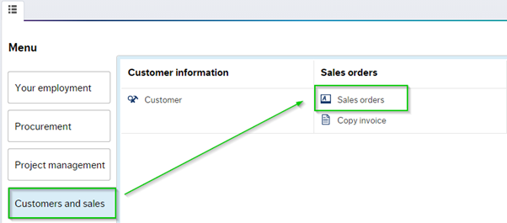

Click on the Sales order folder, the sales order template will open in a new window, click on the Open tab:
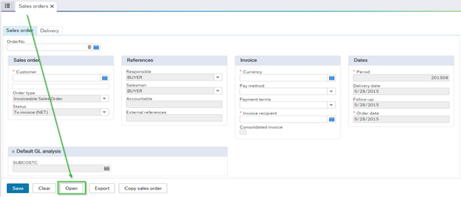

Type in sales order number, then hit search:
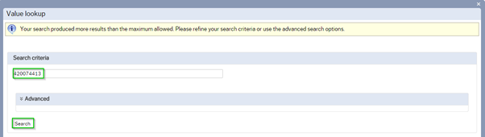

This will display the details of the relevant sales order:
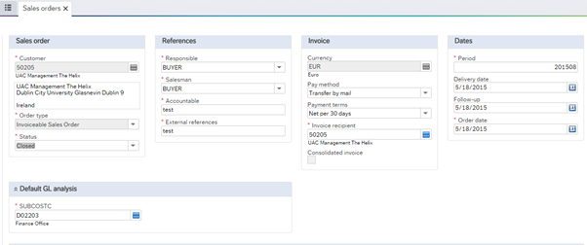

The VAT rate can be amend under GL Analysis section, as per screenshot below
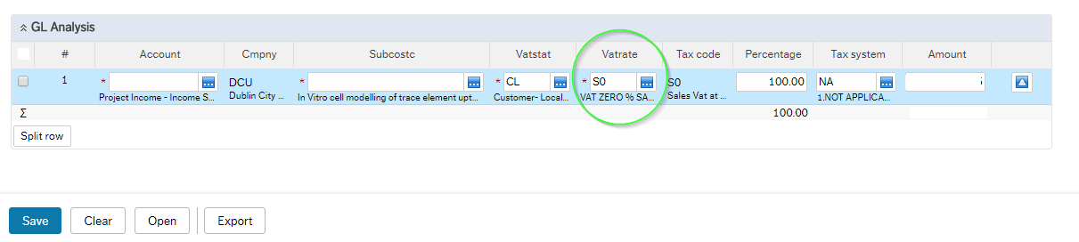

Make the necessary amendments and save the details. Please note you cannot amend a sales order if it has already converted to a sales invoice.
The status of the sales order will read 'Invoiced' if the sales invoice was created. As seen in screen shot below:
