How to enquire on a new Customer

Customer Set up Enquiry

To run an enquiry on the status of a New Customer go to, Reports /Global reports/ Customer Master/ Customer Master lookup:

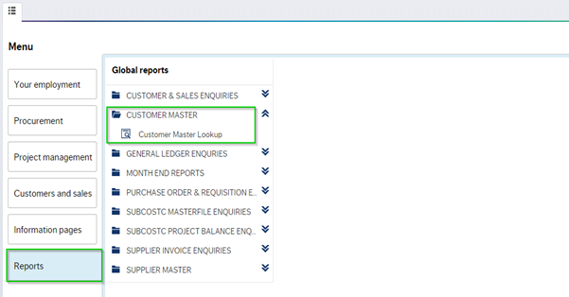

Click on ‘Customer Master lookup’ a new window will open:

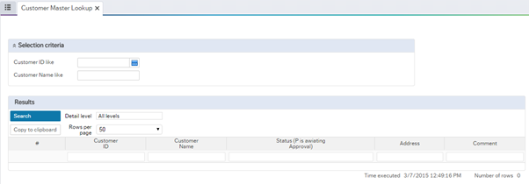

To check the status of a customer you have submitted, simply enter the ID number in the customer window and click search:

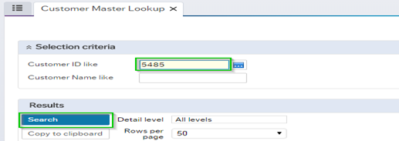

Details of the Customer will populate. If the Customer is active it will be at status ‘N’, Any customer awaiting approval will read “P” for parked:

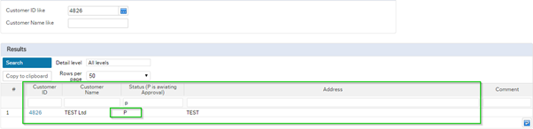

If the Customer is Closed details will read ‘C’ for closed, with a comment beside it e.g. ‘Duplicate’:
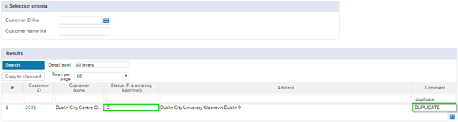

Related Articles
- How to enquire on a New Customer
- How to Enquire on the Status of a New Supplier Set Up
- How to set up a New Customer
- How to set up a New Customer
- How to to Enquire On The Workflow Of a Requisition
- How to View/Print a Sales Invoice
- How to Set up a New Supplier
- How to enter a Sales Order
- How to Check if Payment Was Processed/Paid to Payee via Non Invoice Expenditure Requisition (NIER)
- How to Validate Bank Details Before Submitting NIER

