HOW TO ENTER SALES ORDER

Go to Customers and Sales/Sales Orders:

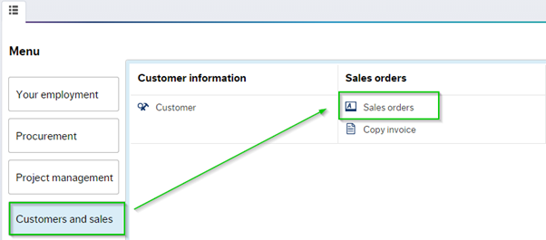
Click on the Sales orders folder, the sales order template will open in a new window:
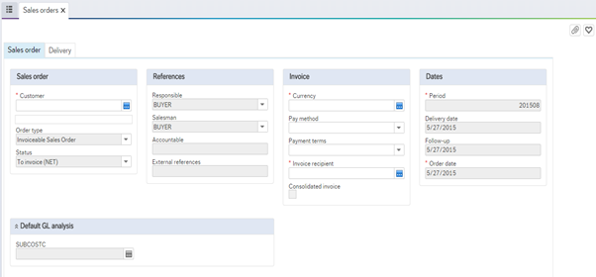
To enter a new Sales order, type in the relevant customer ID, e.g. 50205, the user can also use the type ahead function to search for a customer’s details e.g. ‘The Helix’:
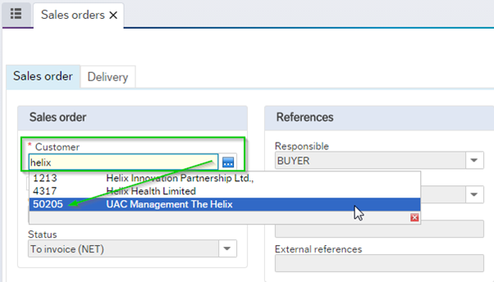
If the user does not know the full customer details, they can click on the standard search tool:
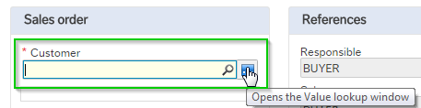
Type in a key word and click search:
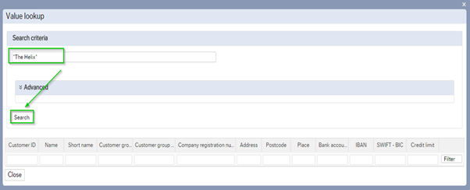
A list of results will populate, Click on the row with the customer name that you want to select, please ensure the address is correct:
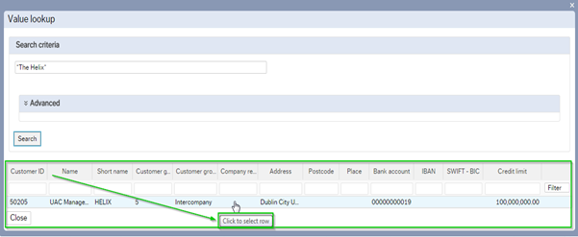
The following details must be entered to complete a sales order successfully; accountable person (this contact will appear on the address of the Sales invoice). Next enter the relevant details in the external references field, e.g. PO or contract reference number, please also enter these details into the external order ID field:
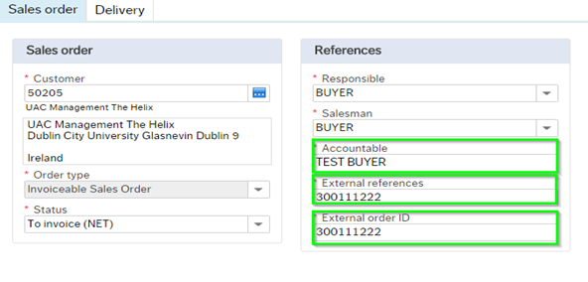
This information will appear on the Sales Invoice. Scroll down using your mouse then enter Project/Subcostc number:
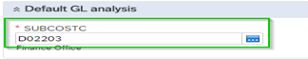
*All DCU Invoices must be raised to an income account, which range from 10000 to 17999, see list attached to these notes.
Please use the type ahead function to search for an income suspense code please use the most relevant code for your sales order, see below:
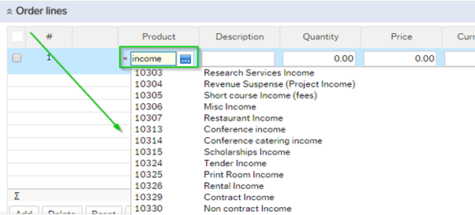
To enter a new line, click on the 'Add' icon, and select the appropriate product code:
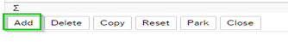
Type in the product code; quantity, price, the currency amount will default in. The User can type over the default text that populates, with more relevant information, if they so wish:
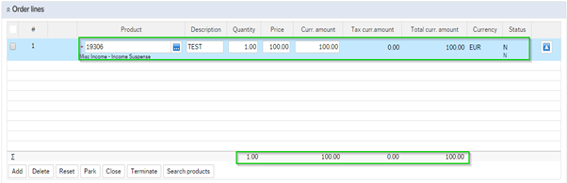
The Product description should have the project title, period, and a detailed text of the supply of goods or services. You can add in additional information by clicking on the tab available. It is very important that a detailed description is provided of the product or service:
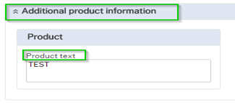

The User can change the VAT rate in the GL analysis section. Simply scroll down and click on the window, type in relevant rate:
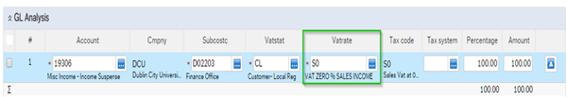

See a list of vat rate codes that should only be submitted for sales orders:
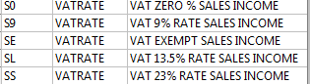
Please do not change any other detail in the GL analysis as the information will default from the vat rate. To add a line, click on the ‘add’ button, this is used if you require multiple lines on your sales order:
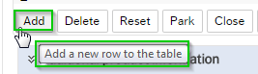
To delete a row, select the row by ticking the box on the left-hand side and click the ‘Delete’ button:
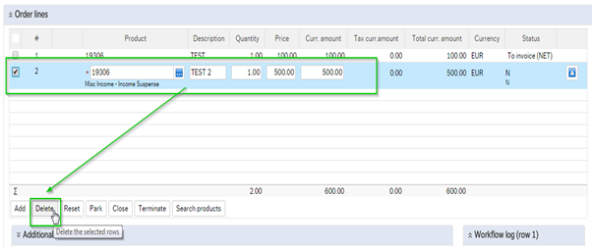
The User can review the invoice and delivery address under the customer Delivery details from the delivery tab, to insure they are correct:
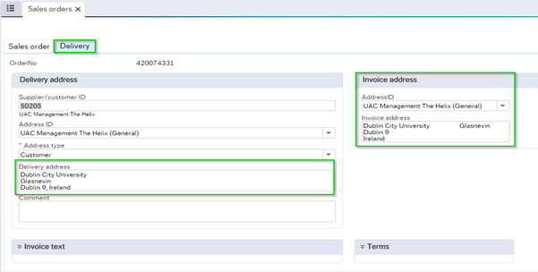
Click Save and a sales order number will generate, take note of the sales order number which will appear on the screen:

Sales Orders must include a purchase order from the customer or written confirmation attached from the customer confirming it is ok to invoice.

