How to run an enquiry on a sales order
Modified on: Mon, 31 Jul, 2017 at 3:30 PM

HOW TO RUN AN ENQUIRY ON A SALES ORDER

Go to Reports/Customer Sales Enquiries/Sales Order enquiry by date:
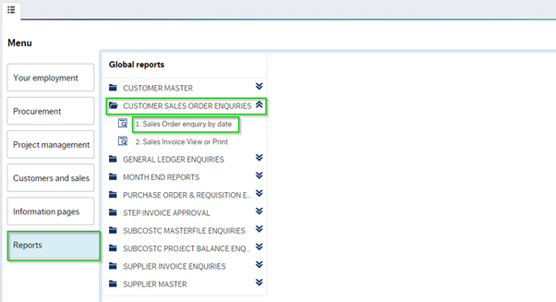
'Sales Order enquiry by date', this will enable the user to view all sales orders set up in their area.
Enter the period range, of the Order you would like to query:
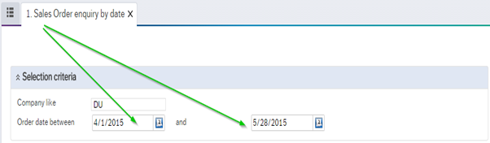
This report will give the user the following details:
- Who submitted Sales Order
- Sales Order no.
- Customer ID
- Sales Invoice no.
- Who created Sales Invoice
- Subcost
- Product
- Description
- Net amount
- Vat rate
- Vat amount
- Gross amount

If there are no details in the 'sales Invoice no.' column, this means no invoice has been generated:
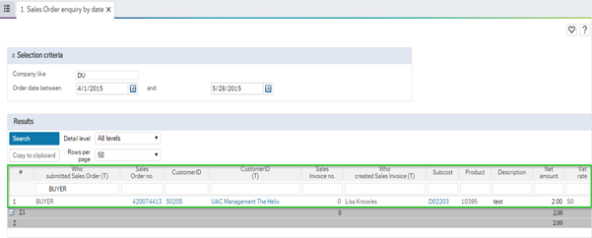

When a sales invoice is issued, the number will appear in the relevant column:
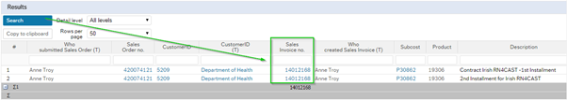

Click on the highlighted column to drill down on the transaction:

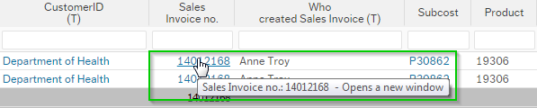

The following screen with transaction details will appear:
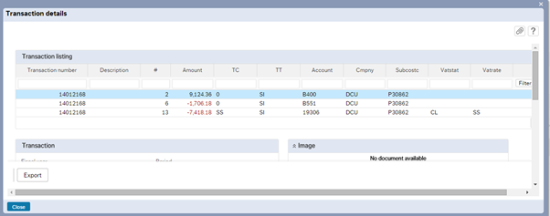

To view the invoice click on the paperclip icon button:
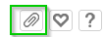

The User will be presented with a PDF invoice version:

Click twice on the Pdf to print or save the invoice:

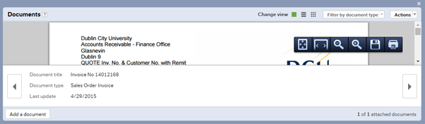

Invoices, statements and reminder letters are issued electronically to customers. All sales orders that are completed correctly are converted to a Sales invoice.

Statements are issued on the 4th of every month by Accounts Receivable

Reminder letters are issued on a weekly basis.

In relation to sales order/invoice enquiries please contact accounts.receivable@dcu.ie

