How to View/Print a Sales Invoice

HOW TO PRINT A SALES INVOICE

Go to Reports/Customer Sales Enquiries, select option 2 'Sales Invoice View or Print':
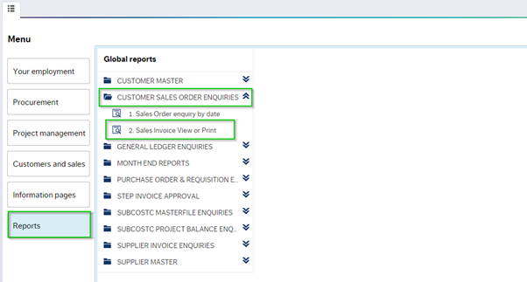
'Sales Invoice View or Print' will enable the user to view or print a sales invoice, and provide the user with the following details:
- OrderNo
- CustID
- InvoiceNo
- Account
- Period
- Pay date
- Cur
- Cur.amount
- Trans No
- COMPANY
- SUBCOSTC
- Text
- Amount
To View/Print a Sales Invoice, enter the Sales Order or Sales Invoice number you would like to enquire about, click search:
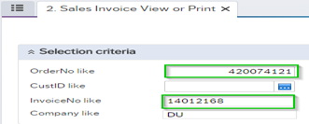

The result of your search will show, see below:
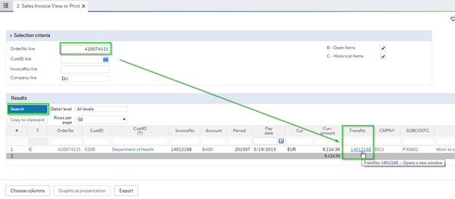
Click on the Transaction Number column to drill down on the transaction, the following screen with the transaction details will open:
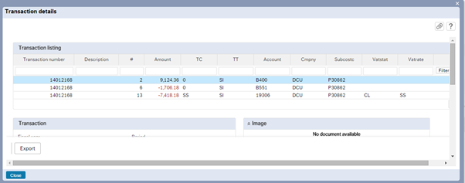

To View/Print, the invoice click on the paperclip icon button:

The User will be presented with a PDF invoice version:

Click twice on the Pdf to print or save the invoice:

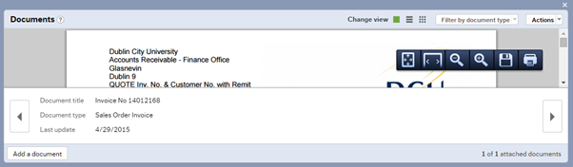

Invoices, statements, and reminder letters are issued electronically to customers. All sales orders that are completed correctly are converted to an invoice.
Statements are issued on the 4th of every month by Accounts Receivable. Reminder letters are issued on a weekly basis.

In relation to sales order/invoice enquiries please contact accounts.receivable@dcu.ie

