**Seminar: What can we learn from research to better support adult learners in higher education?**

9 June 2014

Dublin City University

A growing body of research is now investigating the experiences of different groups of adult learners (over 23 years of age) in Irish higher education.

The distinctive feature of this seminar is that it will bring together two different communities: (i) lecturing staff working with adult learners across a range of disciplines in universities, institutes of technology and colleges; and (ii) social science researchers who have undertaken research relevant to this highly diverse student population.

The Seminar will be introduced and chaired by Professor Maria Slowey, Director Higher Education Research Centre (HERC) Dublin City University

Keynote Speakers:

* Professor Miriam Zukas, Executive Dean of the School of Social Science, History and Philosophy, Birkbeck College University of London.
* Professor Mark Morgan, Cregan Professor of Education and Psychology, Emeritus, St Patrick’s College Drumcondra and Co-Ordinator Growing Up in Ireland, Trinity College Dublin.

Other Contributors will include:

* Professor Anne Ryan, Department of Adult and Community Education, National University of Ireland Maynooth.
* Ann Reilly, Chair Mature Student Society, Dublin City University.
* Dr Mark Glynn, Head of Teaching Enhancement Unit, Dublin City University

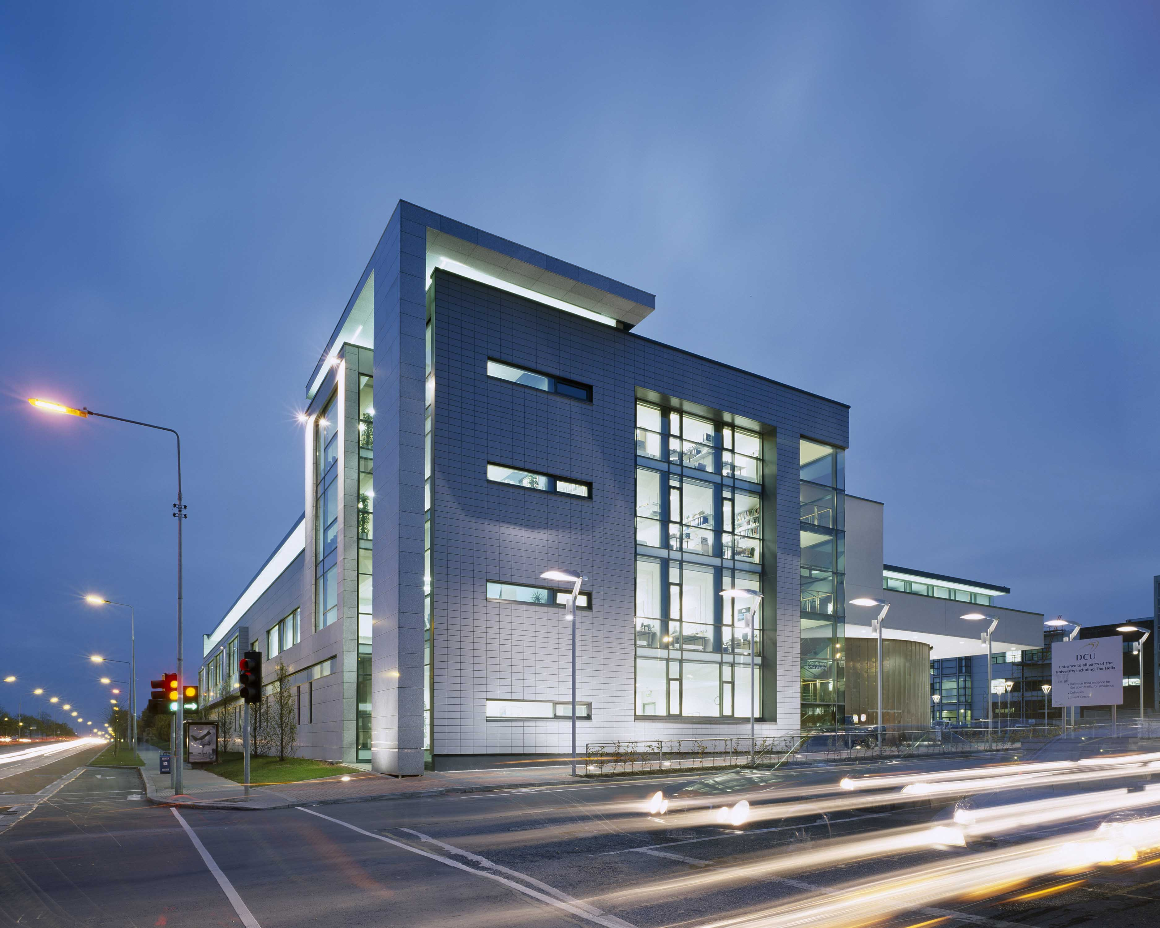





**Date**: 9 June 2014

**Time**: (Registration 09.45) 10.00-15.30

**Venue**: Room HG18, School of Nursing, DCU, Dublin 9.

**To facilitate in-depth discussion, places are limited. If you are interested in attending please register through the following link:** [**https://www4.dcu.ie/herc/teaching-and-learning.shtml**](https://www4.dcu.ie/herc/teaching-and-learning.shtml)