School of History and Geography  Doctoral Research Scholarship Application Form  In advance of submitting this application, applicants must discuss the research proposal with a member of academic staff in the School.  All sections of this form must be completed, and the form emailed to juliana.adelman@dcu.ie before 5pm on 24 April 2023. | 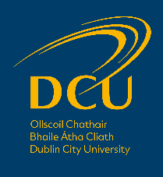

Section 1: Applicant Details
First (Given) name: | Surname (Family name):

Email address:

Highest academic degree achieved:

Section 2: Research Proposal
Research Proposal Title:

Abstract (max. 250 words):

Description of the proposed research (max. 1000 words):

Relation to the state of the art in the field (max. 500 words):

Methodology /approach (max. 500 words):

Proposed Supervisor:

Have you been in touch with the proposed supervisor prior to submitting this application?
Yes
No

Comment on why DCU and the proposed supervisor are the best fit for the proposed research (max. 250 words):

Section 3: Personal Statement

Why do you wish to pursue postgraduate research studies? (max. 250 words)

Section 4: Referees
Please provide the name and contact details of two referees at least one of which must be in relation to your academic studies:
Name & Position Held | Address | Email

Section 5: Scholarship Award Conditions
All scholarship awards are on the condition that you meet DCU entry requirements, that your qualifications are supported by relevant documentation and that you complete an application via the DCU application system.

Section 6: Data Protection Notice
Personal information that you submit in relation to this Scholarship Application will be treated in accordance with the DCU Data Protection policy.

