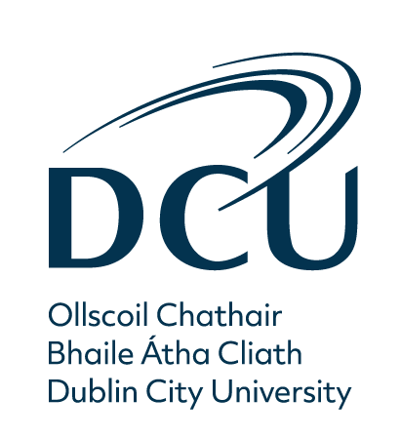

DCU Equality, Diversity and Inclusion

2021 - A Year in Review

Contents
1
DCU Equality, Diversity and Inclusion 1
2021 - A Year in Review 1
Celebrating, Equality, Diversity and Inclusion at DCU 3
Marian Burns, Director of HR, Dublin City University 3
Professor Daire Keogh, President, Dublin City University 4
Brid Horan, Chancellor, Dublin City University 4
Anne Sinnott, Deputy President and Vice-President for 4
Diversity and Equality, Dublin City University 4
Executive Summary 5
Background 5
Key activities and outcomes 6
DCU Equality, Diversity and Inclusion Committee 7
(Sub-committee of DCU Governing Authority) 7
Athena Swan 8
Having successfully retained our Athena Swan Bronze Award in 2020, DCU was formally presented with the Award in a national ceremony held in October 2021. 8
Women in Leadership 10
Vista Development Programme for Women 10
Aurora Leadership Development Programme 10
Preparing for Academic Advancement (PAA) Programme 10
Measuring Success 12
Women on Walls 12
Senior Academic Leadership Initiative 13
Honorary Conferrings 13
DCU Pride 2021 14
Pride Flags 14
Pronouns 14
Bród sa Fiontar agus Scoil na Gaeilge 14
LQBTQ+ Pride Lanyards 14
New EDI Training Opportunities 15
Anti-Racism Training 15
Transawareness Workshop 16
LGBTQ+ Allyship Sessions 16
Autism Awareness Workshops 17
DCU Consent Framework 18
DRCC Training 18
Consent Framework Staff Training 18
NUIG Sexual Consent Promotion Module 19
Action Plan 19
Speak Out Tool 19
International Days of Celebration 21
International Women’s Day (IWD) 2021: 8th March 21
IDAHOBIT: 17th May 21
Black History Month 22
International Men’s Day 22
International Week of Deaf People 22
DCU Ability Project 23
Adam’s Story 23
Aontas Award 2021 23
DCU Library: Equality Champions 24
Meet the HR EDI Team 25
Fiona Carvill 25
Lorna Greene 26
Joanne Mulligan 26
Contact Information 26

Celebrating, Equality, Diversity and Inclusion at DCU

Marian Burns, Director of HR, Dublin City University

I am proud to have steered another very successful year towards a more appropriate gender balance at DCU.

We are making steady progress towards our goal of 40% female representation at Full Professor grade, currently 35%, and we have already achieved 40% at Professor Grade. Gender balance has also been achieved across senior professional roles within the University.
While this progress is very encouraging, we remain steadfast in our
efforts to ensure that the lived experience of women at DCU is equal and respectful. In working towards an Athena Swan Silver application in 2024 we will continue to address disciplinary inconsistencies. While the importance of gender equality will never be diluted, 2021 provided us with the opportunity to extend the remit of the DCU Women in Leadership Steering Committee to cover the broader opportunities available to our University Community through a focus on Equality, Diversity and Inclusion (EDI).

The new EDI Steering Committee, chaired by Prof Anne Sinnott, Deputy President and Vice President for Diversity and Equality, will work to embed a culture of dignity and respect where every member of the University can fully contribute and thrive. This report provides a powerful overview of the range of initiatives across the community in this regard.

The Human Resources Equality, Diversity and Inclusion (HR EDI) team, now in its second year, are driving a broad and challenging agenda to raise awareness and build allyship. Thank you to all those who have engaged and supported the various workshops, training and networking opportunities. It is only with the involvement and commitment of every member of the University community that we can achieve meaningful change and impact.

Professor Daire Keogh, President, Dublin City University

Equality, Diversity and Inclusion are core values within DCU’s ‘People First’ ethos. They are critical to ensuring that DCU is a welcoming, safe community where everyone can develop and thrive. This is a continuing
process, and I welcome the breadth, ambition and dynamism of our University’s evolving EDI agenda, which is captured so well in this report. I am delighted to see the progress we have made and I commend everyone who has contributed to our work in this area.

Brid Horan, Chancellor, Dublin City University

I was delighted to be appointed DCU Chancellor in September 2021 and to work in support of DCU’s mission to Transform Lives and Societies. DCU is on a continuing journey towards genuine equality, diversity and inclusion within the entire University community and it is a great honour to
support this work. As Chancellor and Chair of DCU’s Governing Authority, I am committed to sustainable progress in all aspects of EDI, proud to see the range of initiatives and progress in areas such as Women in Leadership and conscious that we still have more to do! This report is an important celebration of all that was achieved in 2021 and I look forward to
supporting further progress over the coming years.

Anne Sinnott, Deputy President and Vice-President for

Diversity and Equality, Dublin City University

The hallmark of DCU has always been ambition and nowhere is this more important than on our EDI journey. I am proud to lead our efforts towards a truly inclusive culture and am determined that, with your help, we will build on the impressive progress that we have made in 2021. Thank you to everybody across DCU who has played a part in our EDI journey during 2021. Thanks also to Marian Burns, Director of HR and her team for their
dedication to the vision of an equal, diverse and inclusive staff community.

Executive Summary

Background

The DCU Women in Leadership initiative was launched in 2015 against the backdrop of notable gender imbalance across the Higher Education sector. 2021 saw the initiative enter its sixth year, a year of great achievement for women across DCU as they continued to rise to the challenge of COVID19 while still pursuing excellence as they worked to transform lives and societies.

The vision for the Women in Leadership initiative at DCU has always been for our University to explicitly value women as leaders and ensure that women at DCU are supported and encouraged to achieve their full potential. In 2021, that vision has expanded to include a wider perspective on equality and it is with great pride that we launch this first Equality, Diversity and Inclusion Report, encompassing areas including age, sexuality, gender, (dis)ability, and race. DCU’s dedication to Women in Leadership has not changed but rather has been strengthened by applying an intersectional lens to our approach to diversity and inclusion.

This report spotlights and celebrates many of the different ways that the values of equality, diversity and inclusion are present in the work of teams across DCU. It would not be possible to capture the full extent of DCU staff’s dedication to EDI, but we hope this snapshot serves to demonstrate the positive journey that DCU is on. As our University continues to go from strength to strength, we hope you will keep us informed of the important work that you do and share your stories from 2022 so we can celebrate these in the coming months.

Key activities and outcomes

While COVID19 continued to present a significant challenge during 2021, and prevented us from delivering in-person Women in Leadership Lectures and Listening Lunches, the HR EDI Unit facilitated many educational and awareness raising events for staff. We were honoured to welcome exceptional guest speakers in celebration of important events
such as International Women’s Day, International Day Against Homophobia, Transphobia and Biphobia (IDAHOBIT), Black History Month and International Men’s Day.

In May, DCU was very proud to celebrate the honorary conferring of two exceptional women leaders; Annette Kennedy, President of the International Council of Nurses, and Vivien Lusted, Health Programme Manager with the International Committee of the Red Cross who both heroically rose the challenge of COVID19 and worked tirelessly to help others. In September 2021, Bríd Horan was appointed DCU Chancellor. Bríd succeeds Dr Martin McAleese who served two terms as DCU Chancellor since 2011. Bríd has over 30 years’ experience in executive, non-executive, and voluntary roles in leading private and public sector organisations and a distinguished record of service and advocacy in NGOs and the arts.

DCU achieved its first departmental Athena Swan Bronze Award this year with the School of Communications successfully challenging for a departmental Bronze Award. The application process included a rigorous self- assessment, showcasing local commitment to gender equality with an ambitious gender action plan developed to address challenges and gaps at school level.

Lastly, as part of expanding the University’s approach to equality, we achieved a significant milestone early in 2021 when the new Equality, Diversity and Inclusion sub- committee of the Governing Authority was established. This committee will ensure that DCU continues to develop all areas of equality, diversity and inclusion and strengthen our intersectional agenda.

DCU Equality, Diversity and Inclusion Committee

(Sub-committee of DCU Governing Authority)

DCU’s new Equality, Diversity and Inclusion Committee, a subcommittee of the Governing Authority, was established in January 2021.

The role of the committee is to ensure an appropriate governance structure to provide clear, consistent leadership and accountability for equality, diversity and inclusion across DCU. The Committee oversees the development of the DCU strategic framework for equality, diversity and inclusion.

As set out in the Terms of Reference, the committee has a number of very important functions, including:
- To advise the DCU Governing Authority on progress of the equality, diversity and inclusion objectives as outlined in the University’s strategic and equality action plans
- To provide regular reports and assurance to DCU Governing Authority that the University is compliant with relevant legislation and progressively addressing and keeping abreast of relevant equality, diversity and inclusion matters
- To raise the profile of Equality, Diversity and Inclusion in the University
- To provide updates to DCU Governing Authority on the implementation of policies
- To produce an annual report to the Governing Authority

Athena Swan

Having successfully retained our Athena Swan Bronze Award in 2020, DCU was formally presented with the Award in a national ceremony held in October 2021.

Alongside the institutional level award, DCU’s first departmental Bronze Award was also conferred. The School of Communications is the first School to attain a Departmental Bronze Award after going through a rigorous self-assessment, showcasing local commitment to gender equality with an ambitious gender action plan developed to address challenges and gaps at School level.

A number of other Faculties and Schools began their Athena Swan journey in 2021, with the Business School submitting their application for a Bronze Award in the November 2021 round. Five more applications are expected to be submitted throughout 2022.

At an institutional level, a new Athena Swan Self-Assessment Team (SAT) was formed in 2021 as DCU continues to implement our current gender action plan and as we progress towards our Athena Swan Silver application due in April 2024. The SAT is led by Prof Anne Sinnott, Deputy President and Vice President for Diversity and Equality, and includes representatives from each faculty and a number of professional support units, each with skills and expertise necessary for developing our Athena Swan work.

In working towards building a clear picture of our staff profile, and understanding the impact of our equality work, the HR team designed and distributed a staff engagement, diversity and inclusion survey in November 2021. Results of this survey will be made available to all staff in mid-2022 and will support our work towards greater equality, diversity and inclusion moving forward.

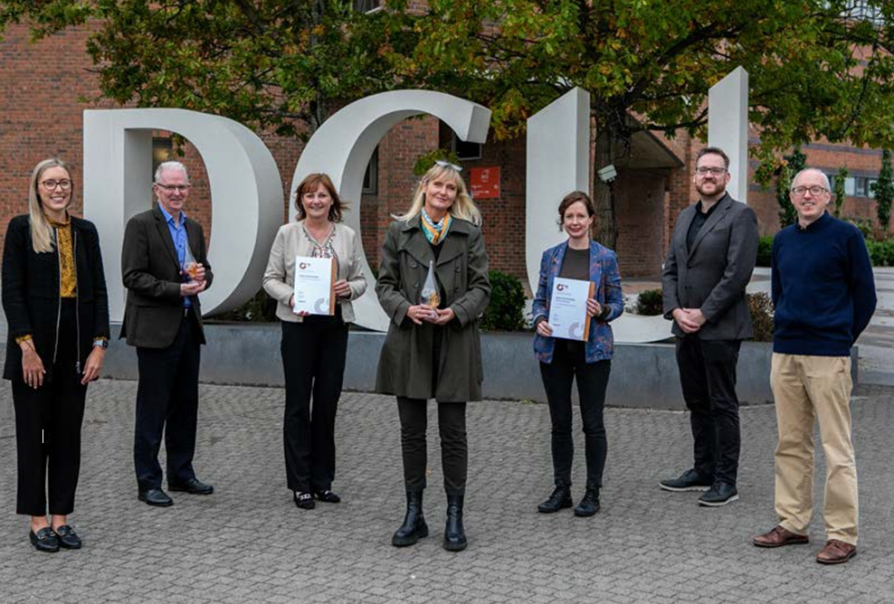

The Athena Swan Ireland charter underwent a re-development in 2021 in line with the findings of a national consultation and now offers a framework for progressing equality in higher education and research that is unique to Ireland. The objective of the Athena Swan Ireland 2021 charter framework is to support higher education institutions, academic departments and professional units in impactful and sustainable gender equality work while also building capacity for evidence- based equality work across the equality grounds enshrined in Irish legislation. The introduction of the new framework provides the opportunity to take an intersectional approach to equality.
You can learn more about Athena Swan by watching this short Athena Swan explainer video, or visiting our dedicated DCU Athena Swan webpage.

Women in Leadership

Vista Development Programme for Women

In December 2020, DCU successfully led a collaboration with NUIG and DkIT and were awarded funding under the Higher Education Authority (HEA) Gender Equality Enhancement Fund to develop Vista - a formal self-development programme for women at mid-career stage, both professional and academic, in the higher education sector.

During 2021 significant work was undertaken to develop the content of the programme and to establish three modules that will support female staff to develop their leadership skills and prepare them for opportunities to move forward in their career.

The pilot programme will run from January to May 2022. A total of ten candidates from each of the three institutions will participate.

Aurora Leadership Development Programme

Aurora, a leadership development programme for women, was designed to help address the issue of the under-representation of women in senior posts in the higher education sector. A highly-innovative programme, it was developed and is hosted annually by Advance HE. The objective of the programme is to embed a leadership mindset whereby women identify as leaders and seek appropriate opportunities to develop capabilities, skills and networks to support them in their developing careers.

In 2021 female members of DCU staff up to Associate Professor level and equivalent professional staff were invited to apply for the programme. The 16 successful applicants commenced the programme in January 2022.

Preparing for Academic Advancement (PAA) Programme

In 2021 DCU was successful in our joint application for funding to run the PAA (Preparing for Academic Advancement) with the University of Limerick. The programme is specifically for academics at Associate Professor level who are ready and credible challengers for promotion to Professor. One of the DCU participants in 2021 was Sarahjane Belton.

“Taking part in the PAA programme really got me thinking about the bigger picture of what I do at DCU. At times you can get so caught up in constantly doing, that you forget to take that step back and realise the significance of the various aspects of the work that you do. This programme really helped me to take that step back, and start to identify and capture my various strengths and impacts, but also identify areas where I needed to put more time and energy.”

Measuring Success

Since the establishment of the Women in Leadership initiative in 2015, there has been an increase in female representation across all academic grades, most notably at Full Professor level where female representation has jumped from 21% in 2015 to 35% in 2021. In 2021, we continued to see an increase in female representation at Full Professor (33% to 35%) and Professor (39% to 40%) levels.
Although we witnessed a slight drop in female representation at Associate Professor level (-1%), our Academic Promotions Committee (APC) will monitor this annually to ensure an upwards trend.

Female representation at non-academic level (pay scale with maximum point above €70,000) remains very well balanced since 2020.
It is important that we continue to proactively monitor all promotions to ensure that we do not lose the very valuable momentum gathered since 2015. The EDI (formally Women in Leadership) Steering Committee and the APC will continue to review the data and any decisions that may impact progress.

Women on Walls

International Women’s Day 2021 marked the official unveiling of Accenture’s Women on Walls at DCU. The project recognises five extraordinary female leaders in science, technology, engineering and mathematics (STEM). They are: mathematician Kathleen (Kay) McNulty; biochemist Dr Marie Maynard Daly; engineer Beatrice Alice Hicks; X-ray crystallographer Dame Kathleen Lonsdale and Nasa scientist Katherine Johnson. The project celebrates these inspirational role models through their portraits which were commissioned from five separate artists.
They are: Bríd Higgins Ní Chinnéide; Blaise Smith; Una Sealy; Jim Fitzpatrick and Jackie Hudson Lalor.

This was followed in October 2021 by the launch of a series of ‘living portraits’ to highlight the contribution of our female academics, from the world of science, technology, engineering and mathematics (STEM) and adjacent fields. Drawn from all five faculties, those profiled are Jennifer Bruton, Dr Lorna Fitzsimons, Dr Suzanne Little, Prof Christine Loscher, Dr Stella Vlachou, Dr Jennifer Gaughran, Prof Deirdre Butler, Prof Cliona Murphy, Dr Orla Kelly, Prof Edel Conway, Prof Yseult Freeney, Prof
Regina Connolly, Prof Jane Suiter, Prof Maura Conway and Dr Tanya Lokot. Their stories are available on the Women on Walls interactive hub. Each profile gives a real insight into the lives of these gifted academics, demonstrating both their disciplinary leadership and passion.

In December 2021, led by Cultural Arts Officer Marcella Bannon, the Accenture Women on Walls at DCU project was the winner of the Diversity, Equality and Inclusion and Education category at this week’s 2021 Women in IT awards.

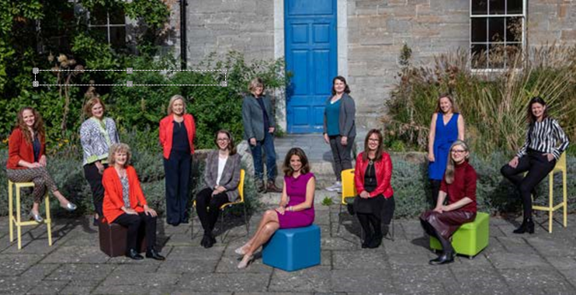

Senior Academic Leadership Initiative

The Senior Academic Leadership Initiative (SALI) aims to accelerate progress in achieving gender balance at the senior academic level in higher education. In 2021, DCU was again successful in securing another position as part of the highly competitive initiative. The funding is for a Full Professor in Sustainable Finance, a field in which women are currently underrepresented.

Honorary Conferrings

In May 2021, DCU was delighted to award honorary conferrings on two truly inspiring women: Annette Kennedy, President of the International Council of Nurses, and Vivien Lusted, Health Programme Manager with the International Committee of the Red Cross.

These inspirational women received DCU’s highest honour in recognition of careers dedicated to transforming lives and societies.

Doctor of Philosophy (Honoris Causa) bestowed on Annette Kennedy, Vice President of Irish Council of Nurses, and Vivien Lusted of the Irish Red Cross. The honorary conferring was part of the Glocalisation in Healthcare event - Nurses and Midwives thinking globally and acting locally to drive the policy and educational agenda event hosted by DCU.

DCU Pride 2021

Pride Flags

June 2021 marked the first time that five DCU campuses; Glasnevin, St Patricks, All Hallows, the Alpha Centre and the DCU Sports Campus had LGBTQ+ Pride flags flying in celebration of Pride month.

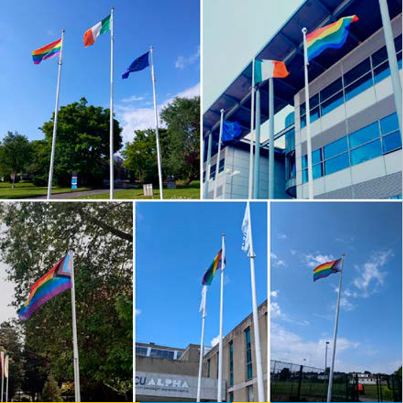

Pronouns

The DCU EDI unit launched an information guide for all DCU staff on the use of personal pronouns. This was accompanied by two exciting developments on our technology platforms when both Zoom and Loop added pronoun fields to their profile set up.
Learn more about pronouns and what steps you can take to include pronouns in your day to day work so that DCU feels safe and inclusive for all.

Bród sa Fiontar agus Scoil na Gaeilge

Fiontar & Scoil na Gaeilge was delighted to host a seminar series on the field of sex and sexuality studies in the Irish language as part of Dublin Pride 2021. The seminars took place on both the 18 and 25 June 2021 and saw themes around gender, queerness, and sexuality in the field of Irish language studies. This series was the first of its kind and brought together researchers from various institutions and has helped build a community of academics who focus on these areas.

LQBTQ+ Pride Lanyards

In Summer 2021 following feedback from our DCU staff community, we introduced free DCU Pride Lanyards for all staff. These lanyards are still available to all DCU staff and can be collected from the reception areas on Glasnevin, St Patrick’s and All Hallows Campuses.

“My experience is that staff almost always ask for one, whether they are collecting their first staff card, or they’re getting a new card when their contract has been extended, or they’re getting a replacement for a lost card. Also, staff have seen other staff wearing them, and come in to us asking for one for themselves. We’ve never had to ask anyone to take one; they seem to be almost universally popular.” – Mary Hassett, DCU Glasnevin Reception.

New EDI Training Opportunities

In 2021, the HR EDI Team launched a number of new training opportunities for DCU staff. Engagement with these opportunities was extremely positive and throughout 2021, we delivered EDI training to almost 550 attendees. We would like to thank all staff who attended the sessions and engaged with these important topics. We would also like to thank all of our facilitators who brought their expertise and knowledge to the sessions and created safe spaces for discussion.

Anti-Racism Training

Participants are empowered with knowledge and skills to identify and correct previously unrecognised patterns which could negatively impact inclusion efforts. With shared language and a clearer understanding of how various dimensions of racism are producing unjust and inequitable outcomes for underrepresented groups, DCU staff will be better equipped to foster an antiracist and inclusive experience within their workplace.
At the end of the session, participants:

- Understand the construction of race and institutional racism within Irish society and Irish workplaces
- Understand the different dimensions of racism and how they can act together to reinforce inequalities
- Recognise how white supremacy culture operates and manifests in workplace practice, policies and procedures
- Understand the complexity and intersectionality of race, gender, class, ability and other identities and their accompanying power or lack of power
- Know how to apply an anti-racism framework to working relationships, team working, managing, hiring, advising and mentoring

“I really learned from the anti-racism session. It was a really good friendly interactive session - going beyond basic diversity, and helped me build knowledge to identify the patterns and barriers which prevent greater inclusion. I now have a better awareness of specific ways to be an anti-racist ally. I really recommend the session for anyone wanting to know more about this essential issue.” Susan Madigan, Occupational Therapist, Disability Support Services.

Transawareness Workshop

This workshop is an opportunity to learn about the unique and complex challenges faced by transgender people. This session explores why respecting a trans person’s identity is important, as well as ‘best practices’ for individuals to ensure that respect is communicated. The workshop provides you with the tools to engage in discussion surrounding trans issues, where you’ll have a chance to ask questions in a supportive environment.

“For me, the Trans Awareness Training was eye opening on my understanding about the challenges faced by a trans person in our society. It is shocking to see that it goes beyond social discrimination and extends to the violation of rights of, for instance, personal health. This training is a ‘must’ for all DCU staff.” Bárbara Iryde (she/her) | (sí/í), Library Assistant.

LGBTQ+ Allyship Sessions

This training, delivered by Certified Proud, supports DCU staff to think about their role as allies to the LGBTQ+ community. This one hour sessions covers:
- What is an Ally
- Privilege checker
- Why are allies needed?
- Allies as disruptors
- Passive Vs Active allies
- Allyship in the workplace
- How to embed active allyship into our daily lives

“I took part in the LGBTQ+ Allyship Training. I would say this training was invaluable to my work in DCU and in my personal life as well. I came away with a fresh perspective on the issues that impact LGBTQ+ people and how I can be a better ally. The facilitators were exceptional and the quality of the training was second to none. Thank you.” Eric Hughes, Chaplain (Student Support and Development)

Autism Awareness Workshops

As part of the Autism-Friendly University initiative, training is offered to all DCU staff to help them better understand the experiences of students and staff who are on the autism spectrum.

The workshops provide a foundation of knowledge for staff members who wish to better understand the experience of life on the autism spectrum. It focuses on sensory, communication and social challenges faced by people on the spectrum, and on the unique strengths associated with autism.

This training is provided by our charity partners, As I Am and in conjunction with Student Support and Development.

“I’m really glad I did the Autism Awareness training. The session was very engaging and gave everyone the chance to ask some of the basic questions we might not have asked in another setting. I now feel better informed about the issues that neurodivergent people face in a university context.” Tom Swift, Content Editor, President’s Office.

DCU Consent Framework

In 2021, DCU EDI Unit in partnership with other members of DCU’s Consent Working Group, undertook extensive work in implementing DCU’s consent framework.

This work is guided by DCU’s Action Plan to Tackle Sexual Violence and Harassment and is reflective of the Government’s Framework for Consent in Higher Education Institutions. This important work will continue in 2022.

DRCC Training

In July 2021, the DCU HR team undertook disclosure training through Dublin Rape Crisis Centre. The session provided specialist advice on how to support victims of sexual violence and how to look after your own wellbeing if you receive sensitive information related to any form of sexual misconduct.

DRCC will deliver further training of this kind to wider groups of DCU staff in 2022.

Consent Framework Staff Training

In order to support teams to become more familiar with the principles and concepts that underpin the DCU Consent Framework, the HR EDI team were invited to provide tailored training sessions to teams. If you would like to request a session, please contact: edi@dcu.ie

“I am very proud that ADAPT was able to roadtest DCU’s EDI consent programmes for both PhD students and staff in the Centre. The sessions were very well facilitated and covered the important topic of active consent in an accessible and thought-provoking way. ADAPT members had the opportunity to engage, discuss and increase our understanding around these very important issues. Feedback from the workshops was very positive and I would encourage all DCU members to attend!” Professor Andy Way, Deputy Director of the Adapt Center.

NUIG Sexual Consent Promotion Module

From March to June 2021, a number of DCU Staff from the HR EDI Unit and Student Support and Development, undertook a Sexual Consent Promotion Module through NUI Galway in order to upskill in the area
of promoting a consent culture across the University community and to bring best practice and latest evidence back to their teams at DCU.

“I found this module very interesting and beneficial. It was very useful to compare notes with others working in the field in the level of depth provided by this, level 9, module as well as giving me access to the most up to date information . It also allowed me to devise a workshop for first point of contact staff in receiving disclosures of sexual assault and harassment which was of direct benefit to key staff in their support of students and colleagues.” Ruan Kennedy, Counselling and Personal Development Service.

Action Plan

DCU is committed to tackling sexual assault and harassment and in February 2021, we published our Action Plan toTackle Sexual Violence and Harassment as part of ensuring that we follow the National Framework for Consent.
The Plan consists of four areas of focus:
- Institutional Culture
- Institutional Processes: Recording
- Institutional Processes: Policy
- Targeted Initiatives
The Action Plan is kept under review by the Framework of Consent Working Group and progress is monitored and discussed at regular meetings.

Speak Out Tool

The Speak Out Tool enables members of our University community to anonymously disclose incidents of unacceptable behaviour such as bullying, harassment, discrimination and sexual misconduct in a way that is safe and secure. As Speak Out is completely anonymous, the University will have no way to identify or make contact with any individual who chooses to submit a report.

This reporting tool is part of the Framework for Consent in Higher Education and enables data collection on the incidence rates of sexual misconduct across the sector. Given the intersectional nature of sexual misconduct the tool also collects data on multiple forms of misconduct. The key reasons for collecting this data are to:
- Monitor trends of misconduct both at institutional level and across the country
- Improve institutional and national policies to ensure that they support the needs of all members of the University communities
- Inform educational interventions such as workshops, campaigns etc. to ensure that they reflect the real-life experiences of university communities
While the tool is anonymous, it also, very importantly, will direct users to the appropriate supports and provides information on what formal reporting procedures are available.

International Days of Celebration

International Women’s Day (IWD) 2021: 8th March

Celebration video
To celebrate International Women’s Day 2021, DCU invited all female members of staff to submit their photo for inclusion in #IWD2021 celebration video. There was an overwhelmingly positive response and over 200 colleagues submitted their picture.

#ChooseToChallenge...Yourself
Additionally on IWD2021, DCU was delighted to welcome guest speaker Carol O’Kelly who facilitated an inspiring workshop on personal branding and encouraged participants to #ChooseToChallenge...Yourself.

#ChooseToChallenge ... Your Creativity
Creativity has never been in higher demand and so as part of IWD2021, DCU HR hosted a highly popular workshop on how to harness your creativity. The workshop was led by DCU’s Peter Robbins and included creative writing, visualisation exercises and rapid-fire brainstorming.

IDAHOBIT: 17th May

To mark International Day Against Homophobia, Biphobia and Transphobia on 17th May 2021, the EDI Team hosted a lunchtime panel event.

The panel explored what homophobia is, what its impacts are and how we can all take action to stop homophobia, biphobia, interphobia and transphobia in order to create a safe university community.

Panelists represented:
- DCU’s Anti Bullying Centre,
- Certified Proud
- DCU’s Students Union
- DCU HR Learning and Organisational Development Team

Black History Month

The DCU Equality, Diversity and Inclusion Unit, in collaboration with the DCU Centre of Excellence for Diversity and Inclusion, hosted a virtual event in celebration of Black History Month 2021. Titled ‘Celebrating Black Excellence’, Linda Keitasha from the Centre of Excellence was in conversation with Mr. Bashir Otukoya, Assistant Professor in the School of Law and Government.

Through the sharing of Bashir’s personal anecdotes and lived experiences, this conversation celebrated Black excellence by exploring what black history month means in the Irish context, the valuable contributions the Black community makes in our workplace, and some of the barriers faced by the Black community in employment. The conversation also touched on the importance of allyship in overcoming these challenges, our progress in combating racism in Ireland, and aspirations for a truly inclusive workplace by looking to the future.

International Men’s Day

In celebration of International Men’s Day 2021, the EDI team were delighted to invite all DCU staff to join Dr Brendan Egan from the DCU School of Health and Human Performance for a lunchtime seminar: Men’s Health: A Life Course Perspective, on Friday 19th November.

In this seminar Dr Brendan Egan took a life course perspective on men’s health by focusing on the strategies that support healthy aging from young adulthood through to older years, in addition to considering the changing healthcare needs for men throughout this journey.

International Week of Deaf People

In recognition of International Week of Deaf People 2021, and International Day of Sign Languages 2021, the EDI Unit teamed up with colleagues from Marketing and the School of Inclusive and Special Education to translate the DCU logo into Irish Sign Language.

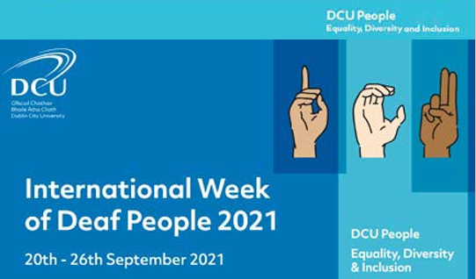

DCU Ability Project

DCU Ability supports young adults with intellectual disabilities. The Project offers a range of practical and learner-centered interventions to enable learners to move towards their work and education goals.

During 2021 DCU Ability provided an online Introduction to Work course. This is an eight week blended learning course and was available to learners across the country. All DCU Ability online learners were provided with our Next Steps Toolkit, a learner resource pack and support person guide alongside individual indications for the use of this toolkit in progressing the learner in the next steps towards employment. An All About Me in Work Resource was created for each learner based on their interests, skills and the work preferences they highlighted during the course. This serves as an accessible document which can be used in place of a CV and allows the learner to self-advocate in their search for work.

Adam’s Story

One of our learners, Adam, who was a participant on the campus course in 2020 secured a paid job in Specsavers during 2021. Adam did a work placement at the DCU Interfaith Centre during the course and the Ability team visited and supported Adam during his initial weeks at Specsavers. Adam received the Employee of the Month Award at Specsavers in October.

Aontas Award 2021

DCU Ability was nominated for the Aontas Award in the Learner Voice category. Members of the team attended the award interviews with one of our learners, Stacey, who spoke to the panel about her experience on the Introduction to Work Course.

DCU Library: Equality Champions

Library staff are encouraged to attend and engage with EDI training and workshops.

During the course of 2021 over 25 staff, from all library directorates and across all
grades, engaged with the following training / workshops:
- Racism Training
- Trans Awareness Workshop
- LGBTQ and Allyship Training
- Supporting Students with Dyslexia
- Diversity, Inclusion and Belonging for all (via LinkedinLearning)
- Allyship Training
- Autism Awareness Training

A large number of library staff engaged with DCUs first Accessibility Awareness Week in May 2021. This included strong participation in the Small Changes Workshop: Introduction to Assistive Technologies at DCU, leading to changes in some library supports
The Trans Awareness training has strengthened our support for initiatives such as pronoun visibility days and prompted library staff to display pronouns in email and on Zoom.

The CONUL (www.conul.ie) libraries Customer Services Group, of which Orla Nic Aodha, Associate Director, Public Services and Outreach in DCU library, is chair organised a show and tell seminar for library staff across the Irish universities during July 2021 entitled Show and Tell: Covid as a Catalyst for Change – Customer Service Initiatives with Impact.

Fiona Early, the DCU Autism Friendly University Coordinator, was invited to present as the keynote speaker to share with the participants the ongoing work in DCU and more specifically the partnership with DCU Library. Mags Lehane, Senior Library Assistant, Research and Teaching, presented at the seminar on her work with automatic subtitles when creating instructional training videos for DCU Library, The title of her presentation was From Chondre to Drumcondra: editing Your Tubes automatic subtitles.

DCU Library staff attended the WHELF (Wales Higher Education Library Forum) Excluded Voices Conference in May 2021. The theme was EDI across academic libraries in Higher Education in the UK and Ireland.

Orla Nic Aodha was invited to speak to colleagues in NUI Galway on customer service initiatives in DCU. The focus was the engagement with the Autism Friendly and Age Friendly University, the sign language training completed by Issue Desk staff to support the deaf students on the IOE programme, exploring how the geographical location on the northside of Dublin is a factor in our customer care initiatives for tackling disadvantage, our work with the access office and finally our engagement with the JAM Card initiative.

Meet the HR EDI Team

Fiona Carvill
Deputy Head of Learning and Organisational Development and Equality, Diversity and Inclusion Lead

Fiona is a passionate advocate of the importance of a diverse, employee-centred workplace in delivering strategic goals and creating real inclusivity and engagement. Fiona’s vision for EDI @ DCU is that we will be renowned as a University that is committed to meaningful inclusivity and that every member of the DCU Community can attest to a work environment that is equal and respectful.

Lorna Greene
Equality, Diversity and Inclusion Adviser

With a professional background in health policy, Lorna is passionate about person centred outcomes and ensuring that policy is intersectional and reflects lived experience. Lorna is always keen to hear directly from DCU staff about equality, diversity and inclusion. If you have any ideas, concerns or questions related to EDI at DCU, do not hesitate to contact Lorna at: lorna.greene@dcu.ie or, any of the team at: equalitydiversityinclusion@dcu.ie

Joanne Mulligan
Athena Swan Coordinator

With a professional background in international development and global citizenship education, Joanne is particularly interested in the topic of gender and finding innovative ways of securing equal opportunities for women in the workplace. Joanne brings an intersectional approach to her work, so while working on gender initiatives, she will also tie in other protected characteristics including age, disability and ethnicity where possible. Joanne will coordinate DCU’s Athena Sean journey to the Silver Award by 2024, and will also provide support to individual Faculties and Schools in attaining Athena Swan Awards.

Contact Information

If you have any questions relating to equality, diversity and inclusion at DCU, contact the team by emailing edi@dcu.ie.
Visit our webpages to keep up-to-date with EDI initiatives at DCU and to access our latest resources.
Follow us on Twitter: @EDIatDCU

