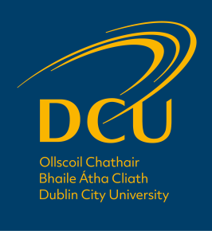

Dignity and Respect at Work

Employee Procedures Document

Table of Contents

Table of Contents 1
Introduction 2
Purpose 3
Scope 4
Chapter 1: Dignity and Respect at Work 6
1.1 Definitions 6
1.2 Responsibilities of the DCU Community 6
Chapter 2: Allegations of Bullying or Harassment 7
2.1 General 7
2.2 What do I do if I feel I am being harassed/bullied/discriminated against? 7
2.2.1 Extra steps to take if the perpetrator is a student 8
2.3 What do I do if I have been accused of harassment, bullying or discrimination? 8
Chapter 3: Resolution of Issues – Employee Procedures 10
3.1 The Informal Resolution Process 10
3.1.1 Recording the behaviour 10
3.1.2 Request that the behaviour stop 10
3.1.3 Facilitated Resolution 11
3.1.4 Formal Resolution 12
3.1.5 Resolution flowchart 12
3.2 The Formal Resolution Process 13
3.2.1 Submitting a formal complaint 13
3.2.2 Incidents involving Senior Management 13
3.2.3 Investigation Terms of Reference 13
3.2.4 The Investigation Panel 13
3.2.5 The Findings of the Panel 14
3.2.6 Withdrawing a Complaint 14
3.2.7 Potential Outcomes of a Formal Complaint Process 14
3.3 Right to Appeal 15
3.4 Malicious complaints 15
Chapter 4: Implementation of the procedures 16
4.1. Vicarious Liability 16
4.2. Employee Development 16
4.3. Operation of the procedure 16
4.3.1 Confidentiality 16
Contact 17
The Equality Diversity and Inclusion Team 17

Introduction

Dublin City University (DCU) is committed to equality, educational opportunity, social justice, ethical behaviour and academic freedom.

The Dignity and Respect at Work and Study Policy sets out DCU’s commitment to the promotion of a university that recognises and respects individual difference and that rejects harassment or bullying as destructive to the recipient, the harasser or bully, and the University. This partner document, Dignity and Respect at Work Procedures explains the steps which individuals may take if they feel that they have been bullied, harassed, or discriminated against.

Dealing with issues regarding bullying, harassment, or discrimination can be stressful and distressing for all parties concerned. Appropriate support is available through the DCU HR Department and/or DCU Employee Assistance Programme for staff and the DCU Student Advice Centre and DCU Counselling Service services for students. Staff who are members of a recognised trade union may also wish to speak to their trade union representatives.
For concerns relating to sexual violence, sexual harassment or sexual misconduct, please refer to the specific Sexual Misconduct Policy and accompanying procedures document.

Purpose

The purpose of this Procedures Document is:

- To provide arrangements to enable formal reports of alleged bullying and harassment to be fully investigated in a manner that recognises the sensitivity of the issues raised, appropriate confidentiality and the rights of the parties involved.
- To assist in upholding a safe environment in which bullying, discrimination and harassment are known to be unacceptable and not tolerated.
- To help develop a culture whereby individuals can raise concerns about bullying, discrimination and harassment, confident that their issues will be dealt with appropriately, consistently, fairly and without fear of ridicule or victimisation.
- To help foster an environment where individuals and groups treat one another with dignity and respect.
- To assist in preventing acts of discrimination, exclusion, unfair treatment, bullying and demeaning behaviours.
- To have adequate and accessible mechanisms in place for handling bullying and harassment effectively.
- To help ensure that all members of the University community are aware of behaviour that may constitute bullying and harassment and their responsibilities for avoiding and/or preventing such behaviour.
- To encourage, where safe and appropriate, the internal and informal resolution of issues.
- To help raise awareness by educating members of the University community on the development of positive relationships and strategies for challenging inappropriate behaviour effectively.

Scope

These procedures apply to all staff of the University including its wholly owned commercial companies and research centres. It also applies to volunteers, contractors, sub-contractors and visitors. These are all hereinafter collectively referred to as ‘Members of the University Community’.

These procedures apply to all areas of the University’s operations and programmes. It applies to conduct which takes place:

- on any University campus;

- at any other university or other place (including abroad) where employees or students are representing the University or are engaged in a University connected activity;

- any virtual setting in relation to any University related activity e.g. zoom meetings, Microsoft teams, etc.

- at events such as social functions, conferences, sporting events, field trips or work assignments which are related to the University or are a University connected activity; &

- in person, in writing, on the telephone, by email or online, including social media, in relation to any University related activity.

What does not constitute harassment or bullying

It is important to differentiate between the exercise of a person’s legitimate authority, as opposed to harassment or bullying. Line managers, supervisors, academic leaders, have the right to manage, direct and govern how work is done, and a responsibility to monitor workflow and to manage performance. The exercise of this right is not harassment or bullying.

Disciplinary action taken against staff or students does not constitute harassment or bullying where the appropriate processes have been applied and communicated in a professional manner, examples of which follow:-
- Constructive feedback and/or advice on performance or professional behaviour are appropriate and reasonable management actions.
- Critical comments indicating performance deficiencies do not constitute harassment or bullying where the comments are objective and communicated professionally.
- Constructive and appropriately delivered feedback which is intended to assist staff to improve their performance or the standard of their behaviour.
- Constructive and appropriately delivered academic feedback to students. Any such feedback should be in keeping with the university regulations.

Chapter 1: Dignity and Respect at Work

Definitions

Harassment and discrimination are covered in legislation by the Employment Equality Acts 1998 – 2015 . These issues are also dealt with under the Equal Status Acts 2000 – 2018 .

Please see this document’s partner ‘‘Dignity and Respect at Work and Study Policy for more information on bullying, harassment and discrimination as well as further related definitions.

Responsibilities of the DCU Community
Please refer to the Dignity and Respect at Work and Study Policy for details of responsibilities of the following groups:
- All members of the DCU Community
- Employees in a position of authority
- The DCU Human Resources Department

Chapter 2: Allegations of Bullying or Harassment

2.1 General
Any allegations or concerns of harassment expressed to employees in a position of authority must be taken seriously, handled sensitively, considered carefully, addressed speedily and, where possible, in confidence. All parties involved must be treated with dignity and respect at all times.
If they feel able to do so, all employees should:
- support those who are being subjected to harassing or bullying behaviour by encouraging them to utilise the Self-Audit Checklist to assess the behaviour and to record the behaviour with the Incident Logbook;
- make it clear, if they observe others behaving in a harassing or bullying way, that such behaviour is unacceptable and ask them to stop;
- with the consent of the individual experiencing such treatment, bring this to the attention of any of the following:
  - Line manager, supervisor, heads of departments (see Section 3.1.3)
  - Equality, Diversity and Inclusion Unit
  - Human resources representative
- Cooperate fully with any informal or formal investigations.

Support can also be sought from the HR Business Partners, the HR EDI Unit and/or Employee Assistance Programme for employees. Staff who are members of a recognised trade union may also wish to speak to their trade union representatives.

Individuals must not be treated less favourably as a result of raising a matter of concern or for providing evidence in a case of alleged harassment.

Once a report of bullying and harassment has been made, any form of victimisation arising out of the report will be taken seriously and can itself lead to disciplinary action.

2.2 What do I do if I feel I am being harassed/bullied/discriminated against?
An employee experiencing harassment, bullying or discrimination may seek support or advice from DCU support areas such as a line manager, head of department, supervisor, a Human Resources Business Partner or the Equality, Diversity and Inclusion Unit. Staff who are members of a recognised trade union may also wish to speak to their trade union representatives.

Please refer to the Dignity and Respect at Work and Study Policy for definitions of bullying and harassment to assess what type of behaviour you are experiencing.

Prior to the invocation of any formal procedures, an individual is encouraged, where appropriate and safe, to attempt to resolve the issue informally. Support can be sought from the Equality, Diversity and Inclusion Unit within the Human Resources Department or from other colleagues within HR. When it is safe and appropriate to do so, it is recommended that informal issues be dealt with at a local level. Please refer to the Self-Audit Checklist and the resolution stages in Chapter 3 of this document.

In cases where the informal procedure is not appropriate or has not resolved the issue, you may invoke formal procedures. Section 3.2 of this document explores the formal resolution process in detail.

Experiencing a feeling of bullying or harassment can be upsetting and may leave you feeling vulnerable and alone. It can be helpful to talk to someone about what is happening. Appropriate support may be provided through your HR Representative, the HR EDI Unit and/or DCU Employee Assistance Programme for staff and the DCU Student Advice Centre and DCU Counselling Service services for students. Staff who are members of a recognised trade union may also wish to speak to their trade union representatives.

2.2.1 Extra steps to take if the perpetrator is a student

The informal procedures as they are outlined in Chapter 3 of this document should be followed. However, you should ensure that your line manager and/or Human Resources/Equality, Diversity and Inclusion Unit are aware of the situation and are involved at all stages of the process.

In order to submit a formal complaint regarding a student, it is necessary to write to the Secretary of the Disciplinary Committee with full details of the complaint including copies of all or any relevant notes of the alleged behaviours. See the Dignity and Respect
Student Procedures for further details.

2.3 What do I do if I have been accused of harassment, bullying or discrimination?
An employee accused of harassment, bullying or discrimination may seek support or advice from DCU support areas such as a line manager, head of department, supervisor, a human resources representative or the Equality, Diversity and Inclusion Unit.

As part of the process of dealing with the accusation, it is recommended that the person accused completes the Self-Audit Checklist which assists individuals to reflect on behaviour, define the problem, and assess if the behaviour(s) fall into the category of workplace harassment or bullying.

Individuals who are accused of harassment and/or bullying should also review the information contained in the Self-Audit Checklist.

Where a complaint has reached the formal investigation stage, a person accused of harassment or bullying has the opportunity to respond to any allegation where this is relevant at the appropriate stage of the procedure and must be given a clear written account of the allegation so as to be in a position to respond to the allegation and to state their case.

Being the subject of a complaint can be upsetting and may leave you feeling vulnerable and alone. It can be helpful to talk to someone about what is happening. Appropriate support is available through your HR Representative, the HR EDI Unit and/or DCU Employee Assistance Programme for staff and the DCU Counselling and Personal Development Service for Students. Staff who are members of a recognised trade union may also wish to speak to their trade union representatives.

Chapter 3: Resolution of Issues – Employee Procedures

3.1 The Informal Resolution Process

3.1.1 Recording the behaviour
Employees who feel that they are being harassed or bullied should consider if the conduct in question constitutes harassment/bullying as defined in the Dignity and Respect at Work and Study Policy. Individuals may complete the Self-Audit Checklist to aid their assessment of the behaviour as bullying or harassment.

Harassment or bullying can sometimes be difficult to prove. If they feel able, it is important to keep a careful record of any incident by filling out an Incident Logbook.

For concerns relating to sexual harassment and sexual misconduct, please refer to the specific Sexual Misconduct Policy and accompanying procedures document.

3.1.2 Request that the behaviour stop
Unless an employee feels that they are unable to, or where they feel it may be dangerous, uncomfortable or stressful for them to do so, they should initially discuss the matter with the person/people concerned and request that the unwanted behaviour stop. It is important to stick to the facts. In this situation, individuals should talk about the impact that the behaviour has had on them, using examples where necessary, and ask the person responsible to stop the unwanted behaviour.

If they feel able, the person who feels they have been bullied or harassed, should raise the issue as soon as possible after it has happened. It is important that any meeting should be an open, two-way discussion. The meeting should be held in a private but safe space away from the formal work environment. Raising the issue with the individual(s) provides them with an opportunity to be made aware of the problem and to desist from the unwanted behaviour.

If the person who feels they have been bullied or harassed is uncomfortable with asking for the behaviour to stop themselves, they may ask another person, such as a line manager, to raise the issue with the person(s) engaging in the unwanted behaviour instead.

Once the person who feels they have been bullied or harassed has made the person(s) engaging in the unwanted behaviour aware of its effect, it is frequently the case that the latter desists and appropriate relations are restored between the parties. However, if the informal process is unsuccessful or deemed inappropriate, the person who feels they have been bullied or harassed may decide to go to Step 3: Facilitated Resolution or to Step 4: Formal Resolution process.

Note: Employees who have been accused of bullying or harassment should refer to section 2.3 of this document.

3.1.3 Facilitated Resolution

- Raise the matter with a line manager
Should the direct approach either not have the desired effect or not be possible, the complainant should raise the matter with either their line manager or the line manager of the person engaging in the unwanted behaviour. In the event that the person who is allegedly harassing or bullying is the line manager, another person in a position of authority within the faculty or unit should be contacted. The line manager may locally facilitate a solution.

- Locally facilitated solution
Having followed the initial process and not reached a solution, the option of a facilitated meeting should be put forward. In this process, a head of department, or a representative from the Equality, Inclusion and Diversity Unit, or a Human Resources representative may facilitate the meeting.

Staff who are members of a recognised trade union may also wish to speak to their trade union representatives.

- Externally mediated solution
Following discussions with the Director of HR, it may be deemed appropriate or necessary to appoint an external mediator to help resolve the issue. The Director of HR may appoint an agreed mediator from a panel. The panel should be gender balanced and, in as much as it is possible, the panel should reflect DCU’s commitment to equality, diversity and inclusion. Any mediation process should be undertaken as soon as possible when both parties have agreed to participate. If the respondent(s) does not wish to participate, the process will move to formal resolution, should the complainant wish to proceed.

Through mediation, a solution may be found at which point the issue will be deemed to have been resolved. The line manager should monitor the work environment to ensure that the unwanted behaviour has ceased.

Where mediation does not provide a solution the complainant may decide to proceed to Step 4, the formal complaint procedure.

Staff who are members of a recognised trade union may also wish to speak to their trade union representatives.

As part of a facilitated informal resolution, a brief written record of the matter will be kept, in line with relevant data protection legislation. Agreed outcomes and dates will be noted by the relevant person responsible for managing the resolution. Both parties should be offered support and/or periodical reviews, insofar as is reasonable.

3.1.4 Formal Resolution
In serious cases and in cases where the informal procedure has not been successful, it may be necessary to invoke formal procedures.

Section 3.2 of this document explores the formal resolution process in detail.

3.1.5 Resolution flowchart

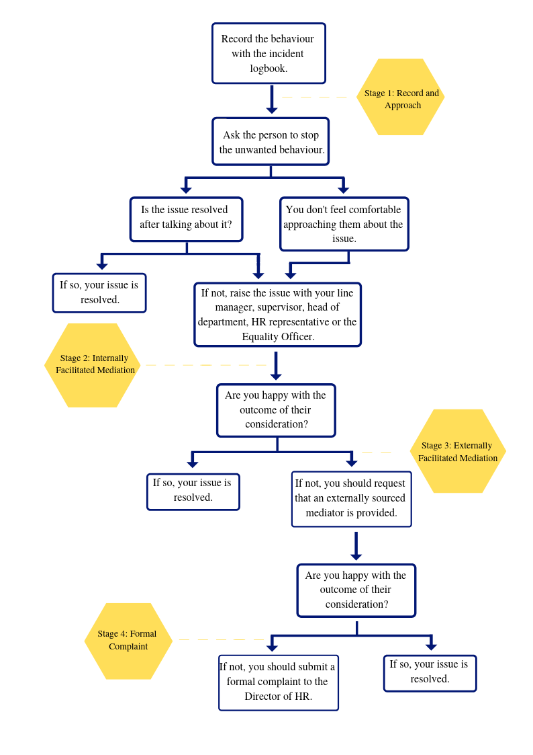

3.2 The Formal Resolution Process
In the event that the informal processes have not proved successful in resolving the issue, the complainant may wish to lodge a formal complaint.

Escalating a complaint to a formal process should only be done following a review of all aspects of the circumstances surrounding matters complained about. Being able to evidence a reasonable decision-making process is important.

3.2.1 Submitting a formal complaint
The complainant must write to the Director of HR with full details of the complaint (see Employee Complaint Guidelines) and copies of all or any relevant notes of the alleged behaviours, for example, a copy of their Incident Logbook. Although a complainant may decide to access the formal resolution process at any time, where an allegation of harassment, bullying or discrimination is made, and informal resolution has not been attempted, the Director of HR may decide to explore other options with the complainant prior to proceeding to the investigation stage.

On receipt of the complaint, the Director of HR will provide the complaint to the person named by the complainant who for these purposes will be called the respondent(s). The respondent(s) should return a written response to the allegations within 10 working days.

3.2.2 Incidents involving Senior Management
In the event that a complaint is made against the employee’s line manager the incident will be dealt with by a senior manager. If a member of senior management is the subject of the complaint the DCU President should be contacted directly. Where the President is the subject of a formal complaint, it should be made directly to the Chancellor of the University.

3.2.3 Investigation Terms of Reference
Normally, investigations will be undertaken in line with a Terms of Reference (TOR) which will reflect the principles of natural justice. The TOR will be agreed in advance by all parties before engaging.

3.2.4 The Investigation Panel
The objective of an investigation is to ascertain whether, on the balance of probabilities, the behaviours complained about occurred, it having already been established that the behaviours align with definitions of bullying or harassment.

The Director of HR will request that the President sets up an investigation panel. The panel may consist of either internal staff members unrelated to the event or external experts or a combination of both. In some instances one person may investigate the complaint. As much as possible, panels consisting of two persons or more will be gender balanced reflecting DCU’s commitment to equality, diversity and inclusion. The name(s) of the investigation panel will be provided to both parties. Either party may raise an objection in relation to a member of the panel based on either conflict of interest or potential for lack of impartiality. Any objection will be fairly assessed by the Director of HR who, with regard to DCU’s commitment to equality, diversity and inclusion will make the final decision on the appropriateness of the objection.

The investigation panel meets separately with both parties and provides them with the opportunity to outline the issues as they relate to the behaviours complained of in the complainant’s written complaint. The panel may also meet with any witnesses who can provide corroborative evidence. The aim of the investigation panel should be to complete this process within a timely manner. Either party may be accompanied during these meetings by an appropriate representative, this must be communicated and agreed in advance.

Once the investigation is underway all parties are expected to make themselves available in order to deal with the issue as expediently as possible. This is in recognition of the fact that a protracted process can cause additional stress and anxiety to both parties.

If the investigation panel considers that it is necessary to do so it may, in exceptional circumstances, convene a joint meeting with the complainant and the respondent(s) with a view to assisting in the determination of any facts in issue or dispute between the parties. Both the complainant and respondent(s) are expected to make themselves available in order to ensure this joint meeting happens as expediently as possible.

3.2.5 The Findings of the Panel
Upon completion of their investigation, the investigation panel submits a report of the findings to the Director of HR. Both parties will be provided with a copy of this report.

Where any disciplinary or other action needs to be taken as a result of the findings of the investigation they will be processed through the appropriate HR policies and procedures.

3.2.6 Withdrawing a Complaint
Should the complainant decide to withdraw the complaint it will not be possible to reactivate it or the resolution process for the same issue.

Should the complainant withdraw from the process, the respondent(s) or the investigating committee may request that the investigation continue to provide a finding in relation to the complaint. This is to ensure that any member of the DCU community accused of behaviour which breaches the terms of the Dignity and Respect at Work and Study Policy has the opportunity to answer the charge and receive a formal determination from the investigating committee.

3.2.7 Potential Outcomes of a Formal Complaint Process
The investigation panel can only make recommendations with respect to the validity of the claim put forward by the complainant.

The panel may find in its view;
- Harassment, bullying or discrimination did take place,
- Harassment, bullying or discrimination did not take place,
- The behaviour of one or other or both parties contributed to the breakdown in working relations,
- No harassment, bullying or discrimination was evident and the claim appears to be malicious or vexatious.

Penalties may be applied in accordance with the disciplinary procedure under the University’s Statutes No. 5 of 2010: ‘Suspension and Dismissal of Employees’.

Employees should be aware that using the formal resolution process will not affect their right to make a complaint under the Employment Equality Acts 1998 – 2015 , or under the Equal Status Acts 2000 – 2018.

In a case where harassment, bullying or discrimination is found or the claim is vexatious the existing DCU disciplinary processes will be used to address the issue. Depending on the seriousness of the behaviour the University may decide to use any stage of these disciplinary processes.

It should be noted, however, that where a complaint is not upheld under the formal complaints process, this does not necessarily mean that the complaint is malicious.

3.3 Right to Appeal
In the event that either party can demonstrate that the investigation process was flawed or compromised, then they may appeal. As a result any such appeal will focus on the process applied and not the outcome. Either party can request the President to appoint an appropriate person(s) to hear the appeal. On hearing the appeal, the nominated appeals hearing officer or external adjudicator will report to the President, who will then decide whether to uphold the appeal.

3.4 Malicious complaints
A malicious complaint can be described as an allegation being made without foundation, and with malicious intent, where a person knowingly or without regard to whether it is true or not, accuses another person of allegedly bullying or harassing them. This could also apply to where one person maliciously complains of someone allegedly bullying or harassing a third party, without fully exploring the veracity of the claim.

If proven to be so, the person making such a complaint may face disciplinary action up to and including dismissal in serious cases, particularly in cases where the good name and reputation of another member of the university community has been unjustifiably attacked.

Chapter 4: Implementation of the procedures

4.1. Vicarious Liability
The University is responsible for the acts of its employees and others engaged in University business, whether or not carried out with the University’s knowledge or approval. The University, through developing these procedures, seeks to help prevent bullying, harassment and discrimination across the institution.

4.2. Employee Development
- Information sessions will be arranged to ensure these procedures and the accompanying Dignity and Respect at Work and Study Policy is shared within the DCU community.
- Training will be part of the essential development for line managers, supervisors, heads of departments, human resources representatives and the EDI Unit to help ensure they have the knowledge and skills to operate this policy effectively.
- Awareness sessions and on-going promotion of good practice will be provided.
- Information about bullying, harassment and discrimination along with sources of help and advice will be offered to employees through the EDI Unit webpages.

4.3. Operation of the procedure
- All documentation relating to the Dignity and Respect at Work and Study Policy shall be kept with the Equality, Diversity and Inclusion Unit in accordance with Data Protection legislation.
- Individuals who feel they have experienced bullying, harassment or discrimination should pursue the issue by using the appropriate procedures discussed in Chapter 3 of this document.
- The working and content of these procedures will be reviewed as required in the light of experience, changes in legislation and other relevant factors.
- Monitoring will be undertaken in accordance with the requirements of the University’s Employee Code of Conduct.

4.3.1 Confidentiality

Confidentiality will be maintained throughout the investigation to the greatest extent possible, consistent with the requirements of a fair investigation.

All individuals involved in the informal and formal complaints procedures are expected to maintain the utmost confidentiality on the subject. However, DCU may be obliged to disclose the details of any complaint to such persons or authorities and to such extent as is necessary to properly and fairly investigate the complaint.

All individuals are required to give due regard for GDPR legislation in the collection and storage of any personal information.

Contact

The Equality Diversity and Inclusion Team

Email: edi@dcu.ie

