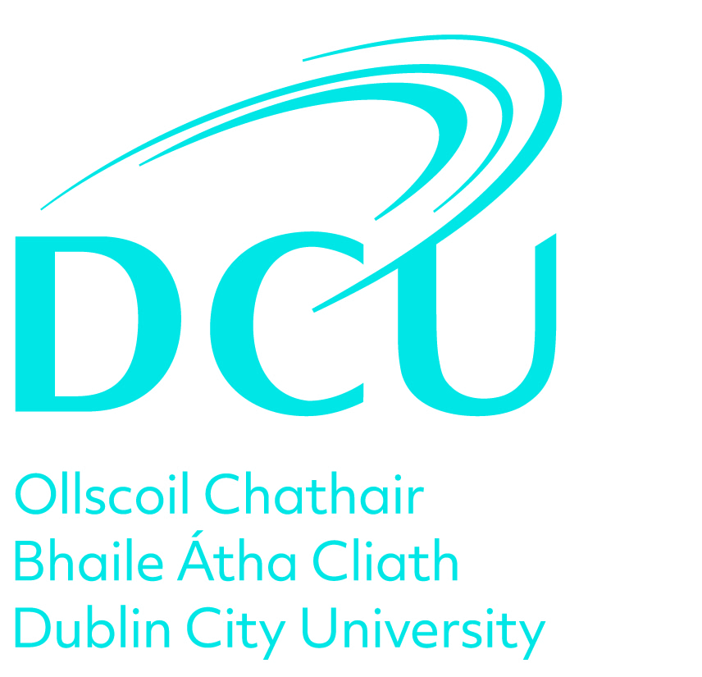

Review Name: Academic Review
Appraisal Date:
Employee:
Manager:

Stage 1. Self Assessment & Review Meeting

Step 1. Review of Objectives

Work Objectives

What were your objectives in the key areas of academic activity in the last 12 months including Teaching and Learning, Research and Scholarship and Service and Contribution. Please outline what progress you have made in achieving these. Please refer to the Academic Development and Promotion Framework.

Learning and Development Objectives

What were your learning and development objectives in the last 12 months and outline what progress have you made in achieving these. You should include compliance training relevant to your role. Please refer to the HR Learning and Development website.

Step 2. Achievements and Challenges

Achievements and Successes

Outline any other key achievements or successes not covered in your objectives.

Challenges and Constraints

Outline any challenges or constraints which have impacted on the achievement of objectives.

Step 3. Draft Future Objectives

Draft Work Objectives

Please give some preliminary indications regarding your objectives for the next 12 months for discussion and agreement at your review meeting e.g. Teaching and Learning, Research and Scholarship, Service and Contribution.

Draft Learning and Development Objectives

Please give some preliminary indications regarding your learning and development objectives for the next 12 months for discussion and agreement at your review meeting. You should include compliance training relevant to your role. Please refer to the HR Learning and Development website

Step 4. Submit

By submitting this stage, your Reviewer will now consider your input in advance of the review meeting.

Sign Off

Stage 2. Agreed Future Objectives

Step 1. Record Future Objectives

In this stage, please outline your agreed future objectives for the next 12 months as discussed and agreed at your Review Meeting.

Agreed Work Objectives

What are your agreed objectives in the key areas of academic activity for the next 12 months including Teaching and Learning, Research and Scholarship and Service and Contribution? Please outline what actions you will take to progress these.

Agreed Learning and Development Objectives

What are your agreed Learning and Development objectives for the next 12 months? Please outline what actions you will take to progress these. You should include compliance training relevant to your role. Please refer to the HR Learning and Development website.

Step 2. Submit

Sign Off

Stage 3. Overall Assessment

Step 1. Outcome of the Review Meeting

The Reviewee should confirm completion of all steps of the review process.
The Reviewer should provide an overall Performance Review and Development assessment in line with the review discussion.

Reviewee - please confirm that you have undertaken all steps in the review process.

The Reviewer should provide an overall Performance Review and Development assessment in line with the review meeting discussion.

Sign Off

