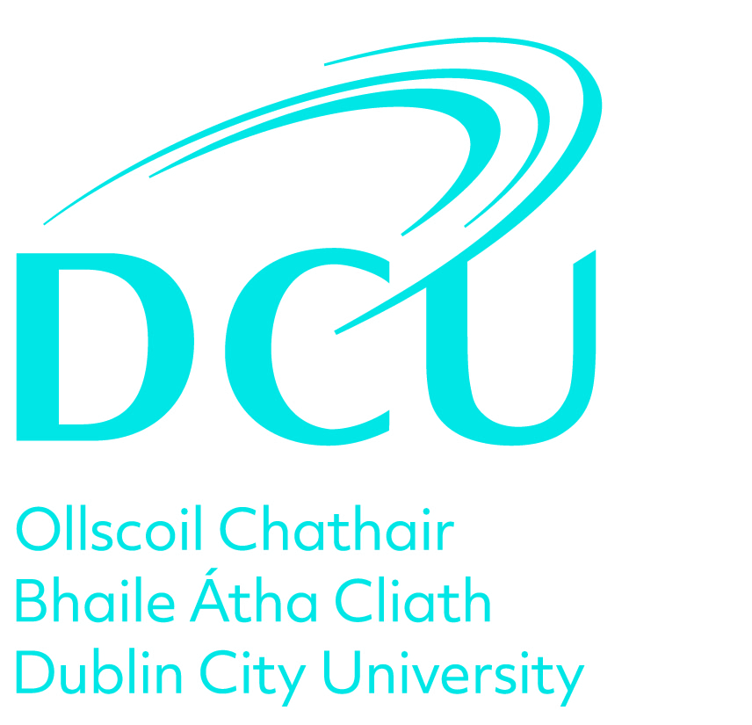

Review Name: Professional Review
Appraisal Date:
Employee:
Manager:

Stage 1. Self - Assessment & Review Meeting

Step 1. Review of Objectives

Where relevant to your role, you should refer to the DCU Development Framework for Professional Staff which outlines the behaviours and attitudes that support the achievement of your objectives.

Work Objectives

What were your work objectives in the last 12 months and outline what progress you have made in achieving these. (Work objectives focus on key results areas rather than activities or tasks).

Leadership/Management and/or Team Objectives

What were your Leadership/Management and/or Team objectives in the last 12 months? Outline what progress you have made in achieving these. (Leadership and Management objectives focus on your contribution as a Leader/Manager to deliver departmental and/or University goals. Team objectives focus on your contribution as a team member to same).

Career Objectives

What were your career objectives in the last 12 months and outline what progress you have made in achieving these. (Career objectives focus on your short-term and long-term ambitions/aspirations and what you need to do to get there)

Learning and Development Objectives

What were your learning and development objectives in the last 12 months and outline what progress you have made in achieving these. (Learning and Development objectives focus on a course of action that was taken to improve knowledge, skills and/or competencies). You should include compliance training relevant to your role.

Step 2. Achievements and Challenges

Achievements and Successes

Outline any other key achievements or successes not covered in your objectives.

Challenges and Constraints

Outline any challenges or constraints which have impacted on the achievement of objectives.

Step 3. Draft Future Objectives

Draft Work, Leadership/Management and /or Team and Career Objectives

Please give some preliminary indications regarding your objectives for the coming year including Work Objectives, Leadership/Management and/or Team Objectives, Career Objectives.

Draft Learning and Development Objectives

Please give some preliminary indications regarding your learning and development objectives for the next 12 months for discussion and agreement at your review meeting. You should include compliance training relevant to your role.

Step 4. Submit

By submitting this stage, your Reviewer will now consider your input in advance of the review meeting.

Sign Off

Stage 2. Agreed Future Objectives

Step 1. Record Future Objectives

In this stage please outline your agreed future objectives for the next 12 months as discussed and agreed at your Review Meeting. Where relevant to your role, you should refer to the DCU Development Framework for Professional Staff which outlines the behaviours and attitudes that support the achievement of your objectives.

Agreed Work Objectives

What are your agreed work objectives for the next 12 months. Please outline what actions you will take to progress these.

Agreed Leadership/Management and/or Team Objectives

What are your agreed Leadership/Management and/or Team objectives for the next 12 months. Please outline what actions you will take to progress these.

Agreed Career Objectives

What are your agreed career objectives for the next 12 months. Please outline what actions you will take to progress these.

Agreed Learning and Development Objectives

What are your agreed Learning and Development objectives for the next 12 months? Please outline what actions you will take to progress these. You should include compliance training relevant to your role.

Step 2. Submit

By submitting this stage, you can now progress to the next stage in the review process.

Sign Off

Stage 3. Overall Assessment

Step 1. Outcome of the Review Meeting

The Reviewee should confirm completion of all steps of the review process. The Reviewer should provide an overall Performance Review and Development assessment in line with the review discussion.

Reviewee - please confirm that you have undertaken all steps in the review process.

The Reviewer should provide an overall Performance Review and Development assessment in line with the review meeting discussion.

Sign Off

By signing off on this stage you have completed the PRD review process.

