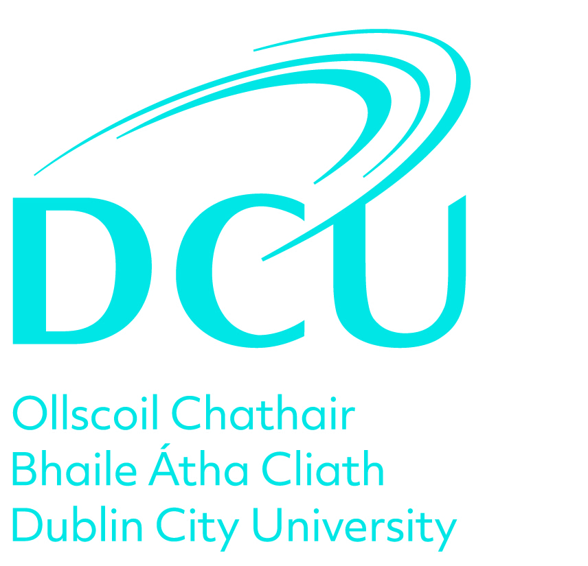

Review Name: Researcher Review
Appraisal Date:
Employee:
Manager:

Stage 1. Self Assessment & Review Meeting

Step 1. Review of Objectives

To be completed by the Reviewee in advance of the review meeting.

Research Career Framework Competencies

What were your objectives in the last 12 months as they relate to the Research Career Framework competencies including, Discipline Specific Knowledge and Research Skills, Communicating Research, Management and Leadership Skills and Understanding the Research Environment? Outline what progress have you made in achieving these. Please refer to the DCU Research Career Framework.

Learning and Development

What were your learning and development objectives for the last 12 months? Outline what progress have you made in achieving these. Please include compliance training relevant to your role. You should refer to the HR Learning and Development website.

Career Objectives

Did you set career objectives? If so, what progress have you made against achieving both medium and long-term career objectives?

Step 2. Achievements and Challenges

Achievements and Successes

Outline any other key achievements or successes not covered in your objectives.

Challenges and Constraints

Outline any challenges and constraints which have impacted on the achievement of objectives.

Step 3. Draft Future Objectives

Draft Objectives

Please give some preliminary indications regarding your objectives as they relate to the Research Career Framework Competencies for the coming year for discussion and agreement at your review meeting eg. Discipline Specific Knowledge and Research Skills, Communicating Research, Management and Leadership Skills, Understanding the Research Environment. Please refer to the DCU Research Career Framework.

Draft Learning and Development Objectives

Please give some preliminary indications regarding your learning and development objectives for the next 12 months for discussion and agreement at your review meeting. You should include compliance training relevant to your role.

Step 4. Submit

By submitting this stage, your Reviewer will now consider your input in advance of the review meeting.

Sign Off

Stage 2. Agreed Future Objectives

Step 1. Record of Future Objectives

In this stage, please outline your agreed future objectives for the next 12 months as discussed and agreed at your Review Meeting.

Research Career Competencies

What are your agreed objectives for the next 12 months as they relate to the Research Career Framework competencies including, Discipline Speciﬁc Knowledge and Research Skills, Communicating Research, Management and Leadership Skills and Understanding the Research Environment? Outline what progress have you made in achieving these. Please refer to the DCU Research Career Framework.

Career Objectives

What are your agreed career objectives for the next 12 months. Please outline what actions you will take to progress them.

Learning and Development Objectives

What are your agreed learning and development objectives for the next 12 months. Please outline what actions you will take to progress these. You should include compliance training relevant to your role.

Step 2. Submit

By submitting this stage, you can now progress to the next stage in the review process.

Sign Off

Stage 3. Overall Assessment

Step 1. Outcome of the Review Meeting

The Reviewee should confirm completion of all steps of the review process.

The Reviewer should provide an overall Performance Review and Development assessment in line with the review discussion.

Sign Off

