To register online students must login to the following link on the DCU website with their DCU Email address and password - https://www.dcu.ie/student-ienabler-login
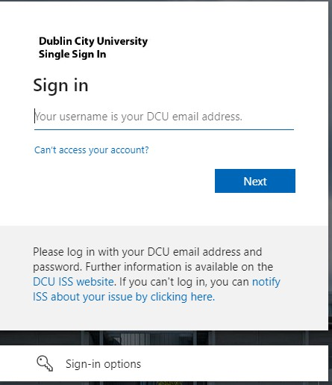

New incoming students will receive information regarding their login details in the welcome communication from DCU.
Continuing students should use their DCU Email address and password details used in previous academic years. These are the details used to log into campus computers/ student email etc.
Before commencing the process please ensure that your Pop-up blocker is turned off.

Review Schedule
On logging in, you will be directed to your registration schedule. This is a document which outlines the core (compulsory) and optional modules on offer for your programme / year of study. Please read the instructions carefully and make a note of any optional modules you wish to take (where a choice exists) and once you are happy with your module choices, please click on the ‘Proceed to Online Registration’ button.

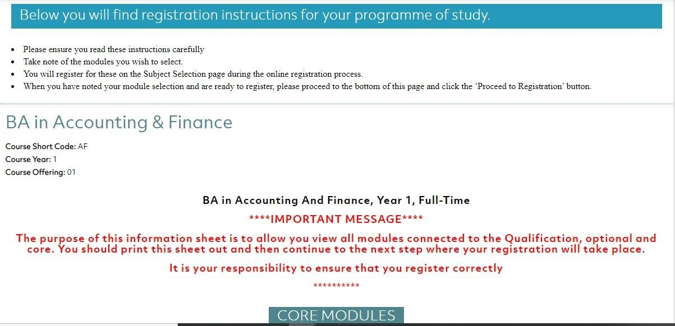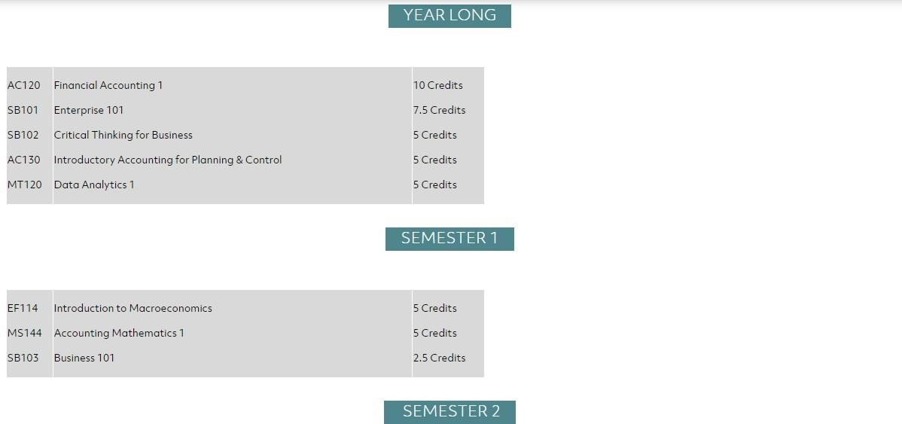
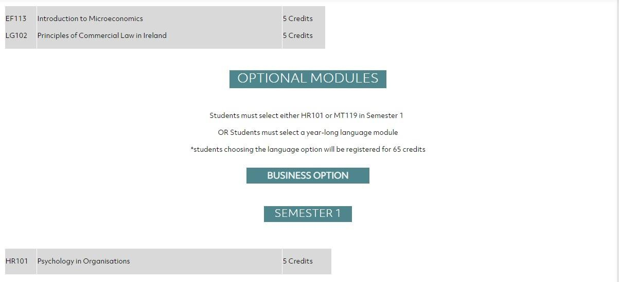

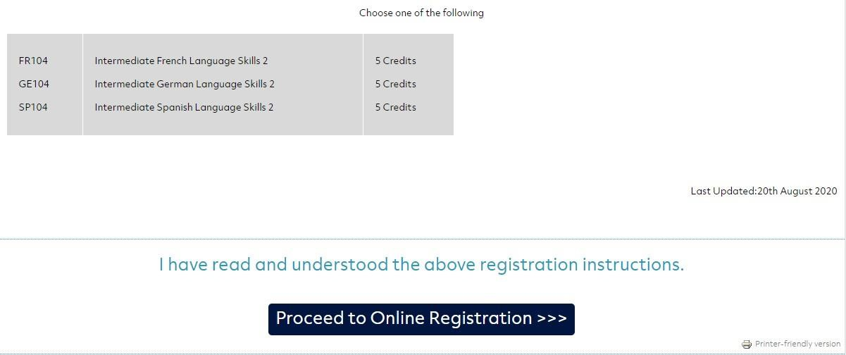

Please note: If you register for incorrect module combinations this may delay your timetable and access to online learning resources. It is your responsibility to ensure you are registered correctly for your qualification and your modules.

Proceed to Online Registration
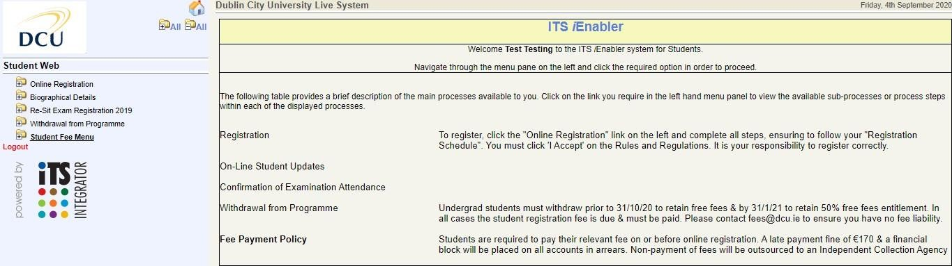

Click on ‘Online Registration’ folder on the Left hand side to expand the menu to reveal all steps of the process. Please ensure to click on each step in order and complete ALL steps of the process to complete your registration.

This is relevant to first year undergraduate students only. You will be asked some questions on your social, economic and cultural background which DCU asks on behalf of the Higher Education Authority (HEA). We encourage you to answer these questions, as the results contribute towards the financial assistance fund available to students in the University.

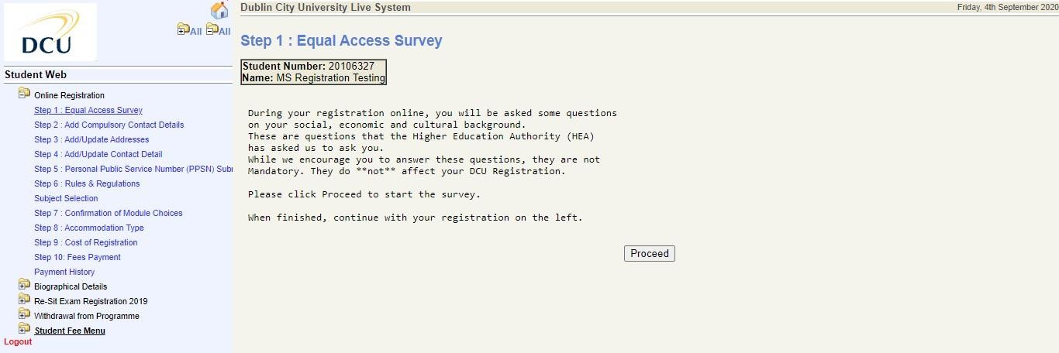
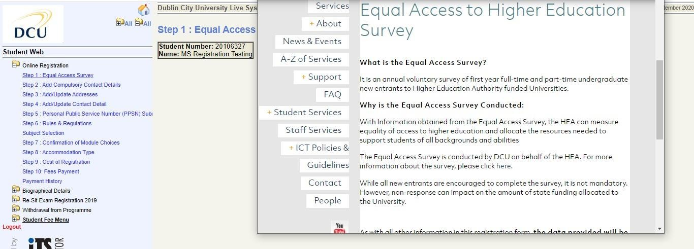

To complete the survey click ‘Proceed’ and the survey will pop up. Once you have completed your details, click ‘Submit’ and your results will be submitted. Then click ‘Yes’ when asked ‘Have you completed the survey?’ on the next screen.

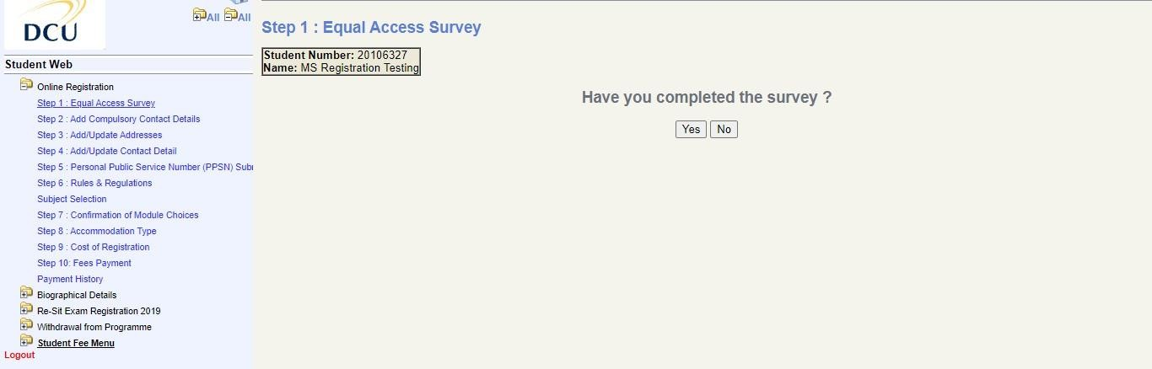

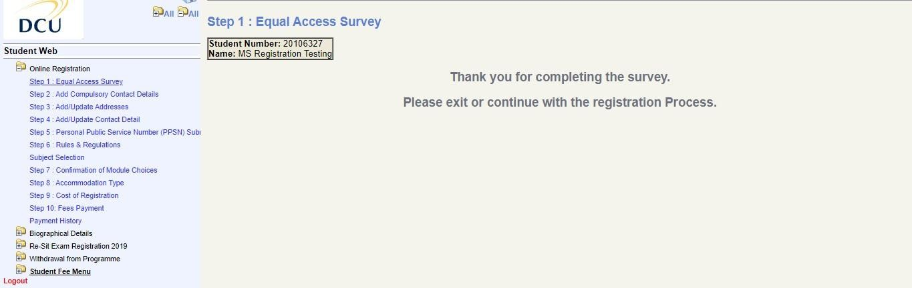

Please enter your ‘Next of Kin Telephone number’ and click ‘Save’ and then enter the ‘Name of Next of Kin’ detail and click Save’. These details will only be used in the case of an emergency.

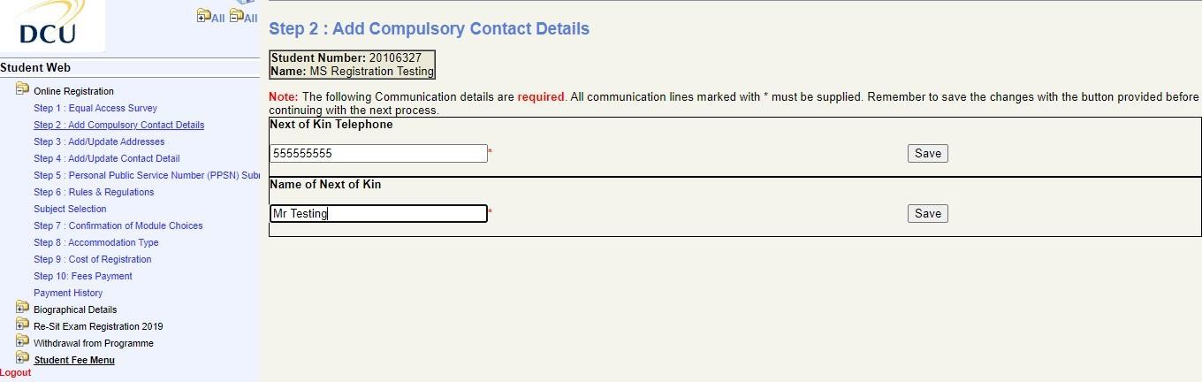

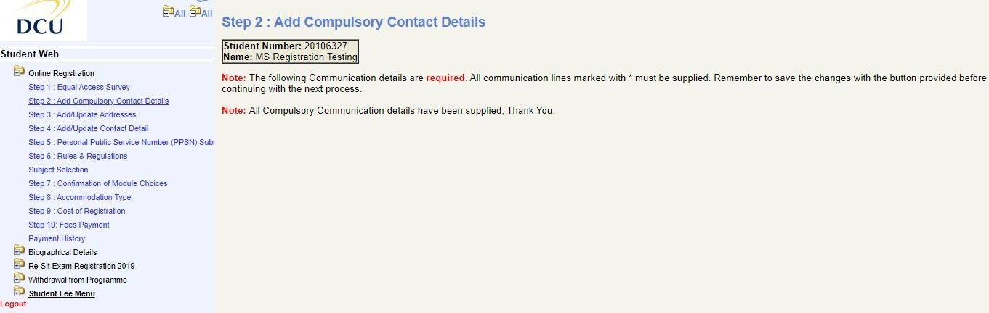

Please update your postal and study address details and save. Please note all correspondence from DCU is sent to your postal address.

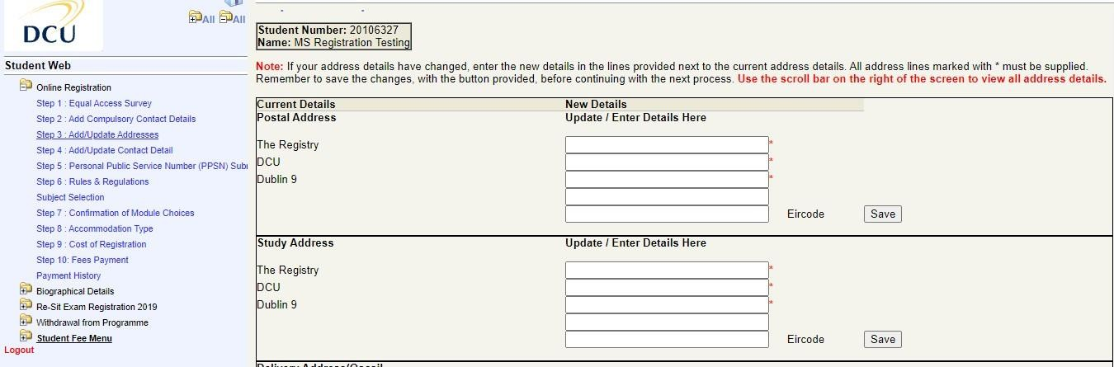

Please update your contact phone numbers and save.

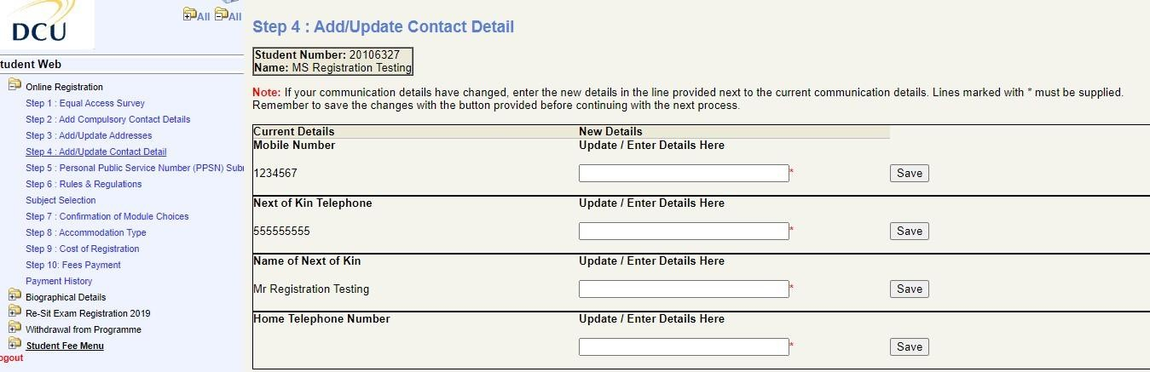

DCU are collecting student Personal Public Service Numbers on behalf of the HEA. Please enter your PPSN (if applicable) and click ‘Continue’ to proceed to the next step.

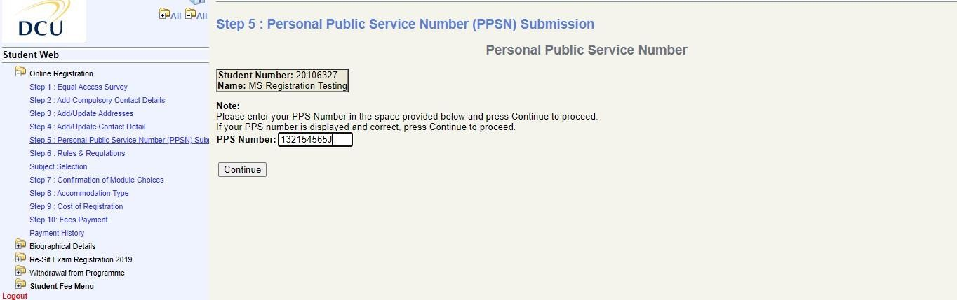

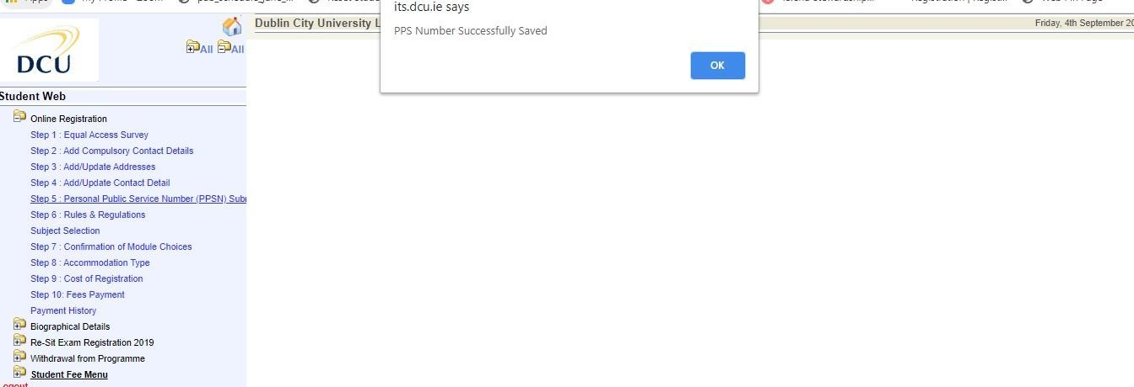

NB you must read and accept the Rules and Regulations of the University prior to registering for your programme of study. Please ensure to click the “I Accept” button on this page before continuing to the Subject Selection page.

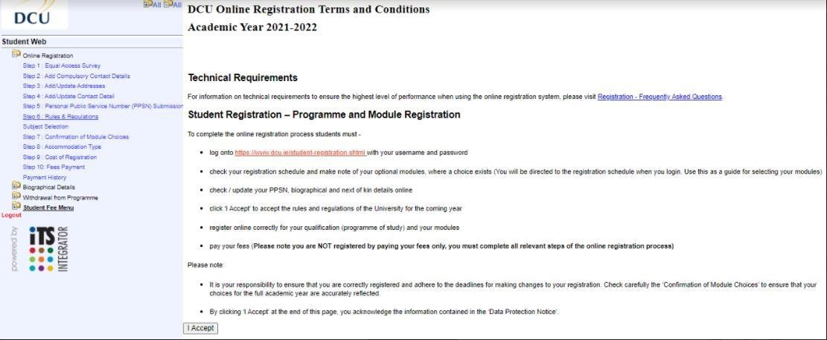

Please note - If you have all compulsory modules (no optional modules) available to you on your
programme, when you click ‘I accept’ on Step 6, you will be registered for your qualification and your modules and will skip to the Confirmation of Module Choices page.

Select your optional modules for each Semester according to the instructions displayed on the registration schedule. This is the document you reviewed on logging in with your
username and password. Please ensure you choose the correct combination and sufficient credits in each Semester. Once you have ticked the box beside each of your preferred optional modules, click
‘Continue’.

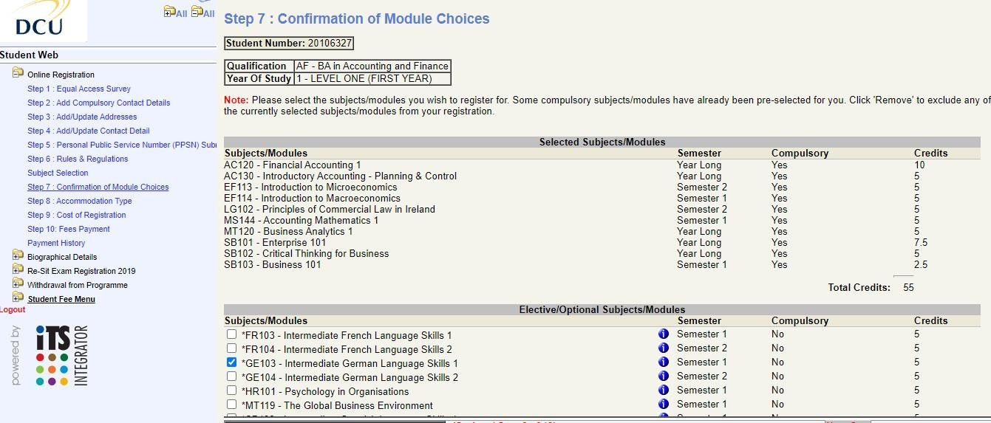

This next page will confirm the modules you have chosen. Please review this to ensure you have registered correctly. If you have not selected the correct modules, you can change the optional modules during the Semester 1 Change of Module Period - http://www.dcu.ie/registry/registration/Semester_1_change_of_module.shtml

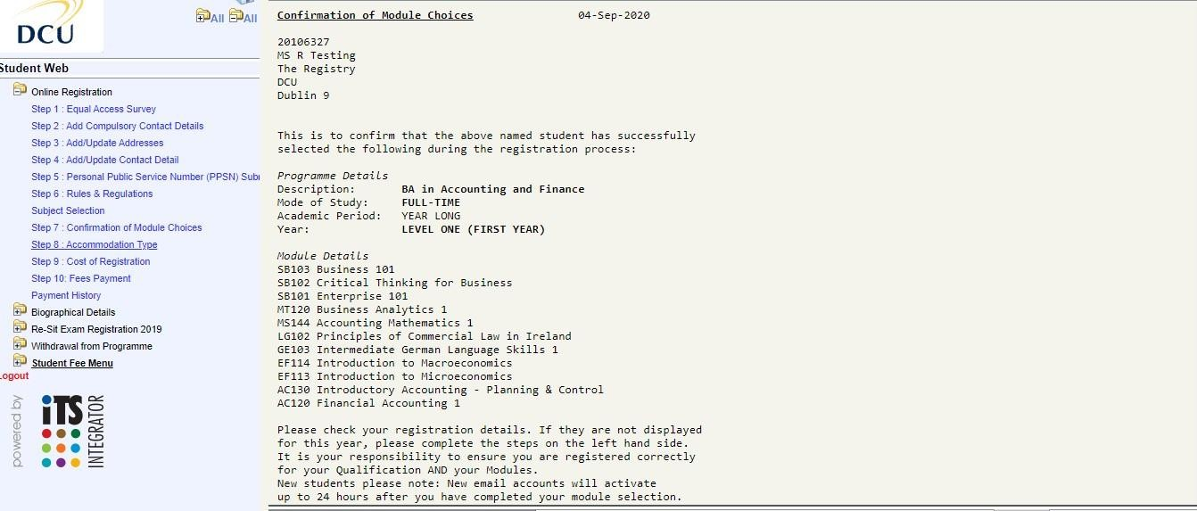

Click on Step 8 and update your accommodation type for the coming academic year i.e. Parental Home

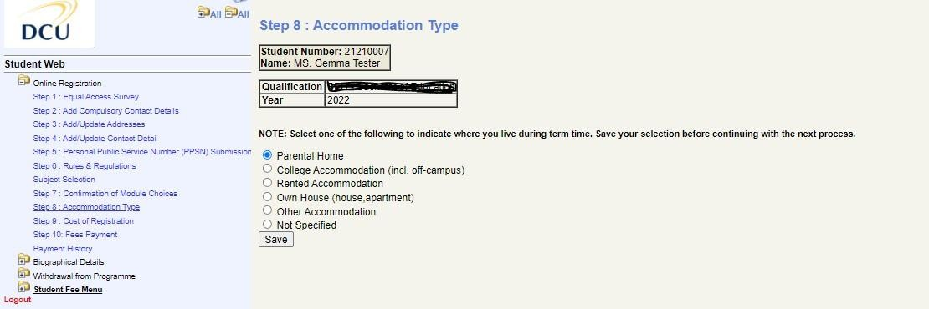

Step 9 Cost of Registration: This details the cost of registration for your programme of study, should you wish to print it for your records.

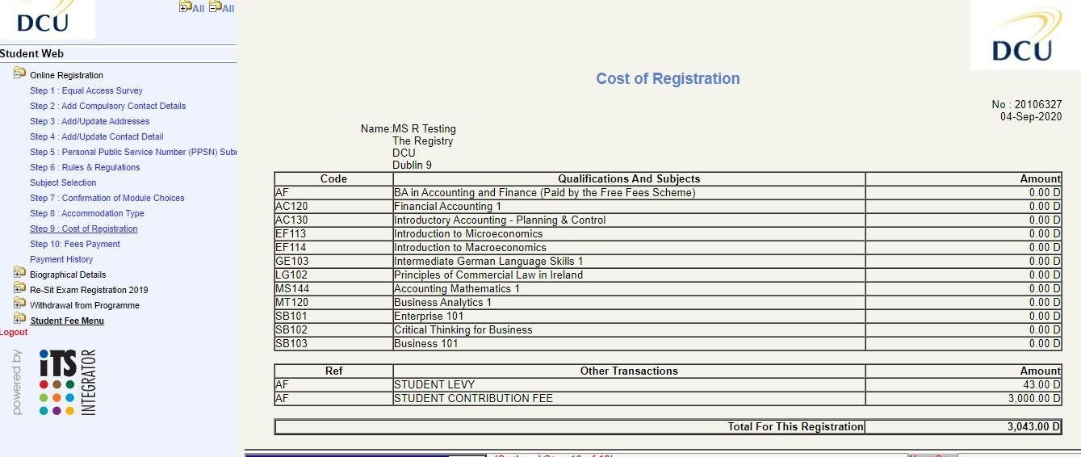

Please click on the fees option relevant to you and complete the payment process. Please note that you can return directly to this step and pay the balance at a later stage. If you do not wish to pay online you can also visit the fees website for more options on how to pay your fees - http://www.dcu.ie/finance/register.shtml
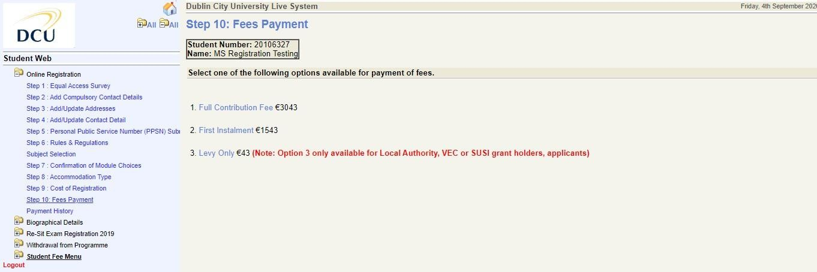

Please note - Your student card (for new incoming students) will not be issued until you have paid your fees.

Please ensure to logout of the process if you are not using your own personal PC or device.

