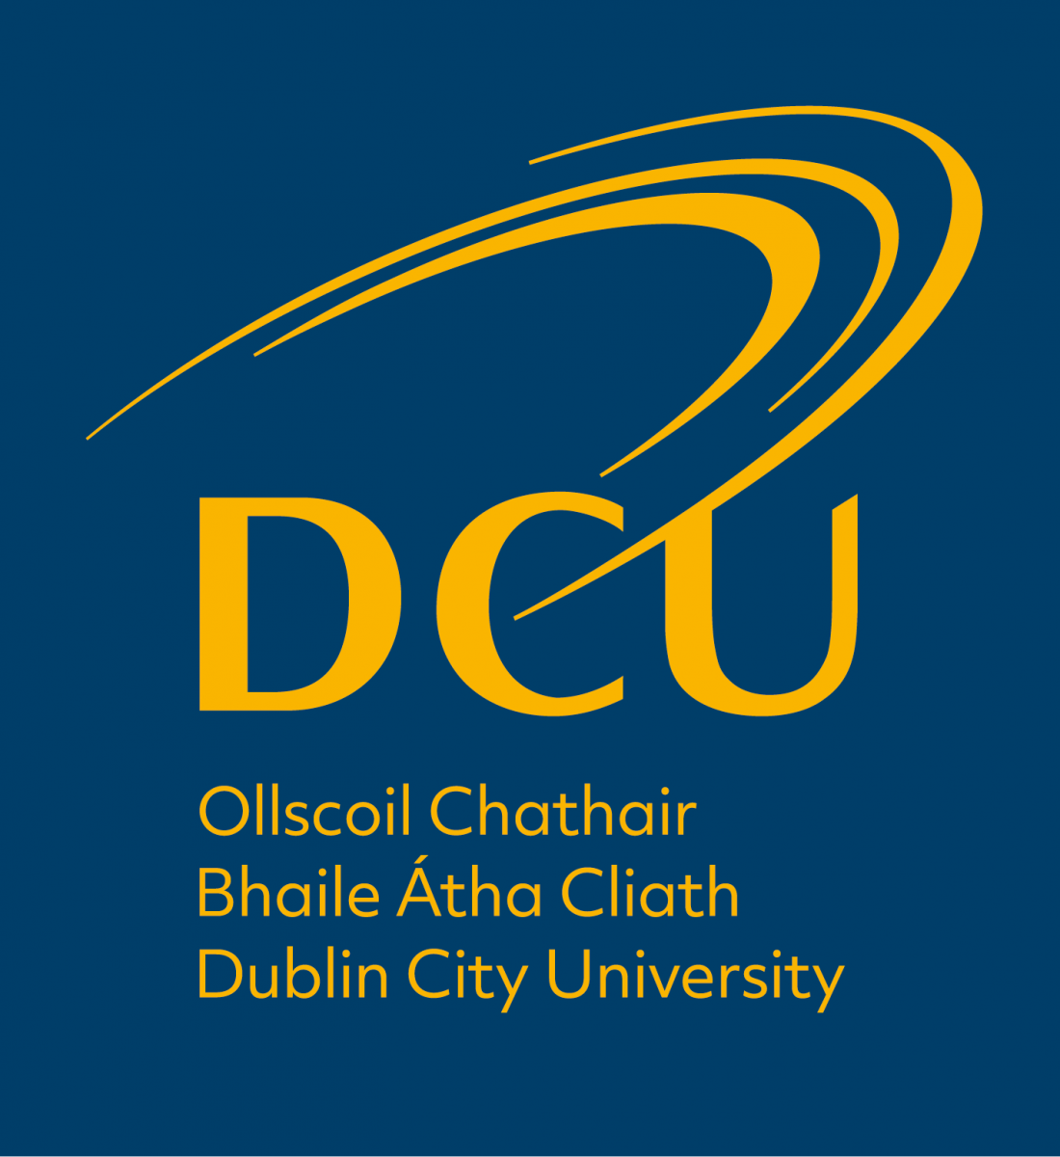

McAleese Scholarship for Northern Ireland Students

APPLICATION FORM

Guideline

- For entry September 2022, DCU applicants with a permanent home address in Northern Ireland, may be eligible to apply for a McAleese Scholarship. The scholarship includes a cash award and allows successful applicants to gain one of up to five reserved places across a number of DCU undergraduate courses.

- Restrictions: There are a number of programmes which will not be included in this scholarship process due to externally driven restrictions to programme quotas.

- Entry Requirements: Applicants must meet DCU minimum entry requirements and specific programme entry requirements as outlined on the DCU website, http://www4.dcu.ie/registry/entry.shtml. The scholarships are based on presentation of three A-levels, with a minimum requirement of 2 ‘A’ and 1 ‘B’ grades. The required personal statement below will be used in the event of ties on point scoring.

- Eligibility: To be eligible, applicants must apply through the Central Applications Office before the normal closing date for applications, 1st February at 5.15pm, or before the late closing date for applications, 1st May at 5.15pm. See: www.cao.ie for further information. In addition, students must submit this form with a personal statement, directly to DCU (address at the end of the form) before 1st July 2022. Applications received after this date will not be processed.

McAleese Scholarship for Northern Ireland Students
APPLICATION FORM

This form must be completed in block capital letters using BLACK ink. All questions MUST be answered.

Date applied to CAO: _______________ CAO Number: _______________

BIOGRAPHICAL INFORMATION

Surname: First Name/s: _______________________________________
(Name used in your CAO application):

Date of Birth: _____ / _____ / _____ Gender: Male Female

Home Address (as used in your CAO application) | Contact Details
 | Home Telephone:
 | Mobile Telephone:
 | E-mail address:

PERSONAL STATEMENT:

Please attach (in typed format) a 400 word statement on each of the following topics;
- Why you want to pursue a degree at Dublin City University (200 words).
- What aspect of your chosen DCU Degree Programme/s interest you most? (200 words).

DECLARATION

I certify that the information given in this application is correct and if admitted as a student member of Dublin City University, I undertake to observe and comply with all the regulations of the University.

Signature of Applicant: __________________________________ Date: ________ / ________ / ________

Data Protection Notice: Personal information that you submit to Registry in connection with any service provision will be treated in accordance with the Registry Data Protection Notice, which can be viewed at the following website address: https://www.dcu.ie/registry/data-protection-notice.shtml

Please return this completed form and your personal statement to the address below before 1st July at 5.15pm:
Admissions Office, McAleese Scholarship for Northern Ireland Students, Registry,
Dublin City University, Dublin 9.
Telephone: +353-(0) 1-700 5338
E-mail: registry@dcu.ie; Web: https://www.dcu.ie/registry/admissions-registry

