**The *Health and Wellbeing Wheel* and *Health and Wellbeing Space*: tools to support student self-care and transition in the first six weeks at University and beyond.**

This project created a series of digital tools to support student wellbeing and successful transition to university within Loop. The personalised approach and self-assessment features serve to empower students to achieving greater awareness and to take action in relation to their health and wellbeing.

Migrate physical resources (workbook based) to an interactive, digital platform within LOOP. The project will involve developing and customising Moodle plugins.

**There are three key objectives:**

1. Design a pilot digital self-assessment tool (Wheel of Health and Wellbeing[1]), aligned to an agreed health and wellbeing framework. This tool will involve:

* a series of questions around how satisfied students are with areas of health and wellbeing, and the ability to rate their satisfaction on a scale of 0 (not satisfied) to 10 (highly satisfied).
* transforming the results into a visual representation. This will provide students with an overview of ‘where they are’ across a series of health and wellbeing areas. The Wheel will also indicate areas where greater balance could be achieved.

1. Create a personalised companion ‘*Health and Wellbeing Space*’. This tool will allow students to:

* target three areas to work on over the first six weeks (and beyond).
* identify techniques or actions under each of these areas to enhance their wellbeing.
* record their progress and evaluate what worked well. Students can then rate (with a star emoji).
* create a personalised toolbox to draw on and support their health and wellbeing.

1. During *Pathways to Success*, and in one-to-one coaching sessions, the Wheel can be shared with coaches as a starting point. It helps to create awareness of imbalances, prompt discussion around priorities, explore where they would like to see change, and identify barriers. This generates a renewed focus by setting goals and taking action to create a more ‘balanced wheel’. It can also be used as a touchpoint to check in regularly.

The QUID funding was used to scope the three frameworks however, additional funding was spent to customise and adjust to support our needs.

The first framework was rolled out in August 2022 to all incoming students as part of orientation. We will be assessing engagement through stats and feedback over the coming weeks.

The second framework was rolled out in week one as part of the Life Skills series.

The third framework is being rolled out this month as part of the *Pathways to Success* (life coaching) programme.

**(1) Sample ‘Healthy Start’ Wheel:**

*Section Intro:*

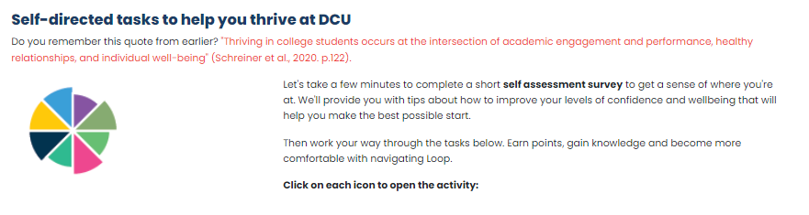

*Visual Wheel: Output based on responses*

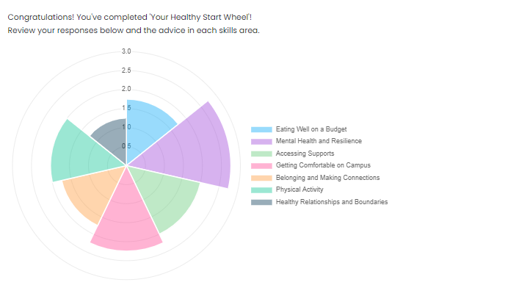

*Feedback*

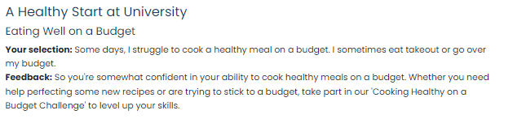

**(2) Sample Wheel of Life**

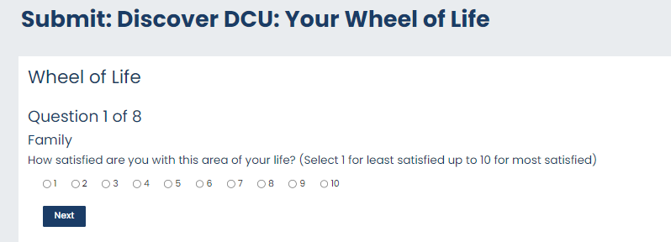

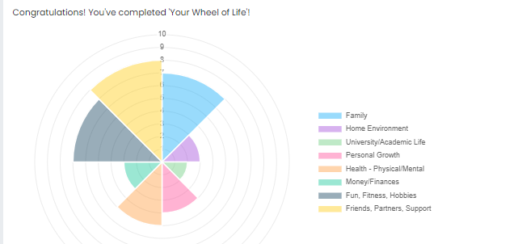

Coaches then work with the student to identify an action plan.

1. The ‘Wheel’ is a recognized and effective positive psychology and coaching tool to self assess areas of fulfilment and balance.