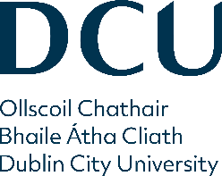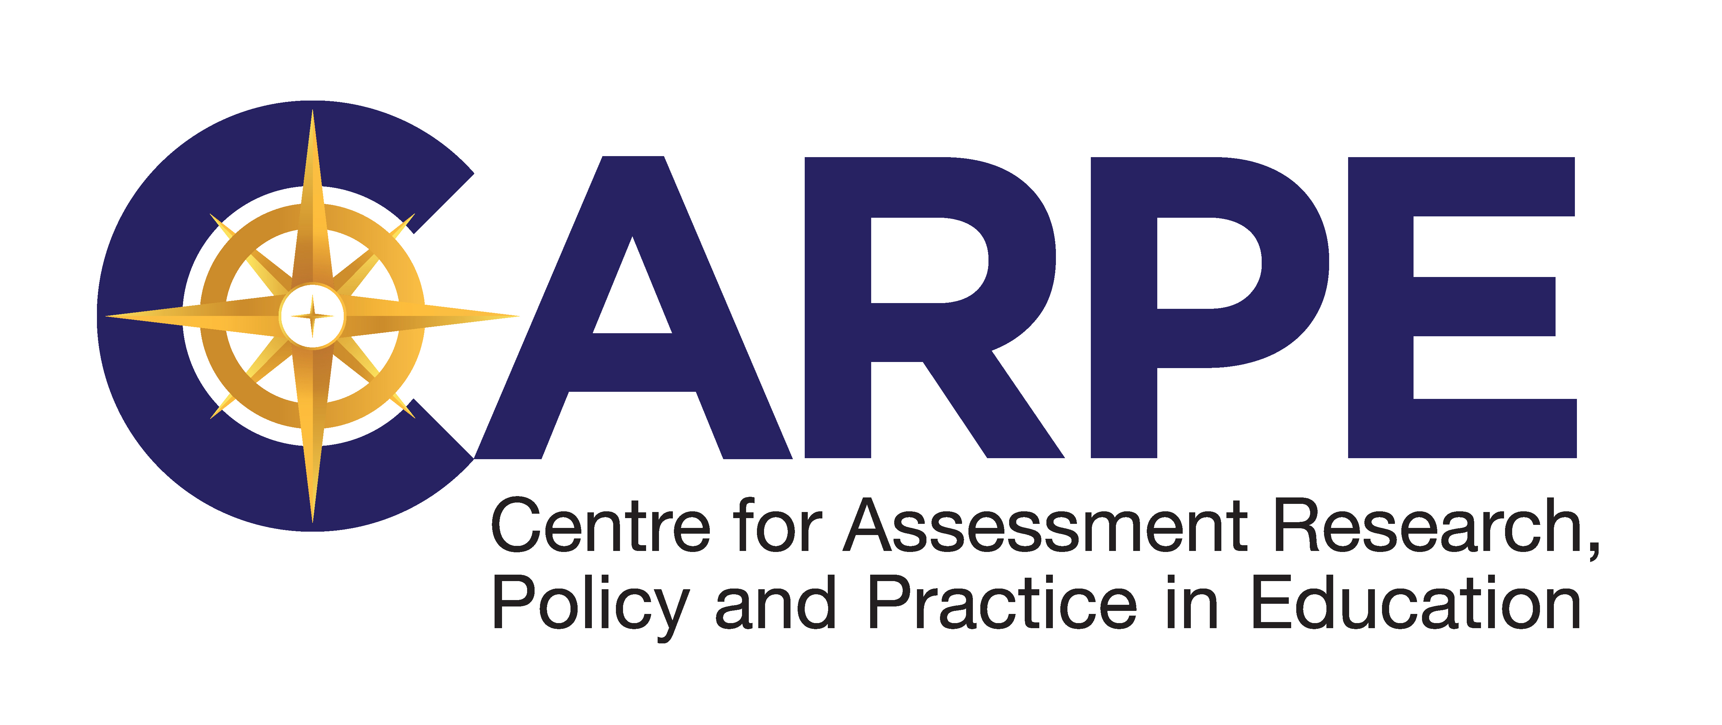
PhD Scholarship in Assessment
Centre for Assessment Research, Policy and Practice in Education (CARPE)
Dublin City University (DCU, www.dcu.ie) is a research-intensive, globally engaged, dynamic institution that is distinguished by both the quality and impact of its graduates and its focus on the translation of knowledge into societal and economic benefits. The Institute of Education (IoE) at DCU is the largest body of educational expertise and the only faculty of education in Ireland. The Centre for Assessment Research, Policy and Practice in Education (CARPE) is a core element of DCU’s IoE. CARPE is supported by Prometric, a leading, worldwide provider of technology-enabled testing and assessment services with a significant operations base in Ireland.
CARPE is now offering a three year fully-funded PhD Scholarship. This represents a unique opportunity to design and implement an innovative research project in the area of assessment, under the supervision of the Prometric Chair, Prof. Ernesto Panadero. The successful candidate will become a core member of the established research team at CARPE and will also have the opportunity to connect and collaborate with international researchers in the field.
In a time marked by increasing globalization, technology infusion and social change, both the education sector and the professional testing industry are facing significant challenges in terms of how best to design and deliver authentic, relevant, and fair assessments. It is, accordingly, a demanding, but exciting time to be a scholar in this field.
Scholarship Details
The research project will be focused on a contemporary issue pertinent to the field of assessment (e.g., harnessing the potential of artificial intelligence to improve assessment design and/or delivery, promoting diversity, equality and inclusion within assessment, enhancing test integrity and security). The specifics of the project will be developed in consultation with Prometric, and the outcomes will likely also be of interest to the educational community more broadly.
The successful candidate will be engaged full-time in their research and will be based on the St. Patrick’s Campus at DCU. In addition to completing their doctoral thesis, the successful candidate will be expected to contribute to related research outputs in the form of academic papers, industry reports and/or presentations at conferences in Ireland and abroad, and to engage in professional development courses as required by DCU’s Academic Regulations for Postgraduate Degrees regulations and by the Prometric Chair.
An annual package of up to € 24, 905 per annum for a maximum of 3 years comprising:
- Fee contribution of up to €4,905 per annum
- Tax-exempt stipend of €19,000 per annum
- Research expense funding of €1,000 per annum to facilitate travel to conferences and purchase of research materials - to be managed through DCU supervisor
Criteria
Applicants should have:
- a sound working knowledge of key issues in the field of assessment, particularly those relating to educational and workplace contexts
- an undergraduate and Master’s degree (or very close to completion) in which quantitative research was an important component
- the ability to conceptualise research projects pertinent to the design, development and/or delivery of tests and other forms of assessment
- high level competence in written and oral communication through English
- the ability to work independently and collaboratively in meeting demanding research goals
Shortlisted candidates will be interviewed. It should also be noted that the award is contingent on the applicant meeting all the requirements for admission to doctoral studies at DCU (https://www.dcu.ie/instituteofeducation/phdmasters-research-application).
To Apply:
Please email the following documents as a single pdf to carpe@dcu.ie, with Prometric PhD Scholarship in the subject bar of the email:
- Cover letter
- Full curriculum vitae, including a list of publications (if any) as co-author, and the names of two academic referees
- A copy of your degree certificate or transcript
- Draft Research Proposal – please use the template that appears within the DCU Postgraduate Research Studies Application Form (pages 4-6) available at https://www.dcu.ie/instituteofeducation/phdmasters-research-application
Note that the purpose of this draft proposal is to allow the candidate to demonstrate the necessary competencies. Following the selection process, the proposal may undergo substantial changes and refinement, and must ultimately be approved by Prometric.
In addition, please attach:
- A copy of your Master’s dissertation (if the candidate is close to completion, a statement including information about the Master’s programme and projected time of completion can be included in the cover letter)

Closing date for receipt of applications is 5pm (Irish time) on Friday, 17th November 2023.

Informal enquiries should be directed to Prof. Ernesto Panadero carpe@dcu.ie

Should the duration of the research project exceed three years, the successful candidate will be expected to self-fund from this point onwards.

