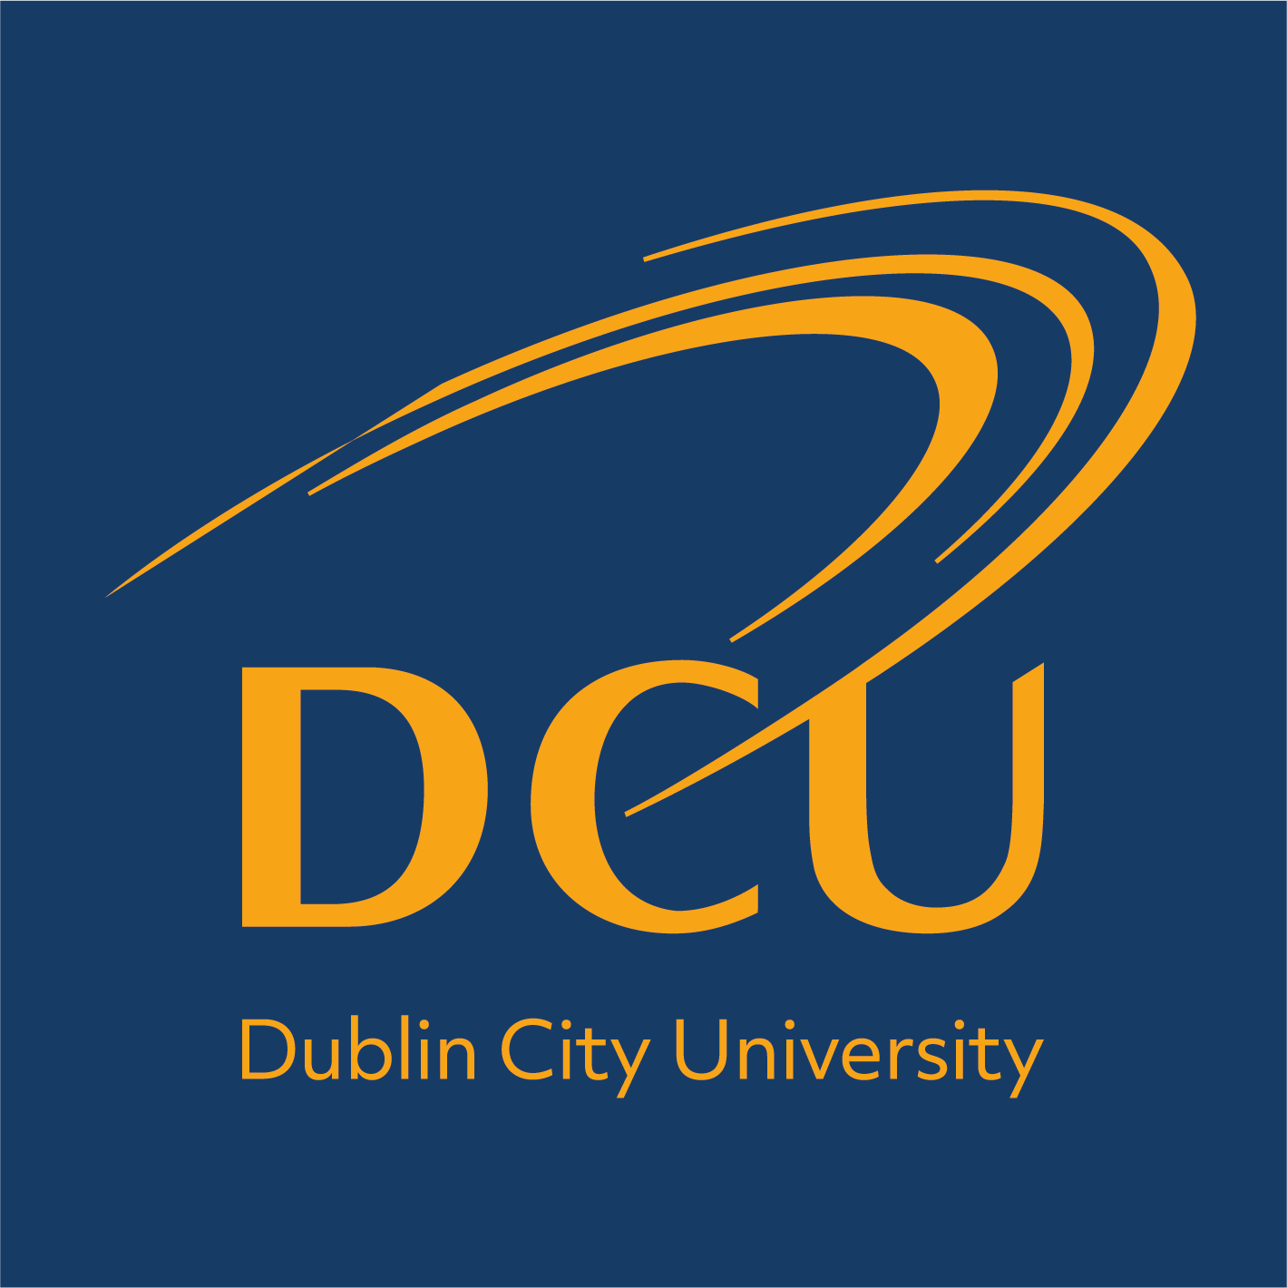

Boston University Fellowship
Expression of Interest Form

Under the agreement between Boston University (BU) and Dublin City University, each academic year DCU may nominate one faculty member for a fellowship of up to four weeks to pursue academic interests at BU. The fellowship exists to further the relationship between DCU and BU. The fellowship must be taken between 01 June - 31 May.

Recipients have full access to BU Library for the duration of the fellowship. BU will pay the faculty fellow's roundtrip coach airfare from Dublin to Boston (to be organised by BU’s programme coordinator at DCU), the cost of accommodations approved by BU, and a meal stipend of $800, pro-rated for stays shorter than four weeks. The fellowship does not include any salary or other stipend.

A call for nominations under the scheme is advertised annually by the International Office.

Steps in the nomination process:
- The International Office issues an annual call for expressions of interest.
- Interested DCU staff members are encouraged to complete this Expression of Interest Form, clearly outlining their intended activities at BU and the benefits of those activities to their teaching / research and to DCU.
- The DCU staff member must seek agreement from his / her Head of School before this Form is considered complete.
- Completed forms should be submitted to the International Office, marked for the attention of Audrey Byrne, or emailed to exchange@dcu.ie by 31st November 2021.
- A selection panel will make the final selection and confirm this year’s nomination to the member of staff.
- A nomination letter is sent to BU via the International Office.
- The BU office will then liaise with the recipient regarding flights, accommodation, and put them in touch with relevant BU personnel etc.
- There is a fairly lengthy lead-in time as recipients need to travel on a non-tourist visa. Therefore, there are a lot of forms to be filled out and recipients will also need to present themselves to the US embassy in Dublin to collect their visa and be processed through immigration procedures.
- Following their stay at BU, awardees are required to submit a report on their activities and experience to their Head of School and the International Office.

Expression of Interest by DCU academic member of staff
Please complete all areas of this form, including page 2

Full name: ____________________________________________________________

School within DCU: ____________________________________________________

Dates of intended visit (max 4 weeks): _____________________________________

- Briefly outline intended activities (for teaching, include subject area and level; for research, include focus area; also include other activities) please attach a separate document if necessary)

____________________________________________________________________
____________________________________________________________________
____________________________________________________________________
____________________________________________________________________
____________________________________________________________________
____________________________________________________________________
____________________________________________________________________

- Briefly outline the benefit of your intended activities to your teaching / research and more broadly to DCU.

____________________________________________________________________
____________________________________________________________________
____________________________________________________________________
____________________________________________________________________
____________________________________________________________________

Any other information relevant to application

____________________________________________________________________
____________________________________________________________________
____________________________________________________________________

Signed _________________________________ Date ________________________

Head of School Approval
N.B. Your nomination must be supported by your Head of School and you should seek approval by way of a signature below:

Name of Head of School: ________________________________________________

Signature of Head of School: ________________________________________________

Date: ________________________________________________

Please submit the fully completed form to Audrey Byrne in the International Office, or by emailing exchange@dcu.ie. The deadline for receipt is: 31st November 2021. It is anticipated the outcome will be announced by 15 December 2021.

