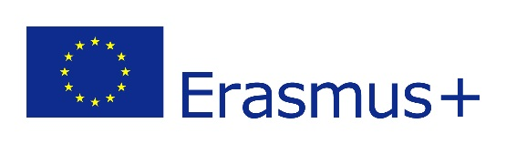

ERASMUS+ Certificate of Attendance
2021/2022
(To be completed at the beginning & end of the study period abroad)

This certificate confirms that:

(Name of DCU Student) ____________________________
(Name of Host University) ____________________________________

(Commencement of Study Date*) ____ / ____ / 2021___
*The date the student began his/her studies or attended an induction/orientation programme, not the date of arrival. To be signed & stamped by the Host office and returned to exchange@dcu.ie within 2 weeks of the Start of Study.
Signed: ___________________________________
Name and function: ___________________________
Date: _________________
Stamp of Host University:

(Completion of Study Date)* ____ / ____ / 2022___
*The date the student finished his/her studies or exams; please do not include an extended stay for leisure purposes.
This Cert can only be signed & stamped by the Host University up to a maximum of 3 days before the students’ official end of study date (i.e. last date equates to the students’ last exam or submission of assignments in person at the Host University).

Signed: ___________________________________
Name and function: ___________________________
Date: _________________
Stamp of Host University:

