**MSc. in Guidance Counselling (DC906)**

**Grad Dip Guidance Counselling Outreach (DC908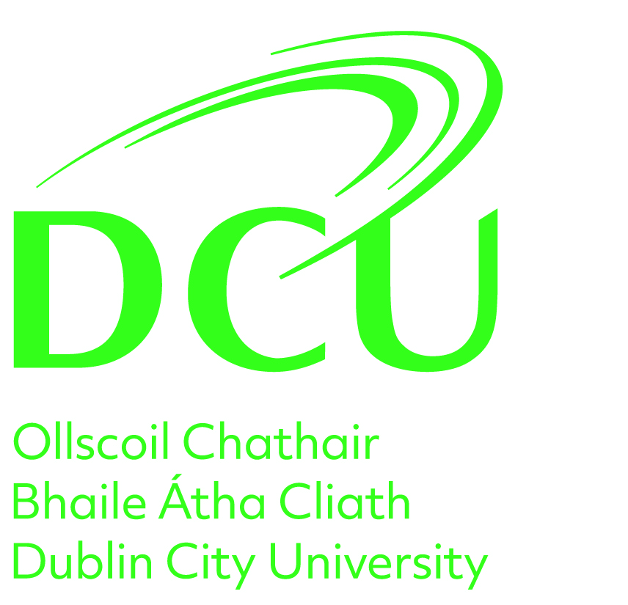)**

**2024/25 Guidance Notes**

**1. N.B. Instructions for Completion of this supplementary form (please read carefully)**

* Please **type** all of the details required on this Supplementary form.
* Please do not submit a CV / personal statement in addition to your application.
* Please upload this completed formto your profile [DCU APPLICATION PORTAL](https://dcuie2.elluciancrmrecruit.com/Apply/Account/Login?ReturnUrl=%2fApply)

**2. N.B. Instructions for completion of references (please read carefully)**

* **TWO REFERENCES MUST BE SUBMITTED FOR YOUR APPLICATION TO BE PROCESSED**. These references must be from an individual who knows you in a professional and/or academic capacity. Please add an email address for each of your referees via the portal.

**3**. **N.B. Official evidence of third level and or other professional/vocational qualifications (please read carefully)**

* **Non-DCU graduates -** please note you must submit with your application official documentary evidence of any third level and or other professional/vocational qualifications that were not completed at DCU.
* **DCU graduates** are not required to submit evidence of degree (s)/postgraduate qualifications pursued at DCU. However, if you are a current DCU student/past DCU graduate and have also completed additional degree (s) /postgraduate qualifications in another University/College, you must submit official copies of your non-DCU qualifications with your application.
* **PLEASE DO NOT SUBMIT ANY DOCUMENTATION REGARDING QUALIFICATIONS DIRECTLY TO THE PROGRAMME CHAIR.**

**DC906 & DC908 Supplementary Form 2023/24**

**Please indicate your preferred programme of study by placing an X in the appropriate space. Applicants who choose both programmes will be asked at interview to state their preference.**

1. **DC906 ______ 2. DC908 _____ 3. Both _____**

**Application Number _______________________**

**Applicants Name: (in full) ________________________**

# **1. You are requested to attach a passport-size photograph below**

# **(for the purpose of identification only)**

**2. Contact Details:**

|  |  |
| --- | --- |
| Address for Correspondence | Home Address |
| Work Telephone No. | Home Telephone No. |
| Mobile Telephone No. | E-mail Address |

**3. Third Level Education**

|  |  |  |  |  |
| --- | --- | --- | --- | --- |
| Date **(Most recent first)** | Institution | Subjects | Qualification | Result |
|  |  |  |  |  |

**4. Other Relevant Academic/Professional Non-Degree Training**

|  |  |  |  |  |
| --- | --- | --- | --- | --- |
| Date **(Most recent first)** | Institution | Subject Area | Qualification | Result |
|  |  |  |  |  |

**5. Career Experience (Paid and Unpaid)**

|  |  |  |  |
| --- | --- | --- | --- |
| **Date (Most recent first)** | **Institution** | **Nature of Work** | **Full-time or Part-time** |
|  |  |  |  |

**6. Please answer (a) and (b) you may add an additional page if necessary**

1. **Why you wish to pursue this programme (max. 200 words)**
2. **The personal qualities and experience, which you consider relevant to your application (max. 400 words)**

**PLEASE DO NOT SUBMIT A PERSONAL STATEMENT ON YOUR APPLICATION AS THIS ONE IS SUFFICIENT.**