How to enquire on a New Customer

Customer Set up Enquiry

To run an enquiry on the status of a New Customer go to, Reports /Global reports/ Customer Master/ Customer Master lookup:

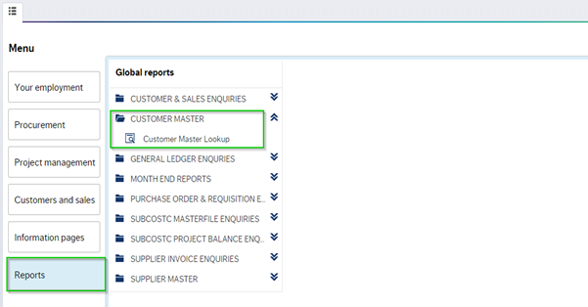

Click on ‘Customer Master lookup’ a new window will open:

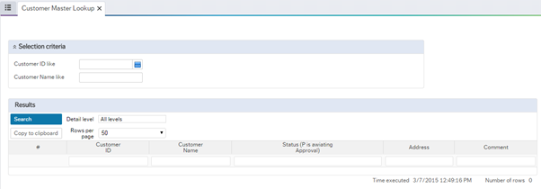

To check the status of a customer you have submitted, simply enter the ID number in the customer window and click search:

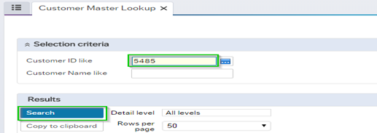

Details of the Customer will populate. If the Customer is active it will be at status ‘N’, Any customer awaiting approval will read “P” for parked:

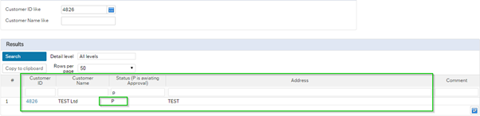

If the Customer is Closed details will read ‘C’ for closed, with a comment beside it e.g. ‘Duplicate’:

