School of History and Geography  Doctoral Research Scholarship Application Form  All sections of this form must be completed, and the form emailed to historyandgeography@dcu.ie before 5pm on 9th June 2025. | 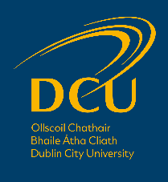

Section 1: Applicant Details
First (Given) name: | Surname (Family name):

Email address:

Highest academic degree achieved:

Section 2: Research Proposal

The research proposal is expected to fit within the aims and framework of the “Diaspora Diplomacy” project, but is nonetheless independent. Candidates should try to balance originality with feasibility and fit.

Research Proposal Title:

Abstract (max. 250 words):

Description of the proposed research (max. 1000 words):

Section 3: Personal Statement

Why do you wish to pursue postgraduate research studies? (max. 500 words)

Section 4: Referees
Please provide the name and contact details of two referees at least one of which must be in relation to your academic studies:
Name & Position Held | Address | Email

Section 5: Scholarship Award Conditions
All scholarship awards are on the condition that you meet DCU entry requirements, that your qualifications are supported by relevant documentation and that you complete an application via the DCU application system.

Section 6: Data Protection Notice
Personal information that you submit in relation to this Scholarship Application will be treated in accordance with the DCU Data Protection policy.

