BRIEFING PAPER 2: TARGETING THE NEEDS OF CHILDREN AND YOUNG PEOPLE IN A HOLISTIC WAY FOR EARLY SCHOOL LEAVING PREVENTION
Dr Paul Downes, Urbact PREVENT Project

INTRODUCTION
A focus on the individual pupil and student’s learning needs is a key dimension of early school leaving prevention for the EU2020 headline target on early school leaving prevention of 10% average across the EU. This focus on individual’s learning needs is to be undertaken in a holistic and systematic way. The following classification offers a framework for teachers’, schools, parents and municipalities to examine aspects where the child or young person’s needs are or are not being met. This framework is also relevant at policy level to assess where there may be strategic gaps in interventions and supports across the system, especially with regard to those pupils and students at risk of high nonattendance at school and of early school leaving.
While these issues below may be relevant for all students as part of a universal approach, many of the issues are mainly focusing on those children and pupils at highest levels of need, at chronic need levels of indicated prevention (see prevention levels below).
Learners’ Supports Needs can be classified under the following areas:

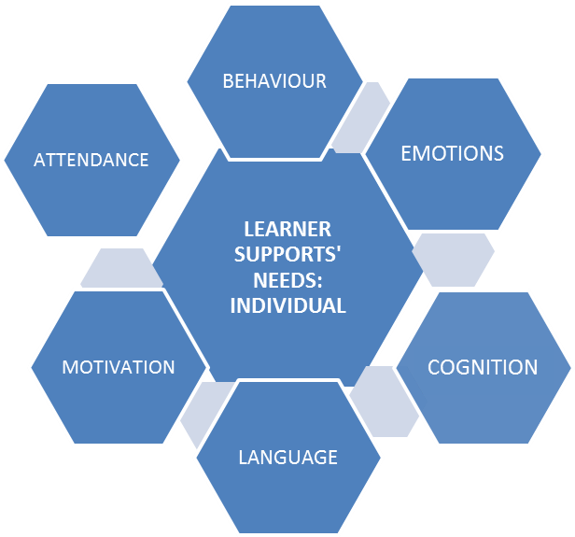

Attendance (Outreach to families, data monitoring of individual’s progress)
Behaviour (Mediators, Alternatives to suspension, Behavioural contracts, assertiveness training, bullying prevention approaches, teacher conflict resolution skills at pre-service and in-service for responsive approach to individual student’s needs, restorative practice programmes in school)
Emotions (Counselling onsite in school, crisis supports, non-verbal therapeutic supports for younger children, mental health supports, substance abuse issues, attachment issues and appropriate supports in place; integrated education and health individual plan)
Cognition (Beyond use of grade retention, classroom assistants for children with special needs, group-work in class to learn from interaction with peers, teacher pre-service on developing higher order questioning skills and constructivist learning approaches)
Language (First language early intervention with speech and language therapy, parental involvement for first language early intervention, including family literacy, State language supports for migrants, parent peer supports, availability of age-appropriate books)
Motivation (Building on strengths through public ceremonies for recognition of achievement, ipsative assessment practices, i.e., assessing progress in relation to the child’s own previous performance, individual education plans, leadership/responsibility opportunities in class and regarding student councils, looking after pets, plants in school, peer tutoring, activity based approaches for engaging boys especially, supports for parental involvement in education at home and in school, specific arts and sports based opportunities, flexible timetable for older students with high levels of need)

- 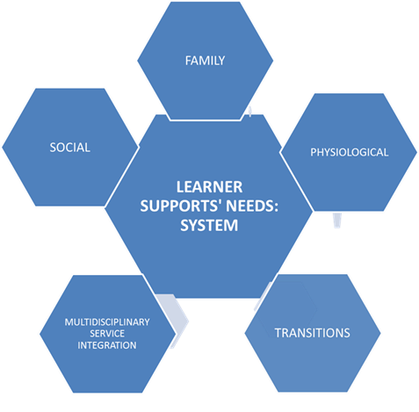

- Social (after-school clubs, clear expression of cultural identity in the physical environment of the school, opportunities for social communication between teachers and later post-primary students through shared meal spaces, festivals in school and community environment to build cultural bridges to minority groups)
- Family (child-centred family support outreach for highest levels of need of families with intergenerational poverty and/or substance misuse problems, family literacy approaches in the home, teenage mothers to have access to childcare to attend school)
- Physiological (Sleep deficit needs affecting memory, concentration, behaviour and learning; hunger in school needs)
- Transitions (Pre-service training for teachers on children’s individual attachment styles and needs, Bridge programmes between primary and post-primary schools, peer supports upon transition to new environment, flexibility to start school at different times of the year)
- Multidisciplinary service integration (flexible interventions depending on level of need at a given time, clear responsibility for lead person, links between community based multidisciplinary teams and specific schools targeting most at risk children and young people)

*With regard to levels of need it is important to distinguish between 3 levels of prevention well-recognised in health and increasingly entering educational understanding (Downes 2011):
Universal prevention – for all students
Selected prevention – for groups of students at moderate levels of risk/need
Indicated prevention – individualised, intensive intervention at chronic/extremely high levels of risk/need.
*Another dimension for consideration is whether the individual support is periodic or ongoing – and whether the intensity of the support can be flexibly altered through support systems

RELEVANT GUIDING PRINCIPLES NEED TO INCLUDE:
A continuum of care approach to ensure needs are consistently met across ages and to minimise disruptive influences of transitions
A holistic approach to integrate academic and emotional/physical needs of the learner
A differentiated approach based on different levels and kinds of need to ensure that students do not fall through the gaps; it highlights the need for strategies to distinguish between those of moderate and high risk of early school leaving.
A systemic approach to go beyond ad hoc, short-term approaches (see also Downes 2014)
Early intervention and prevention
A multidisciplinary approach for level of chronic/highest complex needs of the learner
Outreach needs to include both community outreach and individual (child and family) outreach; this must be clearly distinguished from mere attempts to give out information to groups
A culturally sensitive and responsive approach that engages with different ethnic groups and social classes from the starting point of their own concerns
An evidence informed approach that uses research to inform strategic policy making

SYSTEM FRAGMENTATION
Addressing diverse needs of pupils and students in a holistic way must also address the need to challenge system fragmentation. A key system blockage highlighted by the PREVENT network is that of system fragmentation. This can take place where there is a diffusion of responsibility across different agencies in a municipality about who is the lead person responsible for organising a strategy of engagement with families and children experiencing social marginalisation. There is a need to go beyond a fragmented approach both within a school and of endless referrals across services that are ‘passing on bits of the child’ (Edwards & Downes 2013) and family.

References
Downes, P. (2011). Multi/Interdisciplinary Teams for Early School Leaving Prevention: Developing a European Strategy Informed by International Evidence and Research. Commissioned Research Report for European Commission, NESET (Network of Experts on Social Aspects of Education and Training).
Downes, P. (2014). Towards a Differentiated, Holistic and Systemic Approach to Parental Involvement in Europe for Early School Leaving Prevention. Policy Recommendations Report for the EU Urbact, PREVENT project involving 10 European City Municipalities.

