BRIEFING PAPER 1: DEVELOPING MULTIDISCIPLINARY TEAMS FOR EARLY SCHOOL LEAVING PREVENTION
Dr. Paul Downes, Urbact PREVENT Project

Introduction
Many pupils and students at high risk of school non-attendance and early school leaving present with a range of interconnected difficulties requiring support from more than one kind of professional. These difficulties can also be at a systemic level, such as school climate and institutional culture, as well as involving family systems. The teacher cannot be expected to address the range of these complex individual and system needs on his/her own. Other professionals are needed and these need to be part of a team, including with schools, for a coordinated approach, rather than individuals operating in isolation. While many education systems in Europe are yet to fully develop models of interprofessional working for early school leaving prevention (Cedefop 2014), a range of examples from a number of European countries show this is both possible and necessary (Edwards & Downes 2013; TWG 2013). This briefing paper seeks to highlight key aspects for the establishment and expansion of such multidisciplinary teams.

WHO ?
Target Group

- Those most at risk of early school leaving – Chronic need (indicated prevention level)
- Such chronic needs may be, for example, high non-attendance at school, intergenerational substance abuse, mental health difficulties, experience of trauma, such as domestic violence, sexual abuse, suicide, bereavement, emotional neglect, children in care, first language delays in development
- Poverty may typically contribute to and also exacerbate some of these chronic needs
- Aim for early intervention –both early years and early to prevent onset of problems becoming more severe
- Includes a focus on change to systems – school communication practices, family support

Professionals

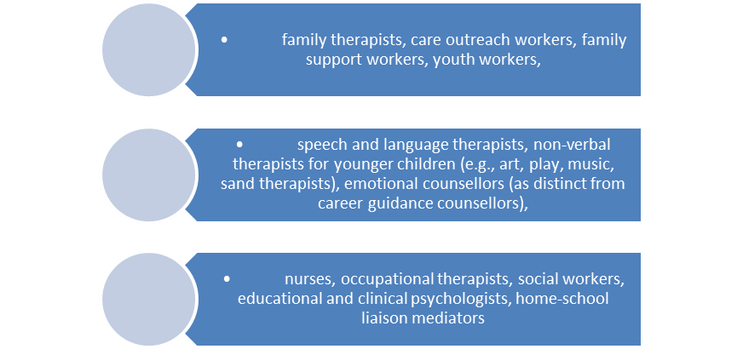

WHY?
- Complex needs of children and their families requires multifaceted response
- There is not one reason why children and young people leave school early
- To address system fragmentation
- To go beyond many services ‘passing on bits of the child’ (Edwards & Downes 2013)
- To be clear on who is responsible for taking lead role with the child and family
- Addresses social and emotional needs, language needs, practical needs of those at risk of early school leaving
- Offer flexibility to change level of intensity of support over time depending on need
- Offer continuity so children, young people and families are not dealing with fast changing staff and can build relations of trust with them
- A family focus is possible rather than simply on individual children

WHERE?
- Location needs to be accessible physically and culturally to marginalized families
- Ideally a both/and model of community location and working in and around schools
- Needs to be in a neutral space in often divided communities
- A community space is part of an outreach approach to families
- It can build from existing services with community credibility, expanding the range of multi-professional approaches

WHAT?
International research suggests that community based teams working also onsite in schools offer a model of good practice to engage with the different systemic levels of intervention at individual, group/peer, school, family and community levels.
Interventions for the following priority areas:

HOW?
- Key issues to be addressed – the what question – requires central direction for a strategic approach but the how question – which exact approach to be used to intervene – depends on the professional judgment of the team
- A key part of the team’s approach is that its staff are culturally competent and have a credibility with the target groups
- There is a need to move from multiple agencies to one or at most two teams collaborating with children, young people and their families for early school leaving prevention
- Develop a funding strand to incentivise local services to take a multidisciplinary approach to early school leaving prevention; make this funding contingent on a clear framework of what issues they seek to address for early school leaving prevention and which proposed members of the team will take leadership on a specific issue. Such a funding proposal needs clear evidence that a range of local schools are part of this agreed framework and have agreed that their pupils/students will engage with this service
- For existing services such as social workers, school psychologists, family support workers, mentors etc., the municipality could facilitate meetings to develop an integrated strategy to decide who is working a) on what issues for early school leaving prevention and b) with which individuals and families. Developing a framework for collaboration is a step towards full multidisciplinary teamwork.

HOW TO EXAMINE THE PROGRESS OF THESE MULTIDISCIPLINARY TEAMS?
Outcome indicators as part of a strategic direction for such mental health multi/interdisciplinary teams are:
a) At an individual level
- gains in attendance at school
- improved behaviour in class
- decrease in bullying in class and school
- decreased anxiety and depression and improved mental health, including academic self-efficacy and global self-esteem
- increased academic motivation and performance
- increased language development
b) At a family level
- increased engagement of previously marginalized families with support services
- increased engagement of previously marginalized families with the school
- improved communication between child and parents
c) At the school system level
- decreased use of suspensions
- increased use of alternatives to suspension
- improved school and classroom climate
- decrease in bullying in class and school
KEY PARTS FOR THE INTERNAL EFFECTIVENESS OF MULTIDISCIPLINARY TEAMS
Common ideas of key goals for the teams – A shared framework of goals across disciplines
Collaboration with schools over shared goals
Awareness of the potential for role conflict
A distinct leadership role to avoid diffusion of responsibility
Awareness of intra-team communication building and conflict resolution approaches
Addressing concerns with confidentiality

References
Downes, P. (2011). Multi/Interdisciplinary Teams for Early School Leaving Prevention: Developing a European Strategy Informed by International Evidence and Research. Commissioned Research Report for European Commission, NESET (Network of Experts on Social Aspects of Education and Training).
Downes, P. (2013). Invited Presentation, Developing multi-agency and cross-sector synergies in and around education, 5th meeting of the European Commission, Directorate-General for Education and Culture (EAC), Thematic Working Group on Early School Leaving, Brussels, 28-29 January 2013
Edwards, A. & Downes, P. (2013). Alliances for Inclusion: Developing Cross-sector Synergies and Inter-Professional Collaboration in and around Education. Commissioned Research Report for EU Commission NESET (Network of Experts on Social Aspects of Education and Training). Foreword to report by Jan Truszczynski, Director-General of the European Commission’s Directorate General for Education and Culture.
Edwards, A. & Downes, P. (2013). -Joint presentation to over 30 European Commission officials from Directorate General, Education and Culture, Cross-sector policy synergies and inter-professional collaboration in and around schools: Examples and evidence. May 28, 2013, Brussels.
European Commission (2013). Reducing early school leaving: Key messages and policy support Final Report of the Thematic Working Group on Early School Leaving. Brussels: Directorate General, Education and Culture.
European Commission/EACEA/Eurydice/Cedefop, 2014. Tackling Early Leaving from Education and Training in Europe: Strategies, Policies and Measures. Eurydice and Cedefop Report. Luxembourg: Publications Office of the European Union.

