Invent hosts technology transfer workshop at ESOF event

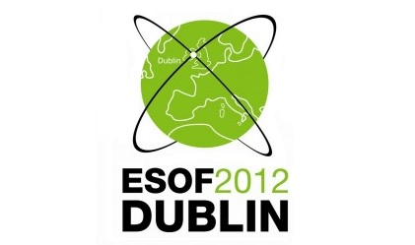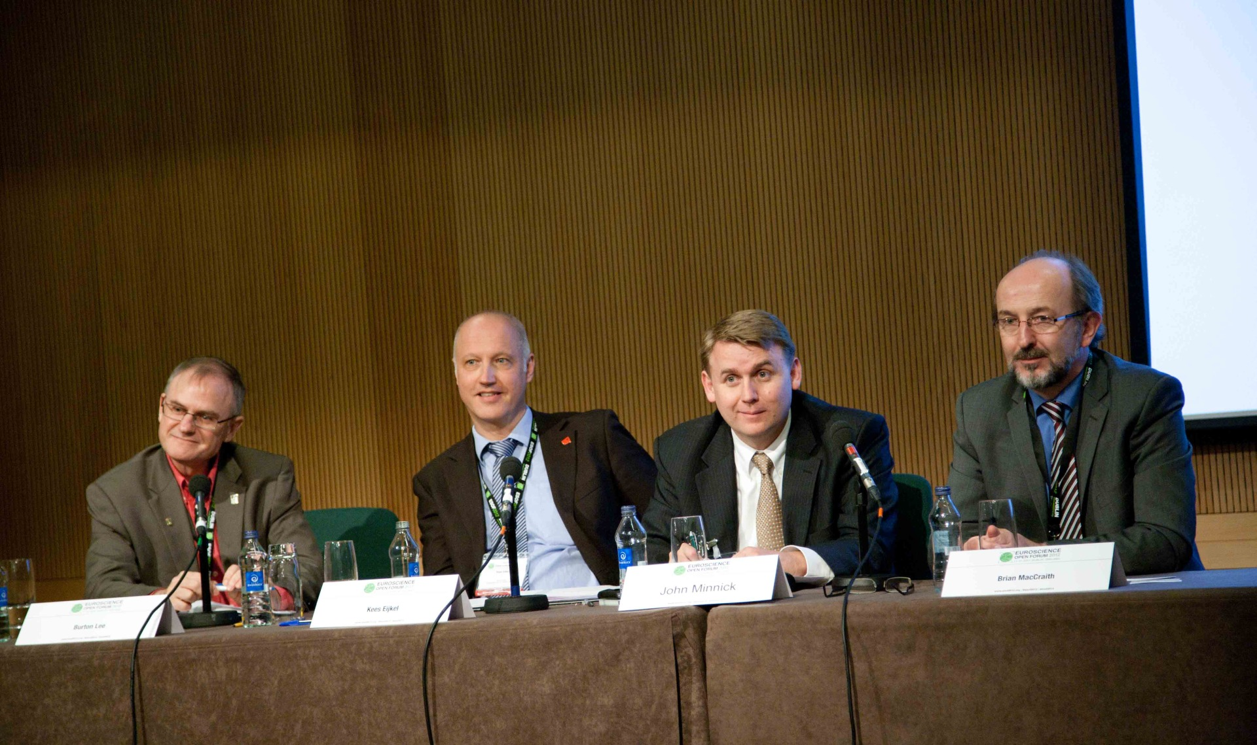

Invent DCU has just hosted a workshop in the Euroscience Open Forum as part of the Science to Business Programme. The workshop was entitled: ‘What should universities do to encourage more spin outs and licensing arrangements?’ and we were delighted with the calibre of speakers we managed to attract for this event.
The workshop brought together leading figures in technology transfer worldwide which included Dr. Burton Lee from Stanford University, John Minnick from the University of Utah, Dr. Kees Eijkel, University of Twente in The Netherlands along with our own DCU President Prof. Brian MacCraith. We were delighted that such distinguished speakers agreed to take part in the event and it was a great accolade for DCU to host this. The presentations from the speakers outlined their own particular campus journey in technology transfer with a focus on the importance of embedding an innovation ecosystem university wide and also linking in with the community. It also became apparent that support for student start ups should also be a key area in a university’s strategy if we are trying to increase university start ups. The presentations were followed by a very lively Q&A session and we would like to express our sincere thanks to Pat Brazel, Invent Board member, who did an excellent job in moderating the event.
Invent DCU also hosted an event the following day in the Helix, DCU where Dr. Burton Lee from Stanford and John Minnick from University of Utah gave more detailed presentations on the topic. It is very important for DCU to build relationships with world leaders in the field of technology transfer.

Pictured L to R: Dr. Burton Lee (Stanford University), Dr. Kees Eijkel, Kennispark, University of Twente, The Netherlands), John Minnick (University of Utah), Prof. Brian MacCraith (DCU).

