ICT research collaboration opportunities for industry highlighted at ‘Collaborate to Innovate’ Event

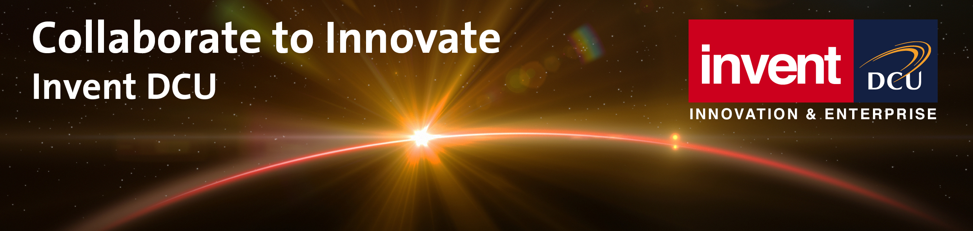

Invent hosted a hugely successful ‘Collaborate to Innovate’ event in the Guinness Storehouse on 21st June. This event was a testament to how DCU engages with companies of all sizes on collaborative research projects and focussed particularly on the EI funded Innovation Partnership scheme. This programme allows Irish based companies to work with universities like DCU and provides funding to cover up to 80% of the cost of the project. The key focus of the evening was a series of presentations from the leaders of companies collaborating with DCU to bring new technologies to market. Presenters included David Walsh, CEO Netwatch; Brian Spector, CEO Certivox; Gabriel Hogan, Research and Innovation Manager, Ericsson Ireland and Joe Marks, Former VP of Disney Research and Founder of New Irish Start-Up Upfront Analytics.
Each of the presenters told compelling stories of the origin of their businesses, the challenges they faced and how a collaboration with DCU helped their business and gave them an advantage in the marketplace. The final speaker was Gearoid Mooney, Director ICT in Enterprise Ireland who singled out DCU as the most progressive university in terms of industrial engagement in the ICT sector. A video outlining the range and variety of projects that DCU has completed in the ICT space was also shown. The presentations were followed by an opportunity for companies to meet directly with the researchers, who came equipped with their demos and an appetite to talk to companies. The event was a great success being attended by over 150 companies. If you are an Irish-based technology company and you want to find out how your company can leverage research in DCU and in the process tap into generous state funding to do so, please contact Paddy O'Boyle at paddy.oboyle@invent.dcu.ie.

