M2C charging ahead in Electric Vehicle industry

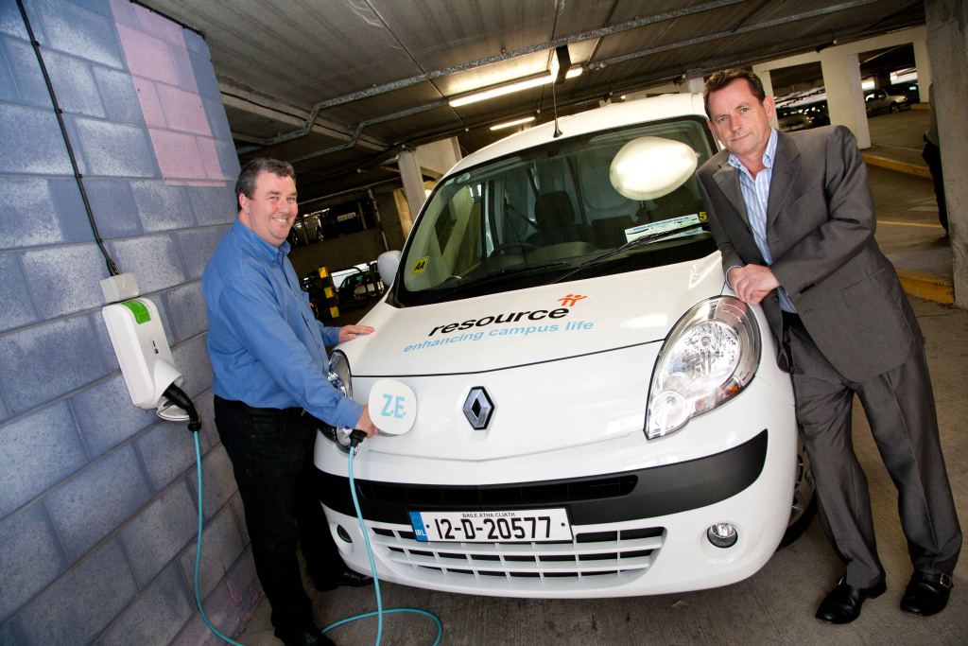

Invent company M2C is delighted to announce that they have successfully developed an electric vehicle charging unit that is more advanced, adaptable and smarter than current product offerings. In October 2010, they began a project with the ESB ECar Division to create an Electric Vehicle Charger. Problems with current charging units include reliability and communications issues. M2C have developed a new reliable product with greater communications capability.
The first delivery of this new product was in December 2011, when M2C delivered 200 Chargers to the ESB ECar Division. Since then they have shipped Electric Vehicle Chargers to Intel, Northern Ireland Electricity and Smith Electric in Newcastle, UK. An additional 200 units are soon to be delivered to the ESB ECar Division. They are currently submitting for an ECar tender worth €1 million over 2 years.
One of M2C’s charging units has recently been installed in the multi-storey car park on the DCU campus. Currently Resource, DCU’s contract cleaning company, has recently purchased an electric vehicle and is now able to charge it on campus. This is a further example of DCU’s commitment to a greener environment.
M2C’s device is also installed at Dublin Airport, the Offices of the Revenue Commissioners, Dublin City Corporation Offices, An Post Depots (Dublin, Galway and Cork), Belfast Hospital and Vauxhall among others. In addition to this, Intel is using the units for research into smarter homes and buildings.
M2C was founded in June 2009 by DCU graduate Michael Berry and a group of engineers. They have developed a range of products in the area of embedded electronic devices. The company has now grown to five full-time and one part time staff. For more information: http://www.m2c.ie/

Pictured L to R are Michael Berry, M2C Founder and CEO and Gary Martin, M2C Commercial Director

