DCU Spin out Pilot Photonics locates in Invent

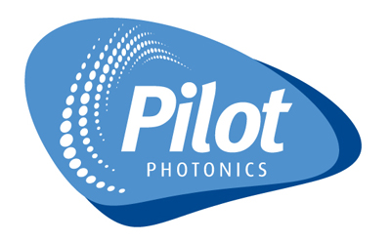
Pilot Photonics is a DCU spin out focused on the high capacity fiber optic networking business. Their optical wavelength comb source technology allows more data to be packed into existing optical fibers and they are currently marketing the technology as a powerful instrument for fiber optic telecommunication R&D and product development laboratories.
Since taking on investment in February 2012, Pilot Photonics has secured initial orders for its optical comb source technology and carried out evaluation trials of that technology with the world’s largest optical component manufacturer. The company has now located in Invent DCU in order to make use of the advanced fiber optic test and measurement facilities available at DCU. We are delighted to welcome the Pilot Photonics team aboard and wish them every success!
For more information see http://www.pilotphotonics.com/index.html

