Instructions for adding logo to email signature

- The Athena Swan logo is available from the Communications and Marketing webpage. Download the Logo to your computer.

- In your email, click on the cog icon on the top right hand corner of the screen and then select Settings.
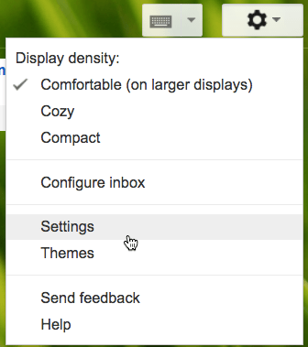
- Scroll down to Signature. If No Signature is selected than select the button below this to turn signature on. Enter the text details that you would like to appear.
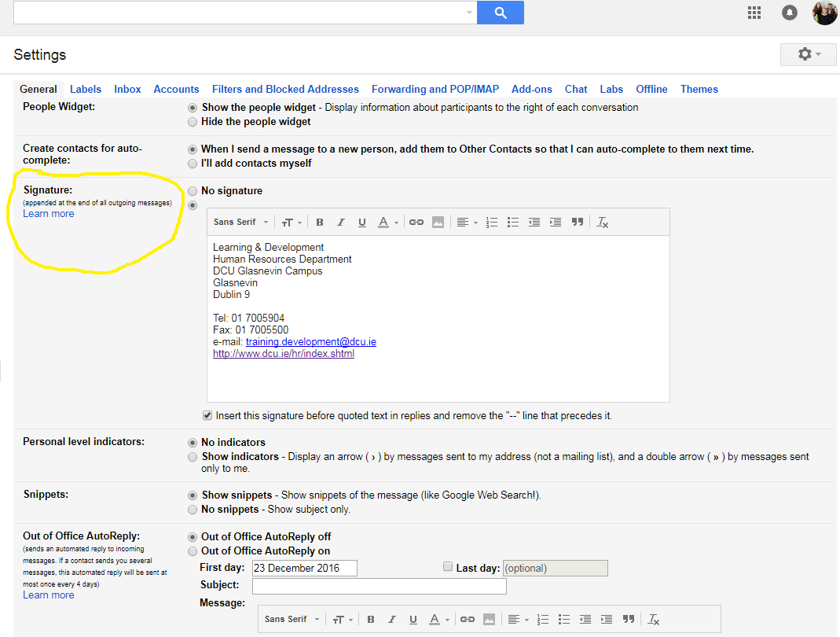
- To add the image select the area you want the image to appear (eg above / below signature) and then press the “Insert Image” button.
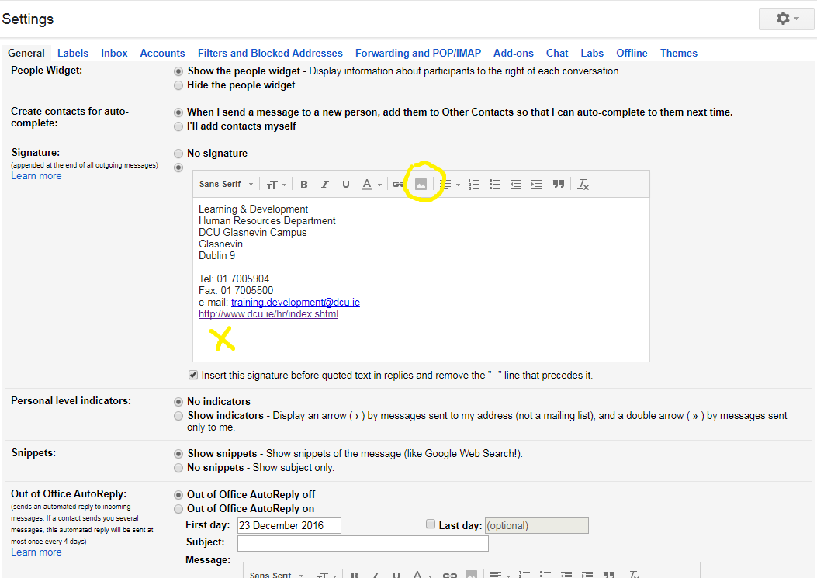

- Drag and drop the image or select and insert from your computer
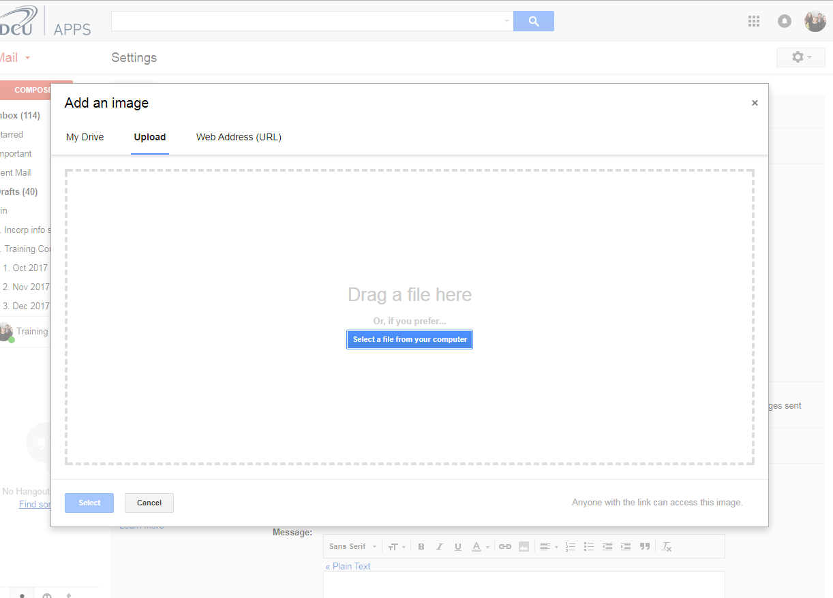
- The logo should appear in the signature window.
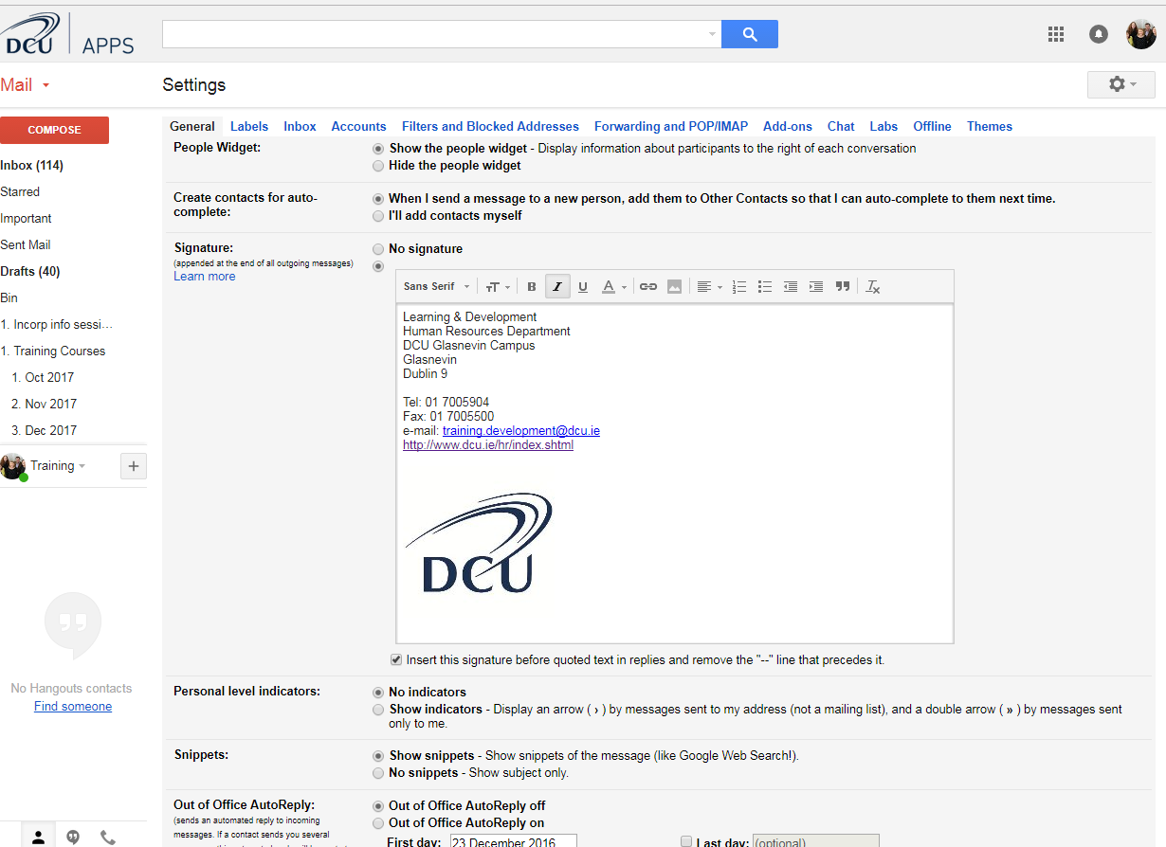

- Scroll down to the bottom on the Settings window and click save.

