Procedure for Academic Misconduct Investigation and Sanction

The text on the process for dealing with alleged academic misconduct is outlined in the flowchart in Appendix III)

This procedure should be read in conjunction with DCU’s Academic Integrity Policy.

Detection and Initial Investigation

1.1 If the academic staff member to whom the assessment is submitted is satisfied that there is a case to answer, they must complete a report in writing (see Appendix II) to the designated School staff member responsible for managing academic misconduct cases (for example Programme Chair, School Teaching and Learning Convenor).

The report must include:

- The relevant material (dissertations, essays, code, diagrams, video, audio, web pages, etc.), including a web link for Internet sources.
- Academic Misconduct: an explanation as to how the student’s submitted work constitutes academic misconduct.
- Plagiarism: a brief textual analysis – for example, identical work, or portions of work, from different students; presenting others’ work as the students’ own; absent or misleading references.

The student’s record will be checked to ensure there is no previous academic misconduct.

Any alleged academic misconduct may be referred directly to the University Disciplinary Committee.

1.2 First Offence

In a case that is considered to be a first offence, an interview may be arranged between the student and the School representative(s) to allow the student(s) concerned to respond to the allegation of academic misconduct. This interview will be conducted electronically or face to face.

1.3 Second Offence

In the case of a second offence, i.e. where a student has already been sanctioned at School or University level, their case will immediately be referred to the University Disciplinary Committee. Notification of such action must also be sent to the Associate Dean for Teaching and Learning/Education at Faculty level for noting at Faculty Teaching and Learning Committee (notification of final outcome must also be sent by the School representative). All communication with the student will be recorded and copies retained by all relevant parties initially. If the allegation of academic misconduct is not upheld by the Disciplinary Committee all official records of the alleged offence must be destroyed/deleted. If the allegation is upheld by the Disciplinary Committee the records will not be destroyed and will be retained according to the University’s data retention policy.

Full Investigation (School/Faculty)

  - Option of interview or referral to University Disciplinary Committee

The student can waive the interview with the School panel and have the matter referred to the University Disciplinary Committee. The matter must be referred to the University Disciplinary Committee if the student retains legal representation, for example a solicitor.

  - Interview

Where a student’s record shows no previous academic misconduct, and alleged misconduct is being dealt with at School level, an interview will be held with that student such that they may answer to the allegation. This interview may be conducted face to face or electronically.

The interview panel will involve, at a minimum, the School representative and another academic member of staff (for example, the staff member who identified the alleged misconduct). As part of the interview process, the student will be asked if they have ever had any allegation of academic misconduct upheld before, either in DCU or elsewhere. The allegation of academic misconduct will be explained to the student with the evidence explained. The student will then be given the opportunity to refute the allegation or outline any extenuating or mitigating circumstances involved in their case. Records of the interview must be kept; these records may be electronic or paper based.

The student is entitled to bring an observer to the face-to-face interview, or involve an observer in the interview process taking place electronically. In the case of a face-to-face interview or a synchronous electronic interview, the interview panel must be notified, at least 48 hours in advance, of such planned observer attendance, including the name of the observer and their relationship to the student. This observer may not be a legal representative. The role of the observer is as a support and an observer for the student, not an advocate. As such, they will not speak or otherwise intervene in the proceedings.

  - Communications and Interview Records

Communications with the student and interview records must be retained initially by the relevant academic staff member. If the allegation of academic misconduct is not upheld, all records of the alleged instance must be destroyed/deleted. If the allegation is upheld, the records will not be destroyed and will be retained according to the University’s data retention policy.

Sanctions

3.1 Sanctions applied at School/Faculty level

The penalty at School/Faculty level for academic misconduct will be proportionate to the nature and scale of the offence. Offences committed in later years of an undergraduate programme will generally be regarded as more serious than similar offences in earlier years.

Taught postgraduate students are generally expected to have a much greater understanding of academic integrity and the consequences of misconduct than are undergraduates.

All penalties for academic misconduct will be greater than the penalty for submitting poor work or none. If the allegation is upheld, local penalties may include:

- A zero mark for an assessment component and a requirement to resubmit the assessment component. Additional work may be imposed.
- A zero mark for the complete assessment and a requirement to resubmit the complete assessment. Additional work may be imposed.
- A zero mark for the module and the requirement to resit the module or repeat it in the following academic session. Additional work may be imposed.

The full implication of the penalty must be made clear to the student, including potential impact for progression and/or award.

3.2 Other sanctions

In egregious cases, the University Disciplinary Committee may impose higher sanctions, including suspension from the University for a year or permanent exclusion from the University.

Recording of local sanctions imposed

  - Faculty Record of Sanction

A record of sanction must be kept at Faculty level. Notification of sanction must be sent to the Associate Dean for Teaching and Learning/Education for noting at Faculty Teaching and Learning Committee.

  - Central Record of Faculty Sanction

Where the allegation is upheld at local level, a flag will be added to the centrally-held student record to ensure that, should a second event occur of this nature, even if in a different School or Faculty, the first incident would be visible.

  - Referral to University Disciplinary Committee

If the interviewing panel believes that the range of available local sanctions is not sufficient, the matter will be referred to the University Disciplinary Committee and record of action kept at Faculty level. Notification of such action must also be sent to the Associate Dean for Teaching and Learning/Education at Faculty level for noting at Faculty Teaching and Learning Committee (notification of final outcome must also be sent by the School representative). If the allegation is not upheld at the University Disciplinary Committee, all official records of the alleged academic misconduct must be destroyed/deleted.

Outcome of School process

Students should be informed promptly in writing of the outcome of the School process.

If a student does not accept the outcome of the School/Faculty process, they should be informed that they have the right to have the case heard from the beginning by the University Disciplinary Committee.

6. Processes in respect of postgraduate research students

- Allegations of unacceptable academic or research practices such as falsification of data are dealt with under DCU Procedures for Responding to Allegations of Research Misconduct.

A judgement as to whether or not academic misconduct has occurred is integral to the examination of research reports submitted for formal assessment (such as at confirmation of a research student on the PhD register, and at award stage). The recommendations of the examiners, in line with Academic Regulations for Postgraduate Degrees by Research and Thesis, reflect the outcome of this evaluation.

7. Retrospective academic misconduct

- In cases where academic misconduct is alleged subsequent to the awarding of credit, DCU may invoke this policy, the policy for the Revocation of University Awards or Credits, or DCU Procedures for Responding to Allegations of Research Misconduct and may, if the allegations are upheld and the offence serious, revoke the credits or award given.

8. Review

This policy and associated procedures will be reviewed by University Standards Committee after the first year of operation and thereafter, every three years of operation. Any updated policy will be referred to Academic Council for approval.

- Appendices

- Appendix I: Student Declaration of Academic Integrity
- Appendix II: Template form for academic staff for reporting cases of academic misconduct
- Appendix III: Flowchart outlining process for dealing with academic misconduct

Appendix I: Student Declaration of Academic Integrity

Students may be required to submit work for assessment in a variety of means, for example physical submission or electronic submission as per the lecturer’s instructions. In all cases students must make a declaration of academic integrity, either by physically completing such a declaration and submitting it with their assignment or engaging appropriately with the electronic version of the declaration on Loop. Assignments submitted such that the form has not been included, or the electronic equivalent has been circumvented, will not be accepted.

DECLARATION

Name:
Student ID number
Programme
Module Code
Assignment Title
Submission Date

I understand that the University regards academic misconduct as grave and serious.

I have read and understood the DCU Academic Integrity Policy (insert hyperlink when approved and published). I accept the penalties that may be imposed should I engage in academic misconduct.

I have identified and included the source of all facts, ideas, opinions and viewpoints of others in the assignment references. Direct quotations, paraphrasing, discussion of ideas from books, journal articles, internet sources, module text, or any other source whatsoever are acknowledged and the sources cited are identified in the assignment references.

I have not made unauthorised use of artificial intelligence aids.

I declare that this material, which I now submit for assessment, is entirely my own work and has not been taken from the work of others save and to the extent that such work has been cited and acknowledged within the text of my work.

I have used the DCU library referencing guidelines (available at https://www.dcu.ie/library/citing-referencing and/or the appropriate referencing system recommended in the assignment guidelines and/or programme documentation.

By signing this form or by submitting material online I confirm that this assignment, or any part of it, has not been previously submitted by me or any other person for assessment on this or any other course of study.

By signing this form or by submitting material for assessment online I confirm that I have read and understood the DCU Academic Integrity Policy (Insert updated link, once approved and published)

Signature

Date:

Appendix II: Form for academic staff for reporting cases of alleged academic misconduct

Where a case is being referred to the University Disciplinary Committee, the form below should also be appended to the Disciplinary Committee complaint form.

Complete section A, B C, D and E

SECTION A:

Provide the following details:

Student ID |  |  |  | Date
Student name
Programme |  | YEAR |  | Module
Lecturer/Tutor,  ETC. |  |  | Academic misconduct Representative

SECTION B: ALLEGED ACADEMIC MISCONDUCT

Indicate as appropriate:

Submission of work not the student’s own, irrespective of whether the student paid for or commissioned this work
Commissioning or buying of work via professional agencies
Submission of same/similar work for more than one assessment
Falsification of research results, data, interview or any other research procedure
Unauthorised use of Artificial Intelligence aids
Provision of false information to obtain unjustified concessions
Reproduction of work (even with small changes) of another, sourced from books, journals, articles, multimedia files, lecture notes, the Internet, etc., without appropriate acknowledgement to the author(s) of that work
Collusion by a group of students to present an assessment, or a substantial part thereof, when the assessment required individual research and outcome to be presented
Other (provide a description of the academic misconduct)

SECTION C:

Describe the academic misconduct involved, providing excerpts or examples as appropriate which demonstrate or represent the same.

SECTION D:

Attach all relevant material (in the appropriate format) relating to the alleged academic misconduct

SECTION E

Record of outcome of local interview procEDURE

APPENDIX III
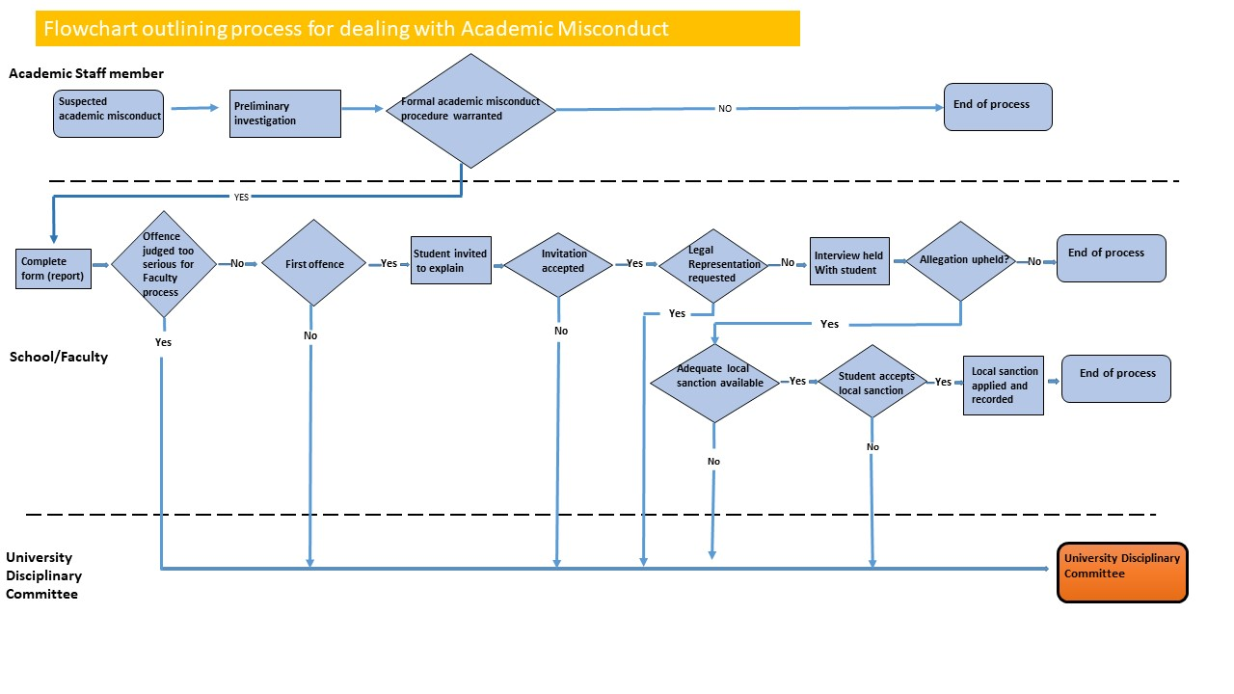

In the case of modular, continuous or part-time programmes, indicate in years the length of the student’s registration on the programme, e.g. first year of registration, second year of registration, to clarify the student’s academic record/experience to date.
Usually programme chair, module co-ordinator, teaching convenor, etc. Please contact Head of School for details

