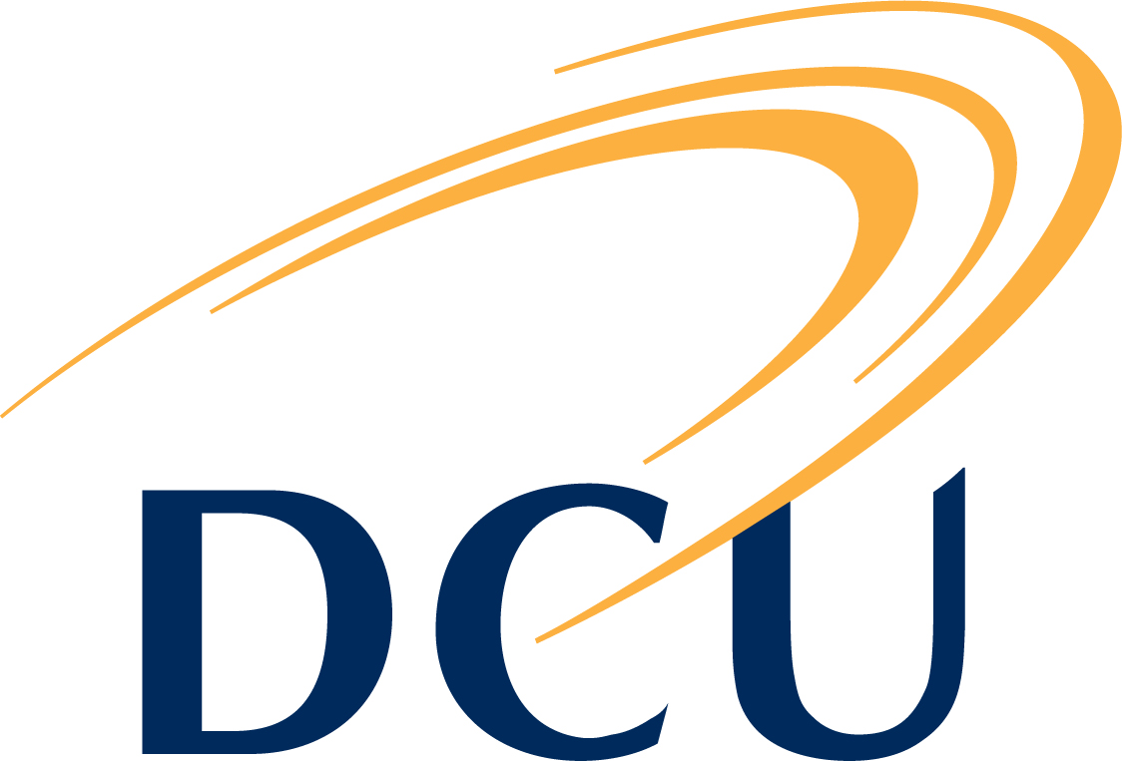
DCU Quality Promotion Office
Quality Improvement & Development (QuID) Funding 2017

2017 Topic Area: Student Engagement

Application Form

1. Name of applicant(s), role(s) within DCU and contact information:

2. Title of project:

3. Overview of the proposed project (100-150 words):
Important Notice:

When completing this section please ensure to provide a high-level overview of your project while highlighting clear goals and objectives

4. Total amount requested from QuID fund: €
Important Notice:

Up to a maximum of €2,500 will be awarded to each successful project

5. Outline the level of agreed support from other areas within DCU:
Important Notice:

Indicate whether support from other areas within DCU will be required, and if so, confirm that an agreement has been reached with the relevant respective staff member(s). The names and roles of staff members involved would be beneficial.

DCU Quality Promotion Office
Quality Improvement & Development (QuID) Funding 2017

2017 Topic Area: Student Engagement

Application Form

6. Project Costs:
Important Notice:

Provide a detailed break-down of the proposed project costs in addition to a summary explaining how the QuID funding will support this project while providing an outline of the planned funding source for any expected or unexpected project shortfalls.

7. Project Outline (to include time-lines and milestones/objectives) (max 500 words):
Important Notice:

This section should include an answer to:
- How will the project improve and / or develop quality assurance and/or enhancement in your area for students?

And could include an answer to some or all of the following:
- How does the project link to the Student Engagement Topic?
- Is the project aligned to the DCU 2012-2017 Strategic Plan: Transforming Lives and Societies?

Applicant(s) Declaration

I am pleased to confirm that I have discussed the outline and objectives of this proposal with the Head of my School / Faculty / Unit and have received his/her full support to ensure we achieve the milestones and objectives set out in this proposal by the end of September 2017. I understand that if successful, I am required to complete and submit a Progress Report to the QPO at the mid-way point and on completion of the project. Furthermore, I have engaged a number of DCU units who have provided their agreement to support the implementation process of this project.

Signature(s):_____________________________ Date: ______________________________
Considering that we may need to liaise with your Head of School/Faculty/Unit sometime post submission, can you please provide his/her contact details in the space below;

Name:
Email:
Phone:

DCU Quality Promotion Office
Quality Improvement & Development (QuID) Funding 2017

2017 Topic Area: Student Engagement

Application Form

Important notes:

- In addition to online submission, applicants must submit a hard copy of the final Application Form to Fiona Dwyer, Quality Promotion Office, Room A154, Glasnevin Campus. To facilitate colleagues based on either All Hallows or SPD campuses we have extended the deadline for hard copies to on or before: Friday 3rd February 2017.

NB – The application process cannot be finalised until the hard copy is received.

- If successful, an outline of the project details will be required for publication on the Quality Promotion Office website.

If you have any queries you are very welcome to contact Fiona Dwyer (fiona.dywer@dcu.ie or on ext 8411).

