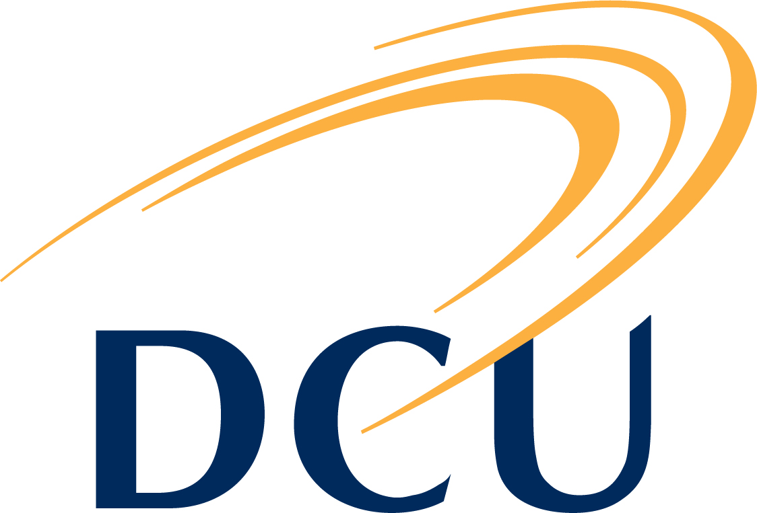
DCU Quality Promotion Office
Quality Improvement & Development (QuID) Funding 2017/18

Topic Area: Internal Communication

Application Form

1. Name of applicant(s), role(s) within DCU and contact information:

2. Title of project:

3. Overview of the proposed project (100-150 words):
Guidance Note:

When completing this section please ensure to provide a high-level overview of your project while highlighting clear goals and objectives

4. Total amount requested from QuID fund: €
Guidance Note:

Up to a maximum of €2,500 will be awarded to each successful project

5. Outline the level of agreed support from other areas within DCU:
Guidance Note:

Indicate whether support from other areas within DCU will be required, and if so, confirm that an agreement has been reached with the relevant respective staff member(s). The names and roles of staff members involved would be beneficial.

DCU Quality Promotion Office
Quality Improvement & Development (QuID) Funding 2017/18

Topic Area: Internal Communications

Application Form

6. Project Costs:
Guidance Note:

Provide a detailed break-down of the proposed project costs in addition to a summary explaining how the QuID funding will support this project while providing an outline of the planned funding source for any expected or unexpected project shortfalls.

7. Project Outline (to include time-lines and milestones/objectives) (max 500 words):
Guidance Note:

This section should include an answer to:
- How will the project improve and / or develop quality assurance?
- How does the project link to enhancing Internal Communications?
- Is the project aligned to the DCU 2017-2022 Strategic Plan, Talent, Discover and Transformation

Applicant(s) Declaration

I am pleased to confirm that I have discussed the outline and objectives of this proposal with the Head of my School / Faculty / Unit and have received his/her full support to ensure we achieve the milestones and objectives set out in this proposal by the end of September 2018. I understand that if successful, I am required to complete and submit a Progress Report to the QPO at the mid-way point and on completion of the project. Furthermore, I have engaged a number of DCU units who have provided their agreement to support the implementation process of this project.

Signature(s):_____________________________ Date: ______________________________
Considering that we may need to liaise with your Head of School/Faculty/Unit sometime post submission, can you please provide his/her contact details in the space below;

Name / contact details:
Email:
Phone:

DCU Quality Promotion Office
Quality Improvement & Development (QuID) Funding 2017/18

Topic Area: Internal Communications

Application Form

Important notes:

- In addition to online submission, applicants must submit a hard copy of the final Application Form to Fiona Dwyer, Quality Promotion Office, Room A154, Glasnevin Campus. The deadline for hard copies is on or before: 13th November 2017.

NB – The application process cannot be finalised until the signed hard copy is received.

- Please note that funding cannot be used to hire research staff on a short-term contract basis.

- If successful, an outline of the project details will be required for publication on the Quality Promotion Office website.

If you have any queries you are very welcome to contact Fiona Dwyer (fiona.dywer@dcu.ie or on ext 8411).

