2015 SFI Starting Investigator Research Grant/Career Development Award
Expression of Interest (EOI)
To be completed and returned to annelouise.holloway@dcu.ie by Friday 14 August 2015
SFI Call Overview
Science Foundation Ireland has launched its 2015 calls to enable early- and mid-career researchers to become excellent, fully independent research leaders and carry out research aligned to SFI’s legal remit (oriented basic and applied research in the areas of science, technology, engineering and mathematics (STEM). There are two calls:
1 Starting Investigator Research Grant (SIRG) aims to enable those at an early career stage to establish themselves as independent researchers. It is a four year award, value of award €400,000 including salary of SIRG and PhD studentship.
Summary of SIRG eligibility:
- 3-8 years post PhD research experience
- applicants must not hold a faculty position at the time of application or at the start of the award.
- applicants must not hold or have held a significant, independent research award of greater than one-year duration (which must be valued less than €100,000)
- applicants must have identified a mentor in DCU who will allow the starting investigator to carry out the project within their research space
- applicants must be senior author on at least 3 primary research articles in international peer-reviewed publications
Full details of eligibility can be found in the SIRG call document
2. Career Development Award (CDA) is designed to support early career and mid-career researchers who already hold a salaried lecturing position. It is a four year award, value €300,000-€500,000 – no request for PI salary allowed.
Summary of CDA eligibility:
- 3-15 years post PhD research experience
- Applicant holds a salaried lecturing position (which can be permanent or temporary)
- Applicants may not have held a previous award whose value is greater than €500,000
- Senior author on at least 5 primary research articles in international peer-reviewed publications
- Applicants may not have held a PI-like award from SFI *
*Exceptions apply please see full details of eligibility can be found in the CDA call document

DCU Selection Process
DCU is only allowed to submit 12 proposals against each category (SIRG and CDA) and therefore there will be an internal selection process. For the SIRG call, SFI mandates that a maximum of six candidates, out of the 12 permitted from each eligible research body, may be male candidates. In addition, up to 4 of the SIRG places will be ear-marked for candidates moving from another institution to DCU.

Interested individuals who believe they meet the above eligibility criteria are requested to complete the enclosed Expression of Interest, which consists of:
- A set of key performance indicators
- Summary of research project (1 Page)
- 5 page CV
And return by email to annelouise.holloway@dcu.ie by Friday 14 August 2015. Expressions of Interest will be reviewed by DCU Research & Innovation Support and assessment criteria will be based on quality of the applicant’s track record and research summary.
Timelines:
Call for EOIs | 25 June 2015
Submission of EOIs | Friday 14 August 2015
Communication of results of internal selection | Beginning of September
Proposal Development period | From September onwards
SFI submission deadline | SIRG: 26 November 2015 CDA: 10 December 2015

2015 SFI Starting Investigator Research Grant/Career Development Award
Expression of Interest (EOI) to be consider as one of DCU’s candidates
To be completed and returned by email to annelouise.holloway@dcu.ie by Fri 14 August 2015

Applicant Name
Affiliation & School/Centre
Please indicate for which call you are submitting this EOI
Starting Investigator Research Grant ^{1,2}  (3-8 years post PhD) | Career Development Award³  (3-15 years post PhD)
DCU Mentor’s name (in case of SIRG only)
¹ Applicants must not hold a faculty position at the time of application or at the start of the award.
²those who graduated during the period of September 2007 to December 2012, inclusive, are eligible to apply
³ Applicants must hold a salaried lecturing position

Key Performance Indicators⁴
Total number of peer-reviewed publications (Journals and Conference Proceedings)
Total number of peer-reviewed publications (Journals and Conference Proceedings) since PhD.
No. of years since PhD (from date of graduation)
Number of peer-reviewed publications as senior author (first, last or corresponding author).
H-index (please indicate source or sources, i.e. Web of Science, Scopus etc.)
Number of Review articles
Total number of citations from peer-reviewed publications (excluding self-citations)
Please include a graphical representation of your peer-reviewed publications by year since your PhD (include detail of source). | E.g.  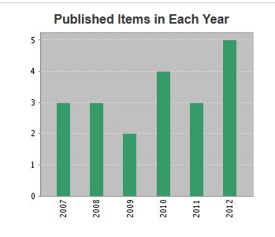
Please include a graphical representation of citation count, excluding self-citation, by year since your PhD (include detail of source). | 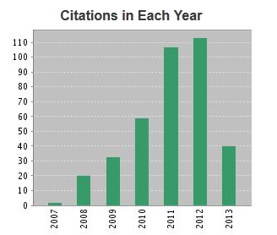
⁴ Please do not include papers in preparation, or submitted for review. Only papers published or in press.
Research Summary (maximum 1 page in total)
Project Title:

Key Words (up to 7)

SFI Research Area | Science Technology Engineering Mathematics
Please indicate which of the Forfás National Research Prioritisation areas the project aligns
Project Abstract
Please provide a brief summary of the proposed project

Impact
Please provide a short paragraph on where you see the potential impact of the project may lie

Applicant CV
Please adhere to the template below (5 pages maximum)

CV for Insert applicant name, Affiliation & School/Centre

Academic Record
Please provide details of your education and training (including dates) and any relevant highlights.

Research Record
Please provide detail of each research position you have held (including dates), outlining your role and any key outputs you would like to highlight.

Awards & Distinctions
Include detail of any awards and prizes of distinctions that you would like to highlight.

Leadership & Supervision
Include details of students supervised, management roles, advisory boards etc.

Funding History. Total value: €X
Please provide a list of funding held (e.g. personal fellowships, research grants etc.) including:
- project title/objective
- award type and awarding body
- date of award (and end date if appropriate)
- value and your role on the project.
If it is an award shared between a team, provide the full award value and the amount assigned to you

Innovation /Commercialisation Activity
Where appropriate, please provide detail on any Innovation /Commercialisation Activity including the number of patents filed/pending. Please distinguish between patents applied and under review versus patents granted.

Other Information as appropriate

Publications & Presentation
Please provide a summary of your publications grouped by type: refereed journals / journals not refereed/ refereed conference papers / conference papers not refereed/other publications. Include the total number by type, indicating on how many you were senior author.

Please highlight below with an asterisk each of your senior author publications and underline your name on each publication listed. Also include relevant presentations and anything you else would like to highlight.

