**PUBLIC AND PATIENT INVOLVEMENT (PPI) IGNITE NETWORK @ DCU**

**Call for Proposals Supporting Public and Patient Involvement (PPI) Activities in Health and Social Care Research – Round 1 2022/2023**

**Overview**

Funded by the Health Research Board (HRB) and Irish Research Council (IRC), the PPI Ignite Network @ DCU [<https://www.dcu.ie/ppi>], over the next three years, will run an annual funding call to support public and patient involvement activities. The first Round of this call is now open. The purpose of the call is to provide funding to enable applicants to develop and advance meaningful public and patient involvement activities within their area of health and social care research.

Public and Patient Involvement (PPI) *is research carried out ‘with’ or ‘by’ members of the public rather than ‘to’, ‘about’ or ‘for’ them.* PPI is distinct from, and additional to, activities that raise awareness, share knowledge, and create a dialogue with the public. PPI is also distinct from recruitment of patients/members of the public as participants in research.

Applications to this call can include PPI activities at any stage in the research lifecycle, from generating ideas and proposal development, to data collection and analysis, and knowledge exchange and impact assessment, as illustrated in Figure 1.

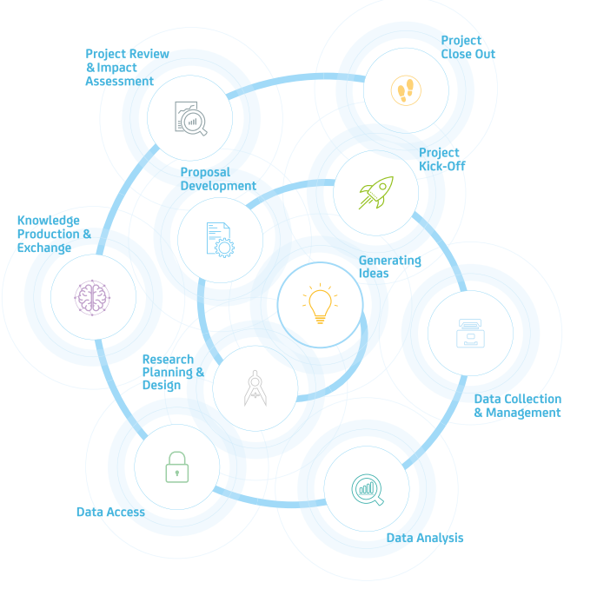

**Figure 1: Engaged Research Framework (Campus Engage, https://www.campusengage.ie/)**

Examples of the types of activities in which the public and patients may be involved include helping to clarify the research question, co-designing the project, assisting in data collection and/or analysis, co-presenting findings, and helping with writing up dissemination materials. Further examples are illustrated in Figure 2.

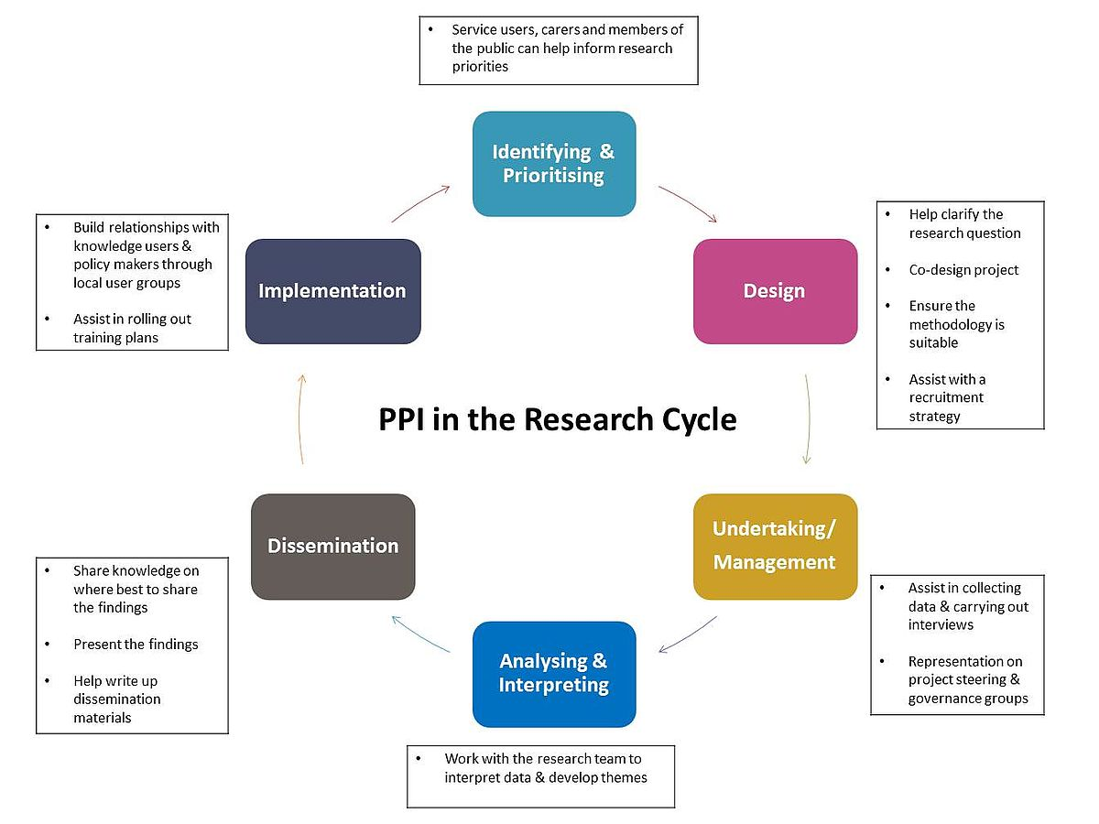

**Figure 2: PPI in the Research Cycle (Health Research Board https://www.hrb.ie/funding/funding-schemes/public-patient-and-carer-involvement-in-research/ppi-in-your-research-your-story/)**

**Funding**

Applicants can request between €100 and €1,500. The total budget available for the first Round of this call is €3,000. Funding can be used to cover running costs directly associated with public and patient involvement activities, for example, honoraria, travel, and childcare for PPI contributors, venues and catering costs for PPI activities, training costs for PPI contributors etc. Costs must be appropriately justified based on the proposed PPI activities.

**Duration and Timelines**

The proposed activities must be completed within 12 months of receipt of the award. See key dates and timelines in Table 1.

**Table 1: Key dates and timelines**

|  |  |
| --- | --- |
| Launch of Round 1 of call | 5th Sept 2022 |
| Application deadline | 1st Oct 2022 |
| Award notification date | 1st Nov 2022 |
| Award start date | Awards must start before 31st Dec 2023 |
| Launch of postgraduate call | Q1 2023 |
| Launch of Round 2 of call | Q3 2023 |

**Reporting**

Recipients of this funding will be required to provide a written summary report to the PPI Ignite Network @ DCU on completion of the proposed PPI activities. Recipients may also be invited to present on their PPI activities at a future PPI Ignite Network @ DCU seminar series. The funding support of the PPI Ignite Network @ DCU must be acknowledged, as appropriate.

**Applicant Eligibility**

The lead applicant must be a member of DCU academic/research staff. They can be at any career stage. While not mandatory, PPI contributors as co-applicants are encouraged. Students are not eligible to apply as lead applicants. A separate call specifically for PhD students will be announced in 2023.

**Application Procedure**

Applications should be submitted via email to [publicandpatientinvolvement@dcu.ie](mailto:publicandpatientinvolvement@dcu.ie),with the completed application form (see Appendix 1) attached.

Please clearly state the funding call and your name in the email subject line using the following format: “Application to PPI Activities Call Round 1_John Smith”. Please write your application in plain accessible English.

**Assessment Criteria, Procedure and Outcome**

A review panel established by the PPI Ignite Network @ DCU will review the proposals. The panel will consist of experts in the area of PPI in research. The panel members will independently assess all sections of the application and score applications based on:

* Clarity of PPI Activity Description
* Generation of Meaningful Public and Patient Involvement
* Feasibility of Implementation Plan
* Consideration of Equality, Diversity and Inclusion
* Outputs and Impact of the PPI Activities

See Appendix 2 for more details on the above assessment criteria and weighting.

All panel member scores and comments will be collated and discussed at a review panel meeting, which will select the applications to be funded. Applicants will be informed of the outcome via email. Reviewer feedback/scores will be made available to applicants.

**Further Information**

If you have any questions or if you would like to discuss the application process in more detail, please contact Prof. Veronica Lambert, Lead, PPI Ignite Network @ DCU.

Email: [publicandpatientinvolvement@dcu.ie](mailto:publicandpatientinvolvement@dcu.ie)

**PUBLIC AND PATIENT INVOLVEMENT (PPI) IGNITE NETWORK @ DCU**

**Call for Proposals Supporting Public and Patient Involvement (PPI) Activities in Health and Social Care Research – Round 1 2022/2023**

**APPENDIX 1: APPLICATION FORM**

**Title:**

**Applicant Name and Email Address:**

Please complete the following five sections:

1. **Public and Patient Involvement Activity Description:** Describe the public and patient involvement activity that will be undertaken. The word limit is 600 words.
2. **Meaningful Public and Patient Involvement [PPI]:** Describe how the proposed PPI activity will establish new and/or strengthen existing relationships and result in meaningful PPI in health and social care research. The word limit is 400 words.
3. **Implementation Plan:** Detail the implementation plan for the PPI activity. Include a detailed budget (with justification) and timeline. Reviewers will use this information to help assess the feasibility of the activities. The word limit is 350 words.
4. **Equality, Diversity, Inclusion (EDI):** Explain the consideration given to EDI in the proposed PPI activity. If EDI has not been considered, provide justification for the same. The word limit is 350 words.
5. **Outputs and Impact of the PPI Activities:** Describe the expected outputs and impact of the proposed PPI activities. The word limit is 350 words.

**PUBLIC AND PATIENT INVOLVEMENT (PPI) IGNITE NETWORK @ DCU**

**Call for Proposals Supporting Public and Patient Involvement (PPI) Activities in Health and Social Care Research – Round 1 2022/2023**

**APPENDIX 2: ASSESSMENT CRITERIA**

The following five criteria will be used to assess applications by the review panel. Review panel members will assess whether the application meets the *Ineffective, Effective or Highly Effective* descriptor in relation to each of the specific criteria. Reviewers may also provide comments (strengths, weaknesses etc.) relating to the assessment criteria. The assessment criteria weighting is noted in column one.

| **Assessment criteria** | | **Ineffective** | **Effective** | **Highly Effective** | **Rating Score** | **Weighted Score** | **Comments** |
| --- | --- | --- | --- | --- | --- | --- | --- |
| Criteria 1,  weight 25% | Clarity of PPI Activity Description | The application does not clearly present a coherent description of what PPI activities will be undertaken (Ineffective: Rating 1-3) | The application clearly presents a coherent description of what PPI activities will be undertaken (Effective: Rating 4-6) | The application clearly presents a coherent, comprehensive description of the PPI activities that will be undertaken (Highly Effective: Rating 7-9) |  |  |  |
| Criteria 2, weight 25% | Generation of Meaningful Public and Patient Involvement (PPI) | The PPI activities will not effectively contribute to generating meaningful PPI in research through establishing new and/or strengthening existing relationships (Ineffective: Rating 1-3) | The PPI activities will effectively contribute to generating meaningful PPI in research through establishing new and/or strengthening existing relationships (Effective: Rating 4-6) | The PPI activities will be highly effective in contributing to generating meaningful PPI in research through establishing new and/or strengthening existing relationships (Highly Effective: Rating 7-9) |  |  |  |
| Criteria 3, weight 15% | Feasibility of Implementation Plan | The implementation plan, budget and timelines are ineffective in terms of feasibility and the proposed activities are unlikely to be successful (Ineffective: Rating 1-3) | The implementation plan, budget and timelines are effective in terms of feasibility and the proposed activities are likely to be successful (Effective: Rating 4-6) | The implementation plan, budget and timelines are highly effective in terms of feasibility and the proposed activities are likely to be highly successful (Highly Effective: Rating 7-9) |  |  |  |
| Criteria 4, weight 15% | Consideration of Equality, Diversity, Inclusion (EDI) | Consideration not given to EDI in the proposed PPI activities and no justification provided for lack of EDI consideration. (Ineffective: Rating 1-3) | EDI was effectively considered to a good quality in the proposed PPI activities (Effective: Rating 4-6) | EDI was extensively considered to a high quality in the proposed PPI activities (Highly Effective: Rating 7-9) |  |  |  |
| Criteria 5, weight 20% | Outputs and Impact of the PPI Activities | The application does not clearly describe the output or demonstrate the potential impact of the proposed activities. Note that impact should be considered in its broadest sense, e.g. relating to the research, research team and/or PPI contributors (Ineffective: Rating 1-3) | The application clearly and coherently describes the output and demonstrates the potential impact of the proposed activities. Note that impact should be considered in its broadest sense, e.g. relating to the research, research team and/or PPI contributors  (Effective: Rating 4-6) | The application clearly and coherently describes the output and demonstrates the potential for significant impact. Note that impact should be considered in its broadest sense, e.g. relating to the research, research team and/or PPI contributors (Highly Effective: Rating 7-9) |  |  |  |
| **Total Rating Scores, Weighted Scores & Overall Comments** | | | | |  |  |  |