AVAYA Workplace Softphone

Installing and logging into a Softphone

Before using a Softphone for the first time, please log a ticket with ISS, requesting that your telephone account is configured to use a softphone.
When logging the ticket, please supply the following information:
4 digit extension number
Full DCU email address;

After you have received confirmation from ISS that your account is configured, you can then install the softphone client.

Please note, the softphone client can only be installed from the Software Centre, so it can only be configured on a DCU Windows device, it cannot be installed on a personal device.

Open Software Centre

Find and Install Avaya Workplace IX client

Open the Application

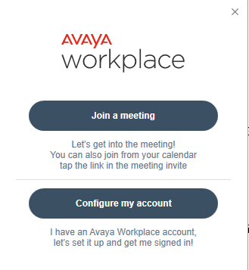

Select "Configure my Account"

Enter your email address in the first window, select Next

On the next window, use your email address for the Username and your DCU password, select Next

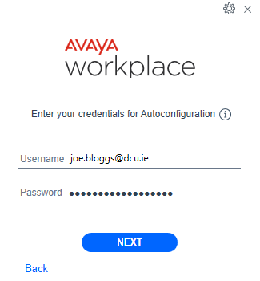

Your client is now logged in, please dial 0 for an outside line

