Escape Room Narratives for DCU Teaching & Learning Week 2021

Lisa Donaldson
Lisa.donaldson@dcu.ie
@dubdonaldson
Two escape rooms were created for this annual CPD event; one a live team based activity in Zoom breakout rooms designed to support staff with podcasting skills, the other an individual asynchronous activity to develop Universal Design for Learning (UDL) awareness within Moodle. Both activities were designed using the Google suite of tools and a gamified Moodle page with the Level Up plugin was developed for the Twas the night before term started… escape room to enable staff to complete the activities as per the narrative below.

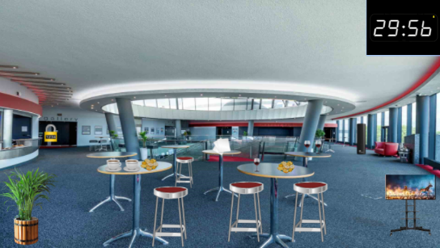
I’m an academic, get me out of here
Delighted to be back on campus, you went to the Helix for an event with some colleagues– but you were so busy catching up you have managed to get yourselves locked in! You need to send a message for assistance. Working together, you decide to create a podcast message for help but you can only use the tools at your disposal in the room. Look around carefully as you have only 30 minutes before the shutters automatically come down and you can’t get out till morning!
Some top tips before you enter the room:
- You will randomly be assigned a breakout room (we will have about 14). You and your team members in the room will need to work together to escape within the 30 minutes
- You will need to appoint a note taker to keep track of clues and manage the tasks.
- All the clues you will need are in the room but watch out for false clues. If you need help, you can send a message from the breakout room
- The clock will start when you enter the escape room
- The first team to escape will win a prize for each member.
- The very best of luck!
I will share the link now and please just keep it open. If you need any help, please just send a message from your breakout room
Link to Escape Room: https://docs.google.com/presentation/d/1yavY8pi2AiFY6NVy97cH5H9FKSwEM293dCHKVJj7C9w/preview?usp=sharing
Note: This escape room will help you develop the skills required to create a podcast.

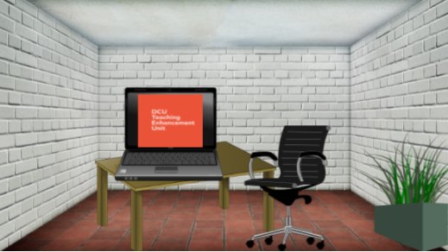
'Twas the night before term started and you are NOT quite ready!
Excited and enthusiastic students will be pouring back onto campus and into your classroom tomorrow and you still have so much to do! Undaunted, you run through a list in your mind. First things first – you have been told you have a very diverse class this term and you want to do your best to support every student. You know that Universal Design for Learning (UDL) principles offers equal opportunities for all to learn so you decide to find out more so that you can unlock the next items on your To Do list. If you can complete all items on your list within 30 minutes you will be prepared and ready to have a great semester with your students! Best go to your office to start looking for clues (they are hidden in the room!)…the timer will automatically start and you have 10 minutes to solve the first clue!
Note: This escape room will help you explore some of the features of Loop/Moodle.

Task 1
Your first task is to access your online space in Loop. To do this you will need to unlock a tile to organise your course materials. You can do this by putting yourself into a group which will open up your space.
Look for the group choice activity called “It’s my space, let me in” and complete it. To complete it you will need to choose a colour from the list, save your choice and then when done, return to this area of the main Loop page to see your subsequent tasks unlocked.

Task 2
Once you have unlocked your tile, it’s time to create a welcome message for your incoming students.
One way to integrate universal design for learning principles (UDL) into your course is to provide your students with multiple means of representation. This particular UDL approach focuses on giving learners, or guiding learners to, content in a variety of formats. You decide to create a welcome message in both text and video format.
The template Module Handbook is a good place to create this welcome message. Go into your tile and check it out to see what you need to do. When you've updated the book, return to the main Loop page and check the small button next to the book title so you know you've completed it: When this task is completed, return to this area to undertake your next one.
Task 3
Phew! That’s one thing done anyway!
Next, you want to encourage your students to participate in the assessment design for your module. You know there are many ways to develop students as partners in assessment and you opt for a simple approach – give them choice in topics to be assessed.
The Choice activity is a good tool to use. Go into your tile to find it. Edit the settings and provide three different options of assessment topic. After saving changes, make a choice yourself to confirm it's working.
When this task is completed, return to this area to undertake your next one.
Task 4
Right, that’s the assessment sorted.
Now, you want to set up a quick online ice breaker activity that will allow students to meet one another virtually. You don’t want to be prescriptive but rather incorporate the UDL principle of multiple means of engagement by allowing your students to use multiple ways engage and share information.
You decide to use a Forum for this, because posts in a forum can comprise text, imagery and more. Go into your tile to locate the forum. Edit the settings on the forum as you wish, and then post the first topic to get the icebreaker going. It's important that lecturers are active on forums to encourage student participation! Insert an image or other type of media in your post.
When this task is completed, return to this area to undertake your next one.
Task 5
Finally, you have heard from other lecturers that using the Loop Reflect eportfolio has proven very successful with students. It enables students to demonstrate their learning using multiple media in creative ways.
Designing the assessment criteria and reflective prompts is tomorrow’s job but for now you just want to set up the Assignment activity in Loop so that students can see the deadline. Go into your tile to find the Assignment. Edit the Assignment as necessary to set up the Reflect assignment (Hint: Full instructions on how to do that are included in this document, but you only need to worry about setting dates and the submission type). When you've updated the assignment, check the small button next to the book title so you know you've completed it.
Refresh the page to see have all your edits taken effect - are you ready for the first day of term now?

